SUBJECT and GRADE | Civil Technology (Woodworking) Grade 12
TERM 2 | Week 6
TOPIC | WALL PANELLING (Specific)
AIMS OF LESSON | To determine the budget.  Prevents wastage of material.  Work out quantities of a project. (Useful to get quotes.)
RESOURCES | Paper based resources:  In your textbook on page 118 - 122 of Chapter 9 |  | Digital resources:
INTRODUCTION | Wall panelling will be discussed in this chapter. Wall panelling is an ideal way to cover walls, from floor to ceiling or only partly, without having to plaster the wall prior to installation. There are panelling to suit every taste.  As a dedicated learner you were exposed to many drawings and concepts within Graphics as Means of communication where you did drawings and sketch some images freehand.  In this lesson we are going to look at wall paneling and do some scale drawings to understand the content.
CONCEPTS AND SKILLS | Sketch the front elevation and vertical section through a tongue-and-groove wall panel from floor to ceiling.  A vertical section showing the rough grounds and the finish at the top of the paneling. Knowledge of the different parts of the wall paneling will be acquired as well.  Drawings skills will be acquired by doing this lesson. Proportionally sketch work and sectional interpretation will be part of the skill set. | CAN YOU?  - Sketch a Tongue-and-groove boards (strip boards)  - Sketch a skirting and quarter round.  - Sketch how the strip boards are attached to each other.

 | Construction of a tongue-and-groove wall panelling  - Horizontal rough grounds are fixed to the walls by means of screws and wall plugs, or steel cut nails if the tongue-and-groove boards are installed vertically.  - The first tongue-and-groove board should be nailed to the rough grounds at a corner with the groove facing the corner.  - Use 45 mm panel pins to fasten the boards to the horizontal grounds and countersink the nail with a pin punch.  - Wood mouldings, such as skirting boards and quadrants, can be used to cover the gaps after the wall panel has been fixed into position.  - The capping is fitted onto the top of the tongue-and-groove board wall panelling to lend an aesthetic appearance. | 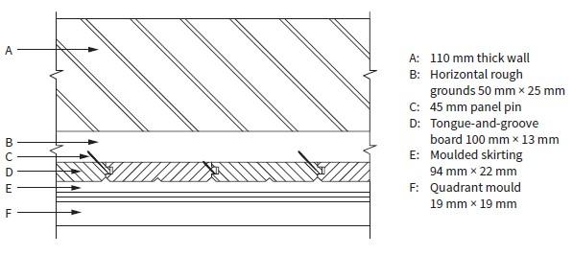  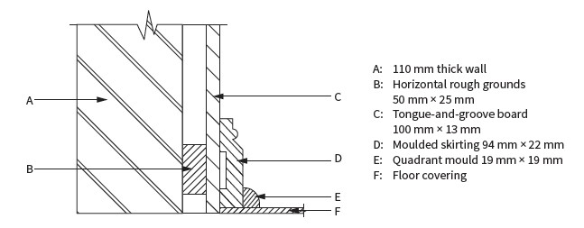  The finish at the bottom of the panelling  The joint between two strips boards
ACTIVITIES/ ASSESSMENT

You can now look on page 120 and complete Activity 9.1. Complete on page 122 Activity 9.2

CONSOLIDATION

With this topic you will be able to identify wall paneling and the different parts of it. Measuring is another skill that will be required and mastered. Wall paneling is a lesson that will make you understand the uses of it and how to install it.

VALUES

By engaging with this lesson, you should: • Express different construction processes by means of graphics and communication. • Realise the importance of correct measurements • Accuracy is an integral part of a draftsmen.

