SUBJECT and GRADE | ENGINEERING GRAPHICS AND DESIGN GRADE 12
TERM 2 | Week 2
TOPIC | ISOMETRIC DRAWINGS (JP p. 58) & (JP p. 59)
AIM OF LESSON | Learners are required to draw an isometric view from a drawing in third angle orthographic projection.
RESOURCES | Paper based resources | Digital resources (Lesson on the content)
 | ISOMETRIC (JP p. 58)  ISOMETRIC (JP p. 59)  See the attached drawings | https://youtu.be/bML4kLl67eo (LESSON 1) https://youtu.be/dC1PCkgTNvY (LESSON 2)
INTRODUCTION | REVISION: Auxiliary Views, Circles  Construction of a hexagon (Gr 10)  Construction of isometric circles (Gr.11)  WEEK 1: LESSON 1  • Auxiliary views  - Revision of Isometric and none isometric lines (Drawing Exercise)  - Use / Function of Auxiliary views  - Drawing exercise (p. 58)  - Revision of Circle (Exercise)  - Exercise consisting of an Auxiliary view and none-isometric lines.  WEEK 1: LESSON 2  Auxiliary views  - Revision of Isometric and none isometric lines (Drawing Exercise)  - Use / Function of Auxiliary views  - Drawing exercise (p. 59)  - Revision of Circle (Exercise)  - Exercise consisting of an Auxiliary view and none-isometric lines  • In this lesson we will concentrate on Isometric drawings in line with external question papers.

CONCEPTS AND  SKILLS | Learners must be able to:  draw isometric drawings as within the activities provided.  Circles drawn in isometric.  The skill to see and draw hidden detail  Construction of different shapes in isometric  Learn and develop the skill to do and convert an orthographic view to an isometric view.  Draw a half section of an isometric object. | CAN YOU?  - Interpret an orthographic view and convert it to an isometric view.  - Identify the different views given to you?  - Determine the point where to start the isometric drawing?  - Draw the construction detail of the drawing?  - Draw the circle in an Isometric drawing?  - Identify where hidden detail will be needed in your drawing?  Learners must adhere to all drawing criteria.
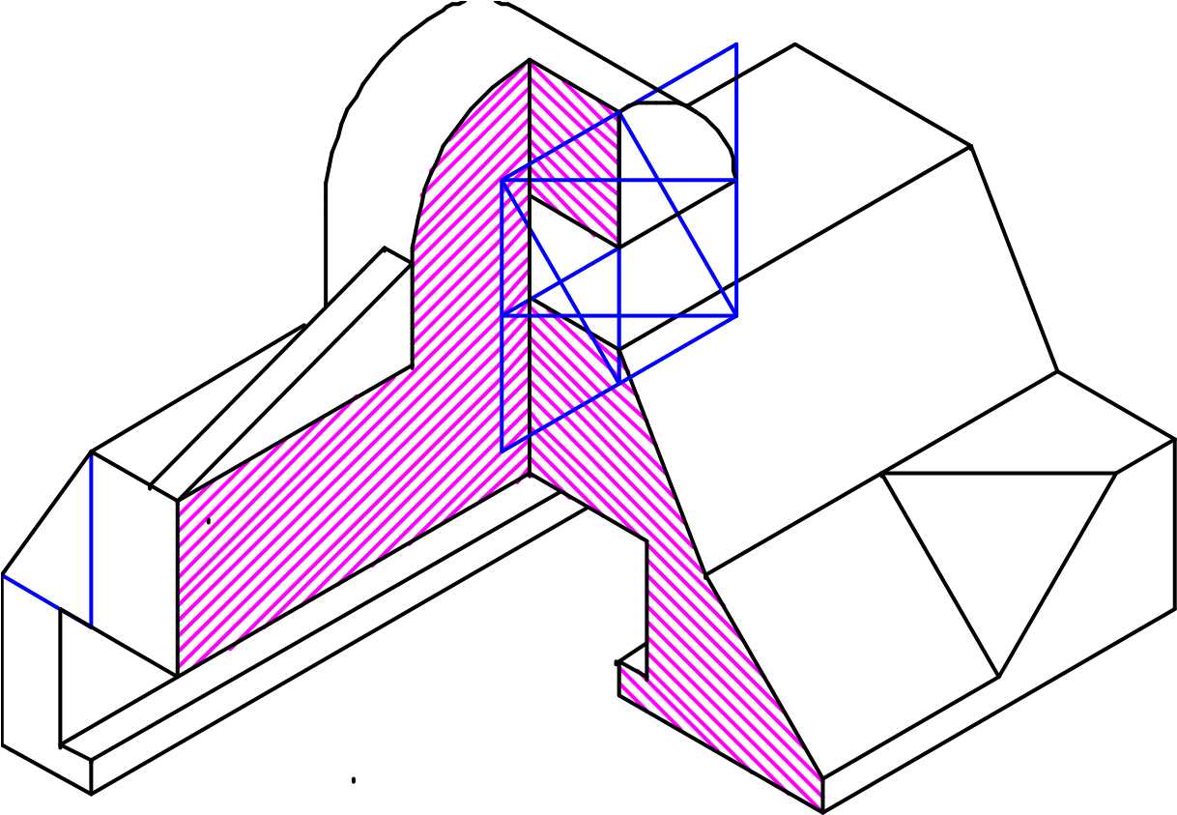
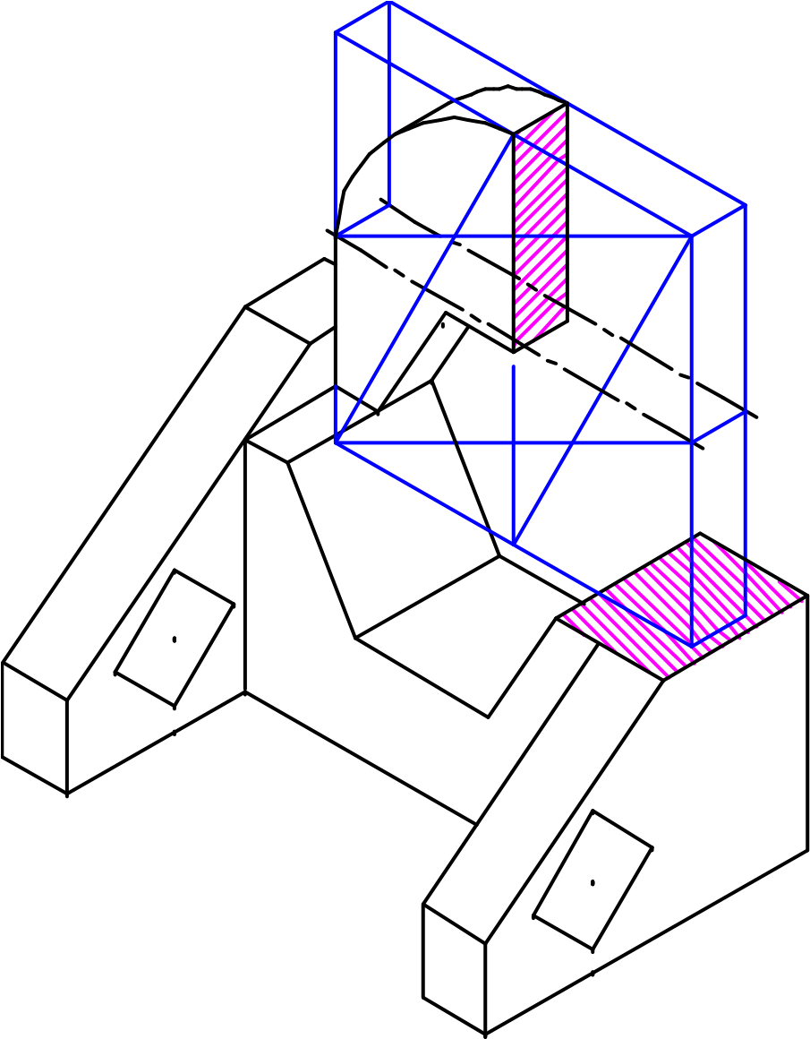ISOMETRIC DRAWINGS (HOW IT LOOKS)
ACTIVITIES/  ASSESSMENT | Complete the activities/questions on Isometric drawings attached.  RECOMMENDATION:  See attached grade 12 exercise for ISOMETRIC DRAWINGS  Standard of Exercise meet all external examination requirements  Draw to scale 1: 1  Read the instruction on the question given.  ALL drawings must comply with the guidelines contained in the SANS 10143.
CONSOLIDATION | - Define all the terminology relevant to the topic/s covered in this lesson:  - Printing of measurements are in some cases important.  - Practice and complete the drawings if you did not finish in time.  - Use the correct line types: Construction lines, hidden lines, ext.  - Practice daily.
VALUES | The ability to be able to draw and interpret isometric drawings.  To be able to draw the isometric drawing from a given orthographic drawing.

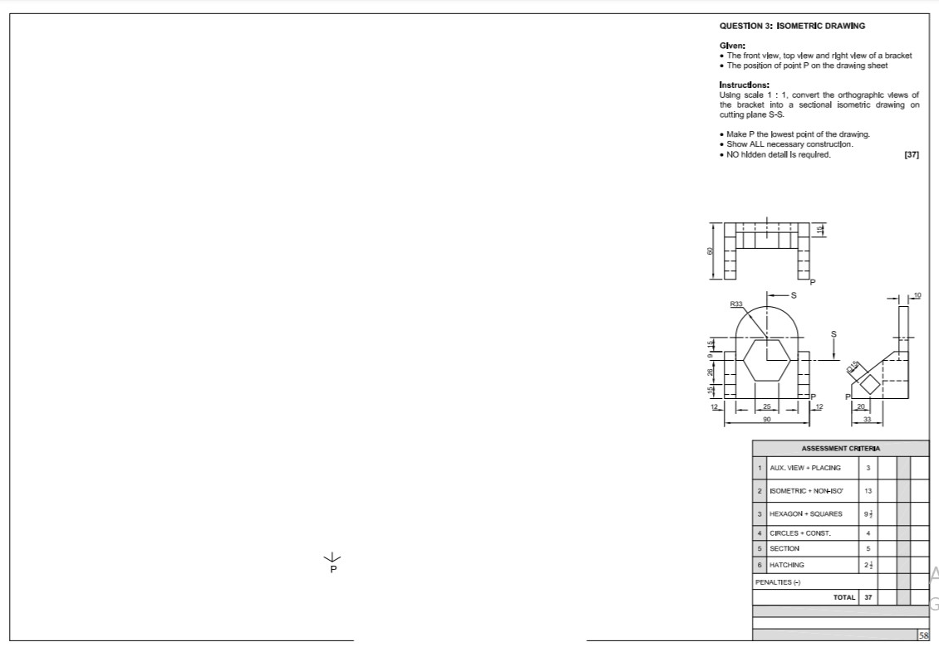

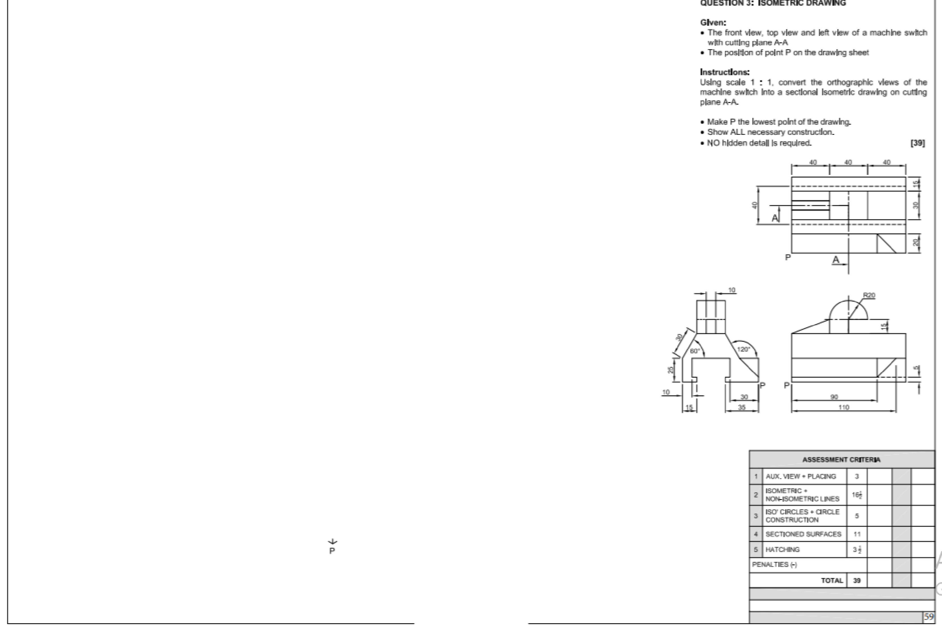

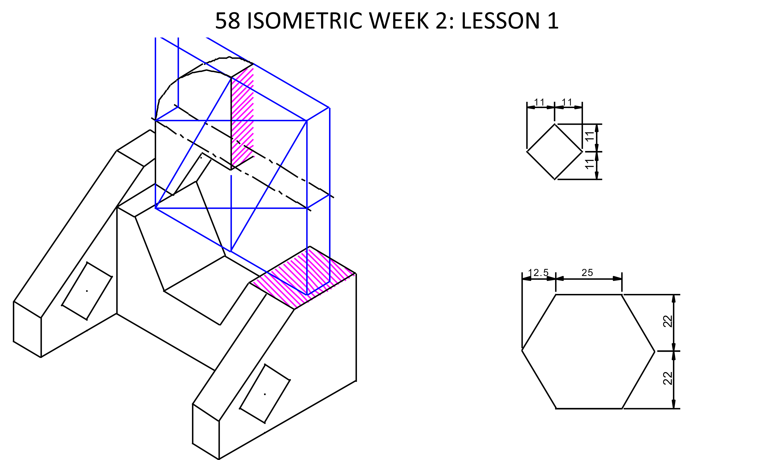

59 ISOMETRIC WEEK 2: LESSON 2

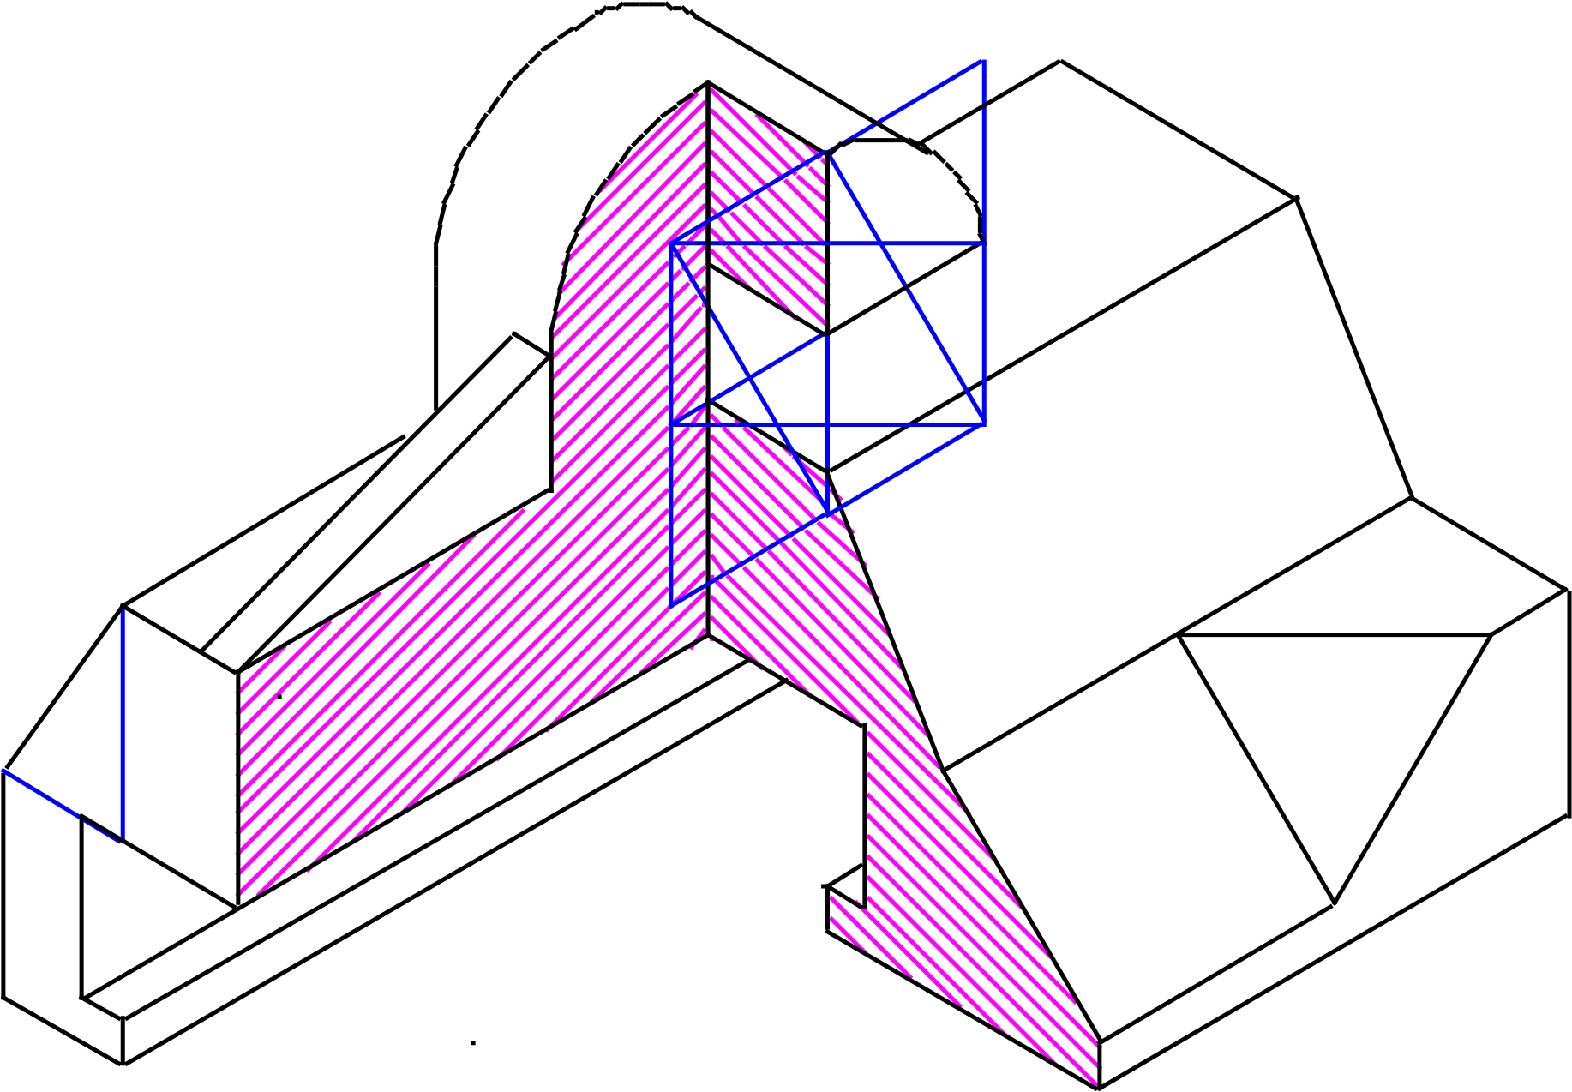
1
5
3
0
1
5
2
6

