Province of the
EASTERN CAPE
EDUCATION

DIRECTORATE SENIOR CURRICULUM MANAGEMENT (SEN-FET)
HOME SCHOOLING SELF- STUDY WORKSHEET
SUBJECT | ECONOMICS | GRADE | 12 | DATE | 22/04/2020
TOPIC | MICROECONOMICS | TERM 1  REVISION |  | TERM 2 CONTENT | X
TIME ALLOCATION | 30 MINUTES MARKS: 40 | TIPS TO KEEP HEALTHY  1. WASH YOUR HANDS thoroughly with soap and water for at least 20 seconds. Alternatively, use hand sanitizer with an alcohol content of at least 60%.  2. PRACTICE SOCIAL DISTANCING – keep a distance of 1m away from other people.  3. PRACTISE GOOD RESPIRATORY HYGIENE: cough or sneeze into your elbow or tissue and dispose of the tissue immediately after use.  4. TRY NOT TO TOUCH YOUR FACE. The virus can be transferred from your hands to your nose, mouth and eyes. It can then enter your body and make you sick.  5. STAY AT HOME.
INSTRUCTIONS | INSTRUCTIONS AND INFORMATION  - Answer ALL questions in the ANSWER BOOK  - Number the answers correctly according to the numbering system used in this question paper.  - Write the question number above each answer.  - Leave 2–3 lines between subsections of questions  - Write neatly and legibly.

QUESTION 1: MICROECONOMICS 40 MARKS – 30 MINUTES
1.1 | Answer the following questions.
 | 1.1.1 | Give any TWO examples of positive externalities. (2 x 1) | (2)
 | 1.1.2 | Why do people in rural areas sometimes pay higher prices for goods and services than those living in urban areas? (1 x 2) | (2)
1.2 | Study the graphs below and answer the questions that follow.
 | 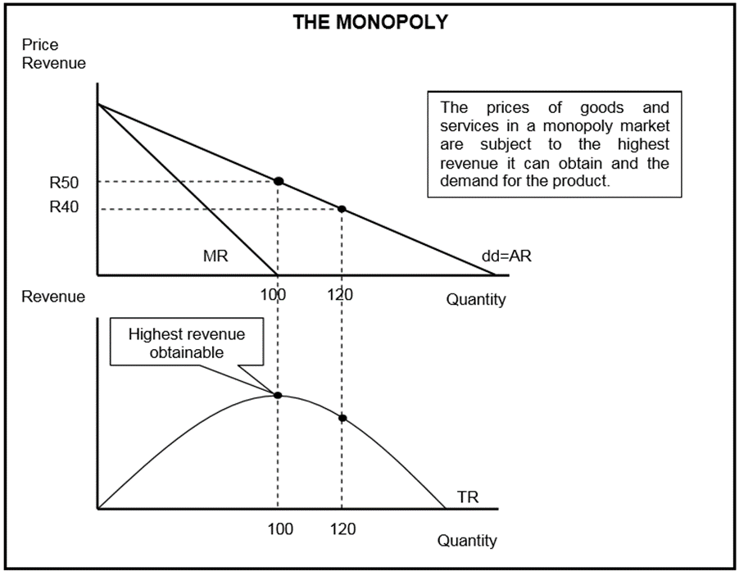
 | 1.2.1 | Identify any factor that can influence the prices of goods and services for the monopoly. | (1)
 | 1.2.2 | At what price must the monopolist sell to obtain maximum revenue? | (1)
 | 1.2.3 | What is the nature of the product of a typical monopolist? | (2)
 | 1.2.4 | Which curves are required to determine how much profit the monopolist will make? | (2)
 | 1.2.5 | Why will you discourage the monopolist from increasing the price of the product drastically? (2 x 2) | (4)

1.3 | Study the information below and answer the questions that follow.
 | 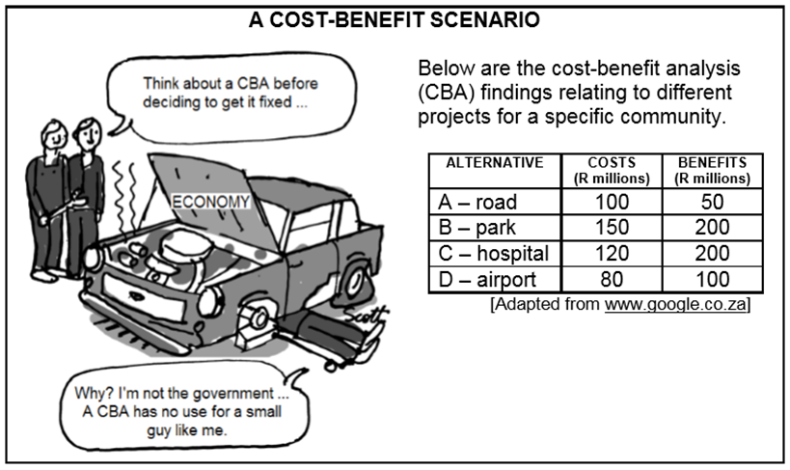
 | 1.3.1 | In the information above, who is more likely to use a CBA when making decisions? | (1)
 | 1.3.2 | Identify ONE project in the data above that the government is considering for this community. | (1)
 | 1.3.3 | Give a reason why a CBA will NOT be of use to the mechanic in the cartoon. | (2)
 | 1.3.4 | According to the data above, which project would be best for the community? | (2)
 | 1.3.5 | Why do you think it is important to do a CBA when deciding about large projects? (2 x 2) | (4)
1.4 | Explain the nature of the product and market entry as characteristics of perfect competition. (2 x 4) |  | (8)
1.5 | How will a monopolistic competitor, like KFC, compete with other fast-food chicken outlets to increase its market share? |  | (8)
 | NSC DBE Nov 2017 |  | [40]

