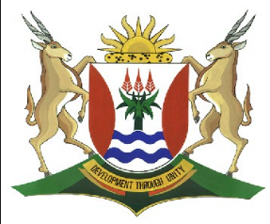
Province of the
EASTERN CAPE
EDUCATION

DIRECTORATE SENIOR CURRICULUM MANAGEMENT (SEN-FET)
HOME SCHOOLING SELF- STUDY WORKSHEET
SUBJECT | ECONOMICS | GRADE | 12 | DATE | 13/05/2020
TOPIC | MICROECONOMICS MARKS: 40 | TERM 1  REVISION |  | TERM 2 CONTENT | X
TIME ALLOCATION | 30 MINUTES MARKS: 40 | TIPS TO KEEP HEALTHY  1. WASH YOUR HANDS thoroughly with soap and water for at least 20 seconds. Alternatively, use hand sanitizer with an alcohol content of at least 60%.  2. PRACTICE SOCIAL DISTANCING – keep a distance of 1m away from other people.  3. PRACTISE GOOD RESPIRATORY HYGIENE: cough or sneeze into your elbow or tissue and dispose of the tissue immediately after use.  4. TRY NOT TO TOUCH YOUR FACE. The virus can be transferred from your hands to your nose, mouth and eyes. It can then enter your body and make you sick.  5. STAY AT HOME.
INSTRUCTIONS | INSTRUCTIONS AND INFORMATION  - Answer ALL questions in the ANSWER BOOK  - Number the answers correctly according to the numbering system used in this question paper.  - Write the question number above each answer.  - Leave 2–3 lines between subsections of questions  - Write neatly and legibly.

QUESTION 1: MICROECONOMICS 40 MARKS – 30 MINUTES
1.1 | Answer the following questions.
 | 1.1.1 | Give any TWO examples of variable costs. (2 x 1) | (2)
 | 1.1.2 | Why is it difficult for new firms to enter an oligopoly market? (1 x 2). | (2)
1.2 | Study the graph below and answer the questions that follow.
 |  | 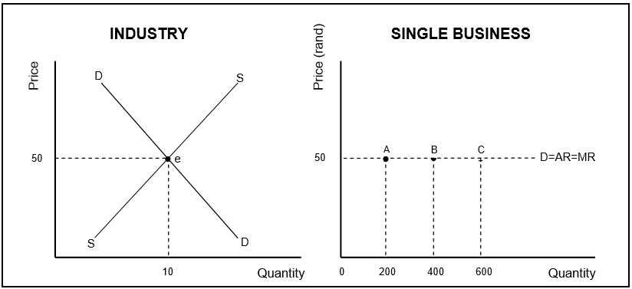
 | 1.2.1 | What market structure is depicted above? | (1)
 | 1.2.2 | What is the market price at which the business will sell his/her product? | (1)
 | 1.2.3 | Briefly describe the term opportunity cost. | (2)
 | 1.2.4 | Why is it not possible for a single business to adjust its selling price? | (2)
 | 1.2.5 | Explain the effect on the market in the long run if the businesses above in a perfect market made an economic profit. (2 x 2) | (4)

1.3 | Study the cartoon below and answer the questions that follow.
 | 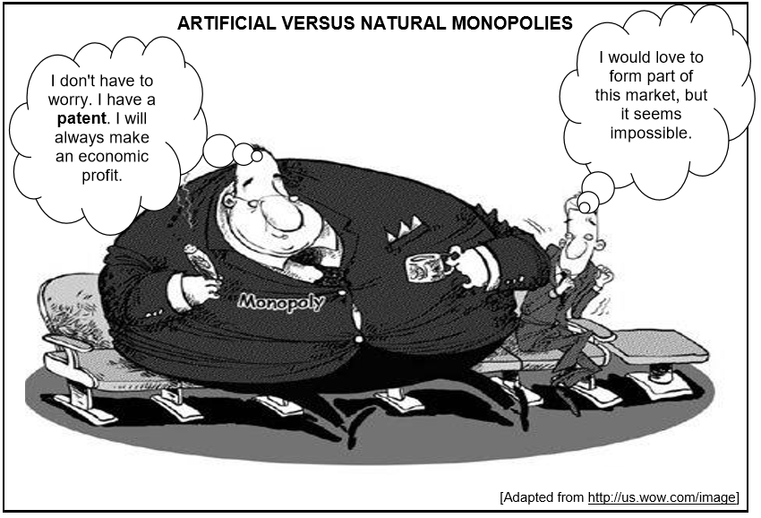
 | 1.3.1 | Identify the type of monopoly depicted in the cartoon. | (1)
 | 1.3.2 | How many firms usually dominate this type of market? | (1)
 | 1.3.3 | Describe the nature of the product produced by a monopoly. | (2)
 | 1.3.4 | How are natural monopolies created? | (2)
 | 2.3.5 | Why will this monopolist always make economic profit in the long run? (2 x 2) | (4)
1.4 | Explain the aims of South Africa's anti-monopolistic policy. (4 x 2) |  | (8)
1.5 | Why do oligopolies often collude, although it is illegal in South Africa? |  | (8)
 | DBE/Feb-Mar. 2018 |  | [40]

