 Province of the

EASTERN CAPE

EDUCATION

**DIRECTORATE SENIOR CURRICULUM MANAGEMENT (SEN-FET)**

**HOME SCHOOLING SELF-STUDY**

|  |  |  |  |  |  |
| --- | --- | --- | --- | --- | --- |
| **SUBJECT** | English FAL/EHL | **GRADE** | 10-12 | **DATE** | May 2020 |
| **TOPIC** | Cartoons/comic strips | **TERM 1**  **REVISION** | (Please tick) | **TERM 2 CONTENT** | (Please tick)  x |
| **Time allocation** | 50 minutes | **TIPS TO KEEP HEALTHY**  1. **WASH YOUR HANDS** thoroughly with soap and water for at least 20 seconds. Alternatively, use hand sanitizer with an alcohol content of at least 60%.  2. **PRACTICE SOCIAL DISTANCING** – keep a distance of 1m away from other people.  3. **PRACTISE GOOD RESPIRATORY HYGIENE**: cough or sneeze into your elbow or tissue and dispose of the tissue immediately after use.  4. **TRY NOT TO TOUCH YOUR FACE.** The virus can be transferred from your hands to your nose, mouth and eyes. It can then enter your body and make you sick.  5. **STAY AT HOME.** | | | |
| **Instructions** | Read notes provided on cartoons and tips on how to interpret cartoons |  | | | |

**CARTOONS/COMIC STRIPS**

* A cartoon is a piece of art, usually humorous intent.
* Designed to comment on current events or tell stories
* Comment on a political or social event in a humorous way

**TYPES OF CARTOONS**

* Single -panel cartoon/one picture/frame

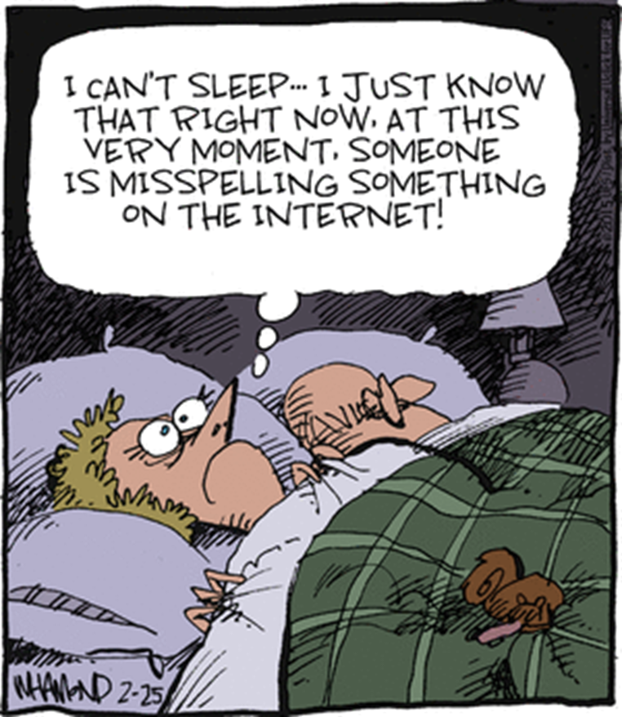

**COMIC STRIP TWO/MORE FRAMES**

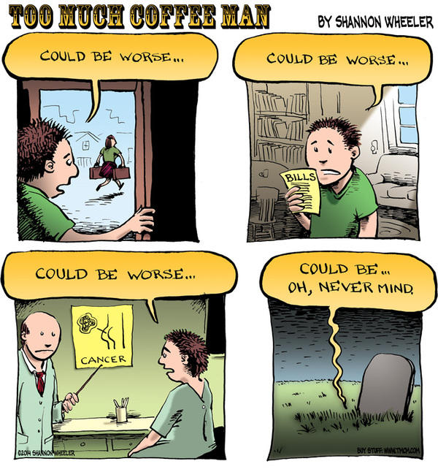

**Editorial cartoons**

* serious in tone, uses visual metaphors and irony is used to satirise social or political situations

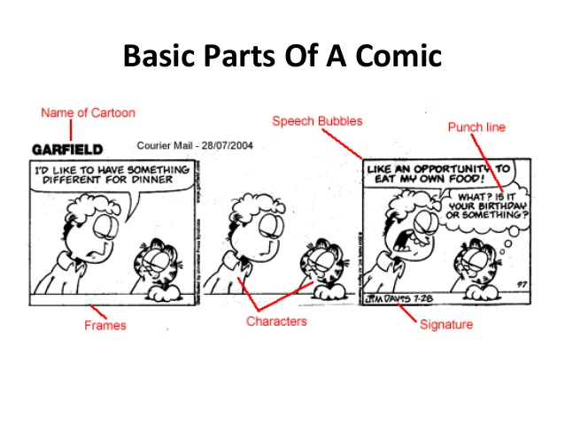

**Features of comic strips/cartoons.**

**Characters** – a fictional character depicted in an animated (full of life or excitements) comic strip/cartoons/films.

**An example of characters: human beings/animals.** 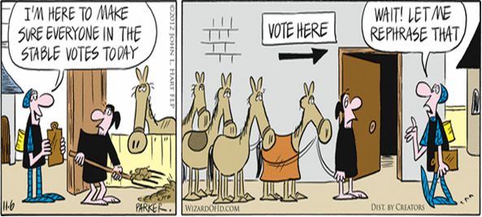

**Caricature** (A caricature is a rendered image showing the features of its subject in a simplified or exaggerated way through sketching, pencil strokes, or through other artistic drawings).

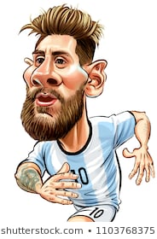

**Body language**

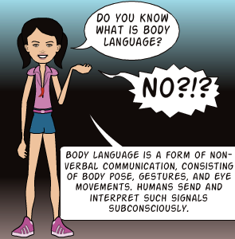

**Facial expressions (vocabulary)**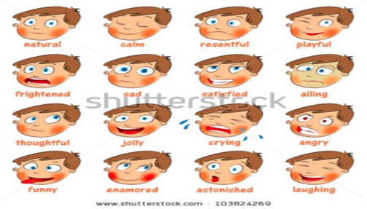

**Setting**

Both the **time and the geographic location** of a cartoon/comic strip. It helps to initiate the main background and mood for a story.

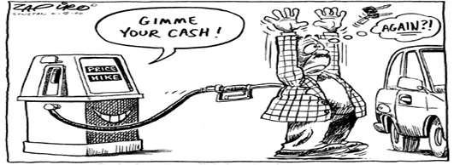

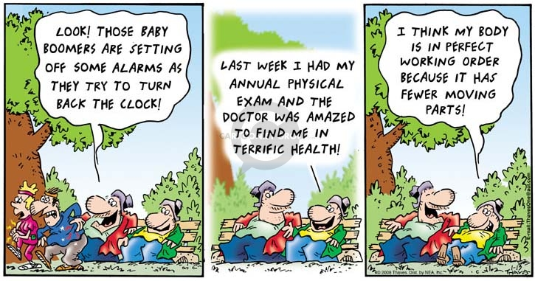

**Commonly used bubbles in comic strips**

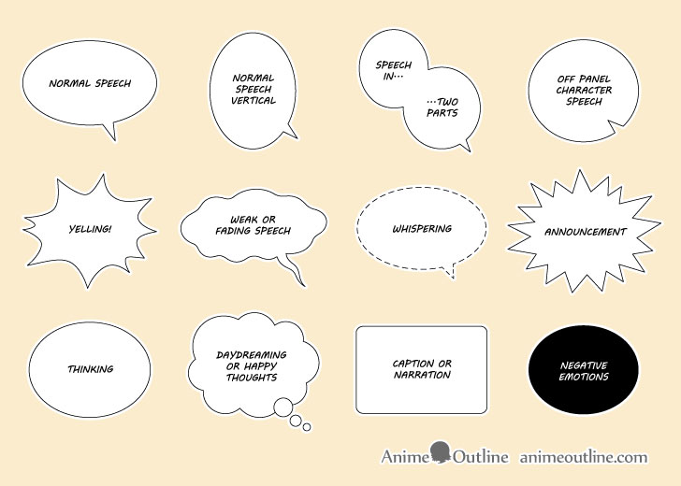

**Punctuation, font and grammar.**

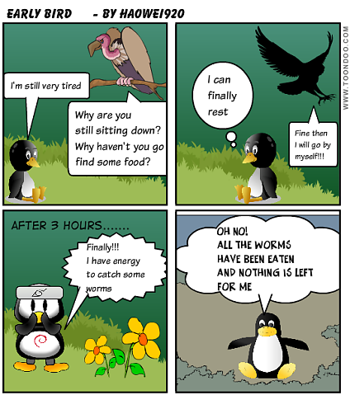

**Movement**

These are abstract lines which appear behind a moving character or parallel to its direction of movement.

**Stereotypes/symbols**

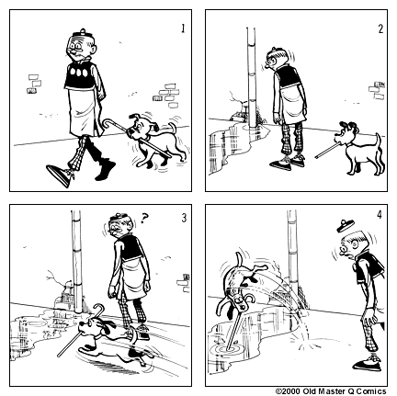

A type of symbol used to represent, among others, ideas; racial and ethnic characteristics and used indicators such as clothing to depict economic or class status.

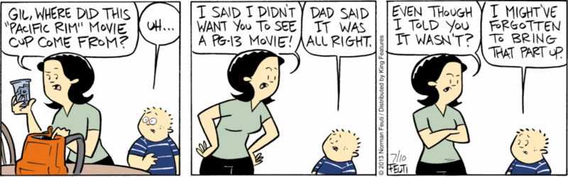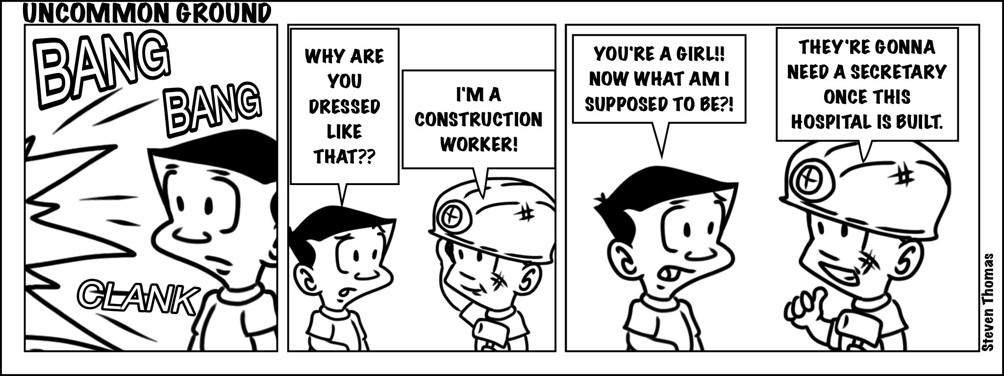

Techniques used to create humour

1. Satire -aims to entertain and educate. Humour that mocks human weakness or aspects of society
2. Sarcasm – witty language used to convey insults or scorn
3. Stereotyping- humour based on a fixed idea about what a type of person or thing is like which is often not true
4. Irony- the intended meaning is opposite, or nearly opposite to the literal meaning
5. Pun – play on words often as homonyms, homophones
6. Paradox - humorous imitation often intended to ridicule an author or genre
7. Hyperbole - humorous presentation marked by exaggeration and outside characterisation

Analysing cartoons

* Look carefully at the picture and read writing attentively
* Take note of the character’s body language and facial expression
* Pay attention to type of language used
* Look at the punctuation and words written in bold
* Take note of setting and background details
* Identify when viewer’s expectations are overturned to create humour
* Determine the intention of the cartoonist