Province of the
EASTERN CAPE
EDUCATION

DIRECTORATE SENIOR CURRICULUM MANAGEMENT (SEN-FET)
HOME SCHOOLING SELF-STUDY WORKSHEET
SUBJECT | GEOGRAPHY | GRADE | 12 | DATE | 25/05/ 20
TOPIC | URBAN SETTLEMENTS:  Urban land use Zones  Urban land use models | TERM 2  REVISION | ✓ | TERM 2 CONTENT | ✓
TIME ALLOCATION | 1HOUR | TIPS TO KEEP HEALTHY  1. WASH YOUR HANDS thoroughly with soap and water for at least 20 seconds. Alternatively, use hand sanitizer with an alcohol content of at least 60%.  2. PRACTICE SOCIAL DISTANCING – keep a distance of 1m away from other people.  3. PRACTISE GOOD RESPIRATORY HYGIENE: cough or sneeze into your elbow or tissue and dispose of the tissue immediately after use.  4. TRY NOT TO TOUCH YOUR FACE. The virus can be transferred from your hands to your nose, mouth and eyes. It can then enter your body and make you sick.  5. STAY AT HOME.
INSTRUCTIONS

RESOURCES YOU CAN USE:
- Textbooks: Urban Settlements
- Attached power point presentation
- Past examination Papers

YOU MUST KNOW THE FOLLOWING:
- The concepts related to urban land use zones,
- urban land use Models

Activity : This question comes from the March 2016 question paper

URBAN LAND – USE ZONES

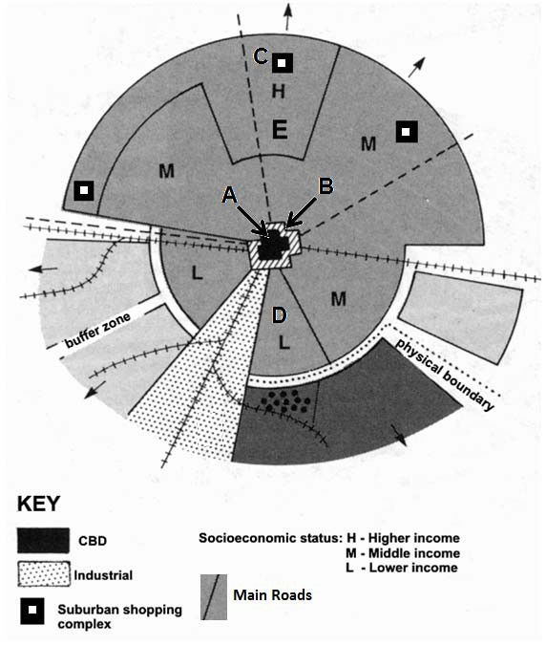

1.1.
 | 1.1.1 | Name land-use zone A. | (1x1) | (1)
 | 1.1.2 | Give a possible reason why the transition zone (B) doesn't fully enclose zone A. | (1x2) | (2)
 | 1.1.3 | Why is land-use zone D likely to be a low-income residential area? | (1x2) | (2)
 | 1.1.4 | State ONE factor that would have promoted the location of shopping centre C. | (1x2) | (2)
 | 1.1.5 | Write a paragraph of approximately EIGHT lines in which you discuss the negative factors in land-use zone A that resulted in the relocation of businesses to C and its surrounding area. | (4x2) | (8)
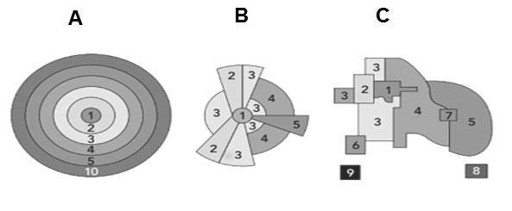
FIGURE 2.1: URBAN LAND-USE MODELS

[
Source:
www.google/images
]

2.1 Refer to FIGURE 2.1 based on urban land-use models. ( June 2018)
 | 2.1.1. | State the purpose of developing land-use models | (1x2) | (2)
 | 2.1.2 | Identify the urban land-use models in sketches B and C. | (2 x 1) | (2)
 | 2.1.3 | Refer to land-use zone 1.
 |  | (a)Name land-use zone 1. | (1 x 1) | (1)
 |  | (b)Account for land-use zone 1’s location in urban land-use models A and B. | (2 x 1) | (2)
 |  | ©Why has the location of land-use zone 1 changed in model C? | (2 x 2) | (4)
 | 2.1.4 | Suggest TWO possible reasons why all land-use models today must include zones for greenbelts | (2 x 2) | (4)
 |  |  |  | [30]

