Province of the
EASTERN CAPE
EDUCATION

DIRECTORATE SENIOR CURRICULUM MANAGEMENT (SEN-FET)
HOME SCHOOLING SELF-STUDY WORKSHEET 15
SUBJECT | ISIXHOSA HL | GRADE | 12 | DATE
TOPIC | Izakhi nemigaqo yokusetyenziswa kolwimi  Iphepha loku-1: Umbuzo 3 no 4 | TERM 1  REVISION | (Please tick) | TERM 2 CONTENT x | (Please tick)
TIME ALLOCATION | 40 Imizuzu | TIPS TO KEEP HEALTHY  1. WASH YOUR HANDS thoroughly with soap and water for at least 20 seconds. Alternatively, use hand sanitizer with an alcohol content of at least 60%.  2. PRACTICE SOCIAL DISTANCING – keep a distance of 1m away from other people.  3. PRACTISE GOOD RESPIRATORY HYGIENE: cough or sneeze into your elbow or tissue and dispose of the tissue immediately after use.  4. TRY NOT TO TOUCH YOUR FACE. The virus can be transferred from your hands to your nose, mouth and eyes. It can then enter your body and make you sick.  5. STAY AT HOME.
INSTRUCTIONS | Le worksheet iqulathe imibuzo emifutshane yentengiso kunye nekhathuni, fundisisa umbuzo ngamnye wandule ukuwuphendula. Unikwe imibuzo emi-2 yombuzo 3 nemi-2 yombuzo 4.  Zikorekishe wandule ukwenza izilungiso ujonge kwiimpendulo ozinikiweyo.

IMIBUZO YOKUZILUNGISELELA
ISIBHENGEZO NTENGISO
ICANDELO C: IZAKHI NEMIGAQO YOKUSETYENZISWA KOLWIMI

UMBUZO 3:

Funda esi sibhengezo-ntengiso singezantsi uze uphendule imibuzo elandelayo.

ITEKISI D: ISIBHENGEZO-NTENGISO

3.1 | Xela igama lemveliso ethengiswa sesi sibhengezo ntengiso? |  | (1)

3.2 | Sijoliswe koobani esi sibhengezo- ntengiso? Xhasa impendulo yakho. |  | (2)

3.3 | Chaza inzuzo yokusebenzisa le mveliso. |  | (2)

3.4 | Sinafuthe lini esi isivakalisi sithi, ‘Thenga namhlanje! kubathengi? |  | (2)

3.5 | Uwuncedisa njani umyalezo wesi sibhengezo umfanekiso weli nenekazi? |  | (2)

3.6 | Caphula ibinzana elithetha ukuba imnandi kakhulu le mveliso. |  | (1)
[10]

IMEMO YESI SIBHENGEZO NTENGISO

3.1 | Yiyogathi iVitalinea |  | (1)

3.2 | Sijoliswe koomama abangafuni kutyeba √, kuba kusetyenziswe umfanekiso woomama abayityayo√ /kubantu abathanda impilo√ kuba inika iingcebiso ngempilo√. |  | (2)

3.3 | Ikugcina usempilweni ungatyebanga√√. |  | (2)

3.4 | Siyabagxagxamisa√/ Sinefuthe lokubangxamisa√ |  | (2)

3.5 | Umfanekiso wenenekazi elihle uchukumisa abathengi banqwenele ukufana nalo. √√ |  | (2)

3.6 | ithi nditye√/ ivuzisa izinkcwe√. |  | (1)
[10]

ISIBHENGEZO NTENGISO

UMBUZO 3

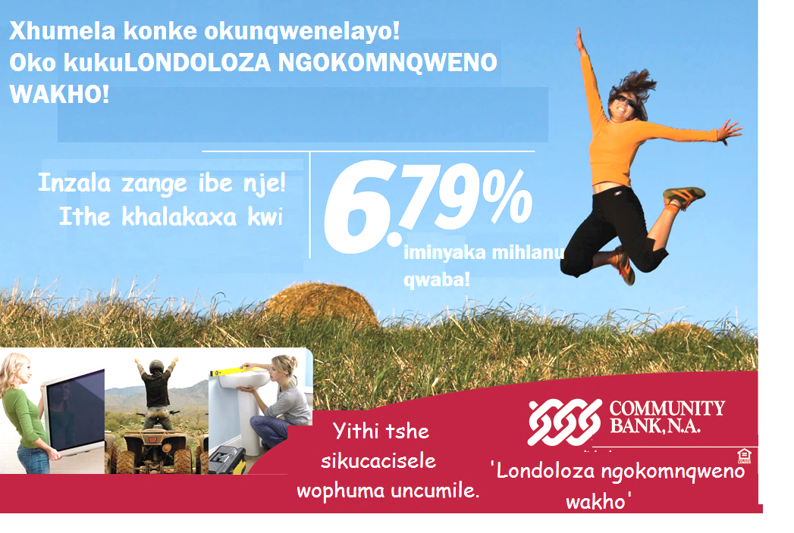

3.1 | Nika isilogani sale ntengiso. |  | (1)

3.2 | Ngokuncediswa yimifanekiso ekule ntengiso, xela zibeNTATHU izinto onokuzenza xa unokufumana le mali-mboleko. |  | (3)

3.3 | Le ntombazana ibhabha emoyeni idlulisa myalezo mni ngale mveliso? |  | (1)

3.4 | Bhala amagama amabini anika intsingiselo yokuba le imveliso yehle kakhulu ngexabiso. |  | (1)

3.5 | Ngqina ukuba izinto zenzeka ngokukhawuleza kule bhanki |  | (2)

3.6 | Uyahambisana nebango elenziwa yile bhanki lokuba wofumana ‘konke okunqwenelayo’ xa uthotyelwe inzala? Xhasa impendulo yakho. |  | (2)
 |  |  | [10]

IMEMO ISIBHENGEZO NTENGISO

3.1 | Londoloza ngokomnqweno wakho. √ |  | (1)

3.2 | Ungathenga iTV√ ungalima√ ungalungisa indlu yakho.√ |  | (3)

3.3 | Owokuba le mveliso iyokonwabisa.√ |  | (1)

3.4 | Ithe khalakaxa.√ |  | (1)

3.5 | Kuthiwa yithi tshe ube sele ufunana imali.√√ |  | (2)

3.6 | Ndiyahambisana ukuba into nganye imele ezinye ngokwalo mfanekiso.√√  Andingqini kuba akuzange kwaphelela okunqwenelayo ngakumbi xa imali ihlawulwa iminyaka emihlanu. √√ |  | (2)
 |  |  | [10]

UMSEBENZI: IIKHATHUNI

UMBUZO 4

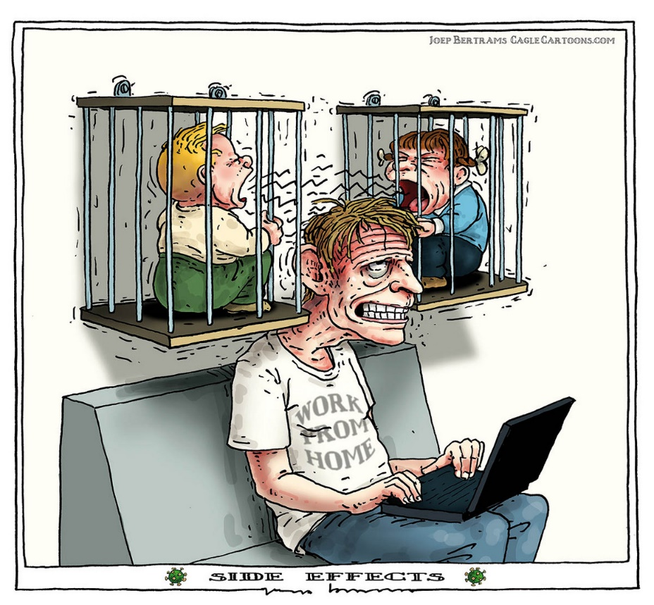

4.1 | Xela zibeNTATHU iimeko zobaxo olukule khathuni. | (3)

4.2 | Chaza ukuba ibali lale khathuni liqhubeka phi. Xhasa impendulo yakho. | (2)

4.3 | Chaza uvakalelo lwabantwana. Xhasa impendulo yakho. | (2)

4.4 | Chaza udaba lobuso lwabantwana. Cacisa impendulo yakho. | (2)

4.5 | Ucinga ukuba kutheni aba bantwana bethelekiswa nalo tata kweli bali. | (2)

4.6 | Cacisa umyalezo womzobi ngale khathuni. | (2)

4.7 | Chaza imeko yalo tata ngokukhokelwa lulwimi lomzimba nodaba lobuso bakhe. Ucinga yintoni unobangela wale meko? | (2)
[10]
IIMPENDULO

4.1 | Ukukhamisa/ ukukhala kwabantwana ngokubaxekileyo.  Ukukhonkxeka kwalo tata kwezi hook.  Ukuthi phuhlu amehlo kotata  Ingxolo egqithisileyo / isikhalo esigqithisileyo | (3)

4.2 | Ekhayeni lalo tata. Kuba isikipa sibhaliwe ukuba usebenzela ekhaya. | (2)

4.3 | Ukukhamisa kakhulu bekhala kwenza sicinge ukuba beva kabuhlungu kukuvaleleka. | (2)

4.4 | Bayakhala kuba bakhamise kakhulu oku ngathi bayakhala. Kukho nemizobo yengxolo engqina ukukhala oku. | (2)

4.5 | Mhlawumbi bathelekiswa kuba kuzanywa ukuthi ukusebenzela ekhaya kwenza eziya ngxaki nanjengoko sisazi ukuba ukuhlala ekhaya kwenza abantwana bazive ngathi baseluvalelweni notata ngokunjalo akeva noko kusebenza.. | (2)

4.6 | Akulunganga ukusebenzela ekhaya/ akumnandanga ukusebenzela ekhaya/ masikulumkele ukusebenzela ekhaya/ ukusebenzela ekhaya kuneengxaki./ kuyasokolisa ukusebenzela ekhaya. | (2)

4.7 | Chaza imeko yalo tata ngokukhokelwa lulwimi lomzimba nodaba lobuso bakhe. Ucinga yintoni unobangela wale meko? | (2)

UMBUZO 4
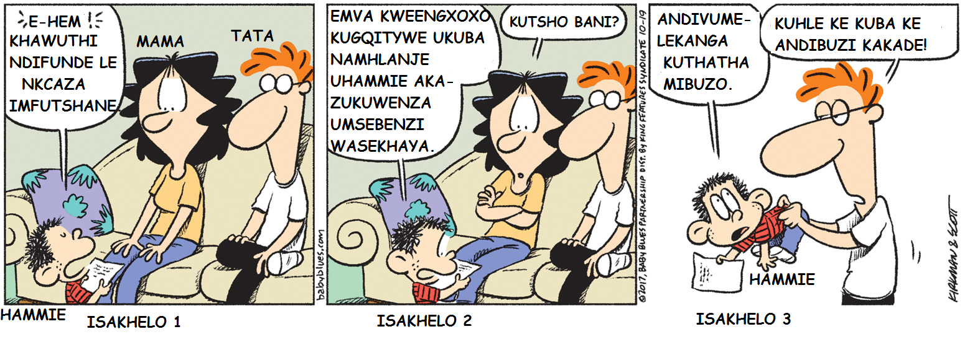
[Icatshulwe kwi-intanethi www.googlesearch.com yaza yahlelwa]
4.1 | Caphula kwisakhelo 1 isagwelo esinika isikrokro sokuba uHammie uza kuxoka. |  | (1)

4.2 | Thelekisa udaba lobuso bukaHannie kwisakhelo sokuqala nesesi-3. |  | (2)

4.3 | Uyacinga uMama okanye uyathetha kwisakhelo sesi-2 ngokweempawu zekhathuni? Xhasa impendulo yakho. |  | (1)

4.4 | Chaza uvakalelo lukaMama kwisakhelo sesi-2. Xhasa impendulo yakho. |  | (1)

4.5 | Umzobi ukholelwa ukuba ngabantu abanjani ootata xa umjonge ukusuka kwisakhelo soku-1 ukuya kwesesi-3? Khetha impendulo echanekileyo ngezantsi.  A. Abafuni kuqeqesha.  B. Abathethi bayenza.  C. Abathethi bayacebisa.  D. Abanqeni ukuthetha. |  | (1)

4.6 | Le khathuni iyahlekisa okanye iyalumkisa?Xhasa impendulo yakho. |  | (2)

4.7 | Cacisa indlela engcono ebenokuyisombulula ngayo uTata le ngxaki anayo ngoHammie. |  | (2)  [10]

IIMPENDULO
4.1 | Ukuthinta isikhohlela/ ‘e-hem! |  | (1)

4.2 | Thelekisa udaba lobuso bukaHannie kwisakhelo sokuqala nesesi-3. |  | (2)

4.3 | Uyathetha kukho iqamza lentetho. |  |  |  | (1)
4.4 | Udanile/ utyhafile. Umlomo wakhe nanko ulichokoza elibekwe emqaleni ngumfanekiso. |  |  | (1)

4.5 | B. Abathethi bayenza. |  | (1)

4.6 | Le khathuni iyahlekisa kuba liyahlekisa eli qhingana likaHammie nesigqebelo esihamba naso kuba ebecinga ukuba uza kuqhatha utata suka utata wambona ukuba uzimisele ukungathethi nyani wamfumana ngemva apha ngezamaxhego.  Iyalumkisa inika umyalezo othi masibalumkele abantwana siqaphele izimbo nezagwelo zabo zokuxoka. / Musa ukuxoka abantu abdala babeqale bawenza la maqhinga uzama ukuwenza. |  | (2)

4.7 | Ebenokuthetha noHammie ambonise ukuba maqhinga anje awasi ndawo/ amtyityimbisele umnwe ngokuxoka. |  | (2)  [10]

