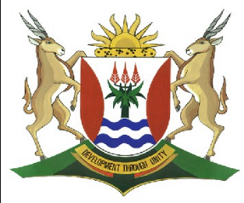
Province of the
EASTERN CAPE
EDUCATION

DIRECTORATE SENIOR CURRICULUM MANAGEMENT (SEN-FET)
HOME SCHOOLING SELF-STUDY WORKSHEET ANSWER SHEET
SUBJECT | LIFE SCIENCES | GRADE | 10 | DATE | 20/07/2020
TOPIC | ANIMAL TISSUES: EPITHELIAL, MUSCLE, NERVE | TERM 1  REVISION |  | TERM 2 CONTENT

1 | 1.1 | Areolar/ Loose Connective tissue
 | 1.2 | White fibrous cartilage
 | 1.3 | Hyaline cartilage
 | 1.4 | Blood
 | 1.5 | White fibrous cartilage |  | (5)

2 | 2.1 d) areolar tissue
 | 2.2 a) blood
 | 2.3 b) cartilage
 | 2.4 c) connects a bone to another bone
 | 2.5 e) connects a muscle to a bone |  | (5)

3 | A | Bone
 | B | Loose connective tissue
 | D | Blood
 | E | Fibrous |  | (4)

4 | 4.1 | Tendons attach muscle to bone
 | 4.2 | Blood transport substances such as food
 | 4.3 | Hormones, enzymes, respiratory gases and excretory wastes
 | 4.4 | Cartilage provides support, prevent damage between bones & in a joint, connect ribs to the sternum
 | 4.5 | Epiglottis opens and closes the glottis |  | (5)

5. | Red blood cells  White blood cells  Platelets  Plasma |  | (4)

6 | 6.1 | Yellow elastic fibres  Collagen fibres |  | (2)
 | 6.2 | Plasma 55% Blood cells 45% |  | (2)

7 | Structure of Long Bone |  | (5)
 | Correct diagram  Correct labels (head, shaft and head)  Caption |  | 1  3  1  (5)
 | TOTAL |  | (30)

