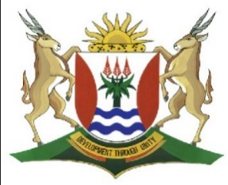
Province of the
EASTERN CAPE
EDUCATION

DIRECTORATE SENIOR CURRICULUM MANAGEMENT (SEN-FET)
HOME SCHOOLING SELF-STUDY WORKSHEET ANSWER SHEET
SUBJECT | GEOGRAPHY | GRADE | 10 | DATE | 6/07/20
TOPIC | THE SRUCTURE OF THE EARTH AND PLATE TECTONICS | TERM 2  REVISION | √√ | TERM 2 CONTENT | √√

QUESTION 1
    - A – Batholith
B - Laccolith
C - Dyke
D - Sill (4X1) (4)

    - Erosion of top soil (1X1) (1)
1.1.3 E (1X1) (1)
1.1.4 (A) Batholith (1X1) (1)
QUESTION 2
1.2.1 Plate tectonics is the theory of formation and motion of the plates that make up
the Earth’s crust (Concept) (1 X 1) (1)
1.2.2 Continental drift (1 X1) (1)
1.2.3 Africa (1X1) (1)
1.2.4 (a) Europe
North America (2 X 1) (2)
(b) South America
Africa
Antarctica
Asia any (3 X1) (3)
    - Pangea (1 X1)(1)
1.2.6 Rocks of similar type
The continents fit together like a jigsaw puzzle
Fossils of similar reptiles were also found
Fold mountain systems
The Rift Valley
Glaciers that covered large parts of the continents any (3 x 2) (6)
[22]

