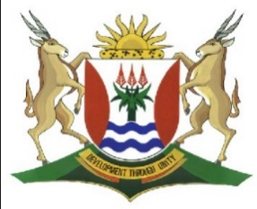
Province of the
EASTERN CAPE
EDUCATION

DIRECTORATE SENIOR CURRICULUM MANAGEMENT (SEN-FET)
HOME SCHOOLING SELF-STUDY WORKSHEET
SUBJECT | GEOGRAPHY | GRADE | 10 | DATE | 6/07/20
TOPIC | GEOMORPHOLOGY | TERM 2  REVISION | √√ | TERM 2 CONTENT | √√
FOLDING AND FAULTING EARTHQUAKES |  | TIPS TO KEEP HEALTHY  1. WASH YOUR HANDS thoroughly with soap and water for at least 20 seconds. Alternatively, use hand sanitizer with an alcohol content of at least 60%.  2. PRACTICE SOCIAL DISTANCING – keep a distance of 1m away from other people.  3. PRACTISE GOOD RESPIRATORY HYGIENE: cough or sneeze into your elbow or tissue and dispose of the tissue immediately after use.  4. TRY NOT TO TOUCH YOUR FACE. The virus can be transferred from your hands to your nose, mouth and eyes. It can then enter your body and make you sick.  5. STAY AT HOME.
INSTRUCTIONS

QUESTION 1
1.1.1 State whether the following rocks are metamorphic, sedimentary or igneous.
- Dolerite (1)

- Shale 1 (1)

- Gneiss (1)

- Dolomite (1)

1.2 Carefully read the extract in FIGURE 1.2 on earthquakes.

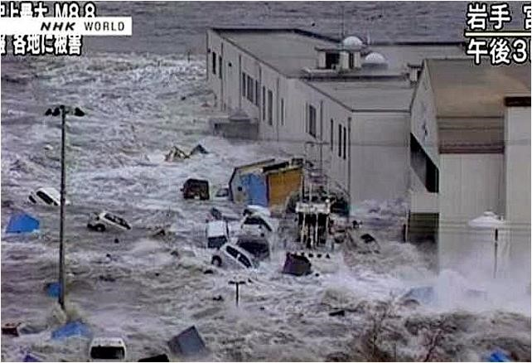
INDIAN OCEAN TSUNAMI 2004

Primary effects of the tsunami

•

The wave killed people in 14 different countries around the
Indian Ocean totalling over
250

000.

•

The highest death toll was on the Indonesian island of Sumatra where over 130

000
were killed and over 30

000
remain missing.

•

In Sumatra over 500

000
people were made homeless, over
80

000
houses were
destroyed as well
as serious damage was caused to any ports, boats, roads, bridges,
hospitals, forests and crops within 1 km of the shore.

•

people were killed in South Africa which is over 8000 km from the epicentre.
8

•

In Sri
Lanka, a train was derailed by the force
of the wave killing over 1

000
.

[
Source:
htttp/www.4w.tagplus.com
]

1.2.1 Provide a geographical term for the following:

- The vibration in the Earth’s crust due to sudden movements

of the crust along a fault

- The point on the Earth’s surface immediately above the focus

of an earthquake (2 x 1) (2)

1.2.2 Give the magnitude of this earthquake and the number of people

who died respectively. (2 x 1) (2)

1.2.3 Which instrument is used to measure the magnitude of an

earthquake? (1 x 1) (1)

1.2.4 Explain why most earthquakes happen close to plate boundaries.
(1 x 2) (2)

    - Briefly describe the negative results or damage caused by the

earthquake in Kashmir. (2 x 2) (4)

    - Discuss why less developed countries are unable to cope with

earthquakes than more developed countries. (2 x 2) (4)

[15]

