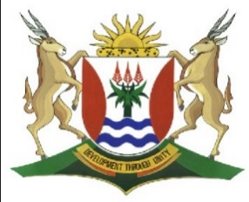
Province of the
EASTERN CAPE
EDUCATION

DIRECTORATE SENIOR CURRICULUM MANAGEMENT (SEN-FET)
HOME SCHOOLING SELF-STUDY WORKSHEET
SUBJECT | GEOGRAPHY | GRADE | 10 | DATE | 6/07/20
TOPIC | GEOMORPHOLOGY | TERM 2  REVISION | √√ | TERM 2 CONTENT | √√
VOLCANOES |  | TIPS TO KEEP HEALTHY  1. WASH YOUR HANDS thoroughly with soap and water for at least 20 seconds. Alternatively, use hand sanitizer with an alcohol content of at least 60%.  2. PRACTICE SOCIAL DISTANCING – keep a distance of 1m away from other people.  3. PRACTISE GOOD RESPIRATORY HYGIENE: cough or sneeze into your elbow or tissue and dispose of the tissue immediately after use.  4. TRY NOT TO TOUCH YOUR FACE. The virus can be transferred from your hands to your nose, mouth and eyes. It can then enter your body and make you sick.  5. STAY AT HOME.
INSTRUCTIONS

QUESTION 1
  - Refer to FIGURE1.1 showing a composite volcano and answer the questions

that follow.

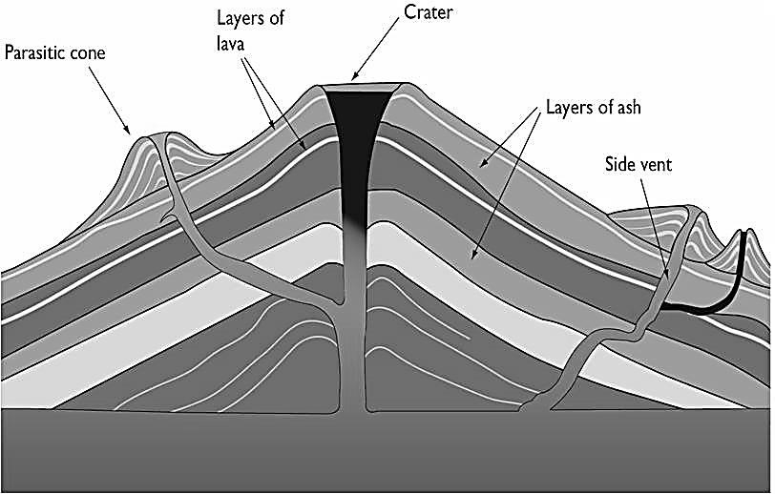

The only thing darker than the plume of ash emitting from Iceland’s volcano may
be its long
-
term implications to the planet, its climate and public health. Despite
some airspace being reopened after volcanic ash forced its closure, millions of
passeng
ers worldwide are still stuck because of the ongoing cancellations.

[
Source:
www.google.co.za/images
/]

1.1.1 Define the term active volcano.
(1 x 1) (1)
1.1.2 Distinguish between magma and lava.
(2 x 1) (2)
1.1.3 Volcanic ash is a threat to people.

Support this statement.

(1 x 2) (2)
1.1.4 Explain how the volcanic eruption is terrible (not good) for aircraft).

(1 x 2) (2)

1.1.5 In a paragraph of approximately EIGHT lines, discuss the positive and

negative consequences (effects) of volcanic eruption on people and the

environment.

(4 x 2) (8)
[15]

