Province of the
EASTERN CAPE
EDUCATION

DIRECTORATE SENIOR CURRICULUM MANAGEMENT (SEN-FET)
HOME SCHOOLING SELF-STUDY WORKSHEET
SUBJECT | LIFE SCIENCES | GRADE | 10 | DATE | 20/07/2020
TOPIC | ANIMAL TISSUES: EPITHELIAL, MUSCLE, NERVE | TERM 1  REVISION |  | TERM 2 CONTENT
TIME ALLOCATION | 45 MINUTES | TIPS TO KEEP HEALTHY  1. WASH YOUR HANDS thoroughly with soap and water for at least 20 seconds. Alternatively, use hand sanitizer with an alcohol content of at least 60%.  2. PRACTICE SOCIAL DISTANCING – keep a distance of 1m away from other people.  3. PRACTISE GOOD RESPIRATORY HYGIENE: cough or sneeze into your elbow or tissue and dispose of the tissue immediately after use.  4. TRY NOT TO TOUCH YOUR FACE. The virus can be transferred from your hands to your nose, mouth and eyes. It can then enter your body and make you sick.  5. STAY AT HOME.
INSTRUCTIONS | Use the following resources to answer the worksheet:  - Textbook  - Via Afrika Grade 10 Study Guide  - PowerPoint Presentation on Animal Tissues  - Video Lesson on Animal Tissues

1.1 | Various options are provided as possible answers to the following questions.  Choose the correct answer and write only the letter (A‒D) next to the question numbers

 | 1.1.1 | Which of the following characteristics can be associated with cardiac muscle?  (i) intercalated discs  (ii) branched fibres  (iii) tapered ends  (iv) striations  (v) voluntary
 |  | A  B  C  D | (i), (iii), (v)  (ii), (iii), (iv)  (i), (ii), (iv)  (iii), (iv), (v)
 | 1.1.2 | Nerve cells are known as:
 |  | A | neurons
 |  | B | mast cells
 |  | C | leucocytes
 |  | D | fibroblasts.
 | 1.1.3 | The type of epithelial tissue found on the surface of the skin is …
 |  | A | squamous.
 |  | B | cuboidal.
 |  | C | columnar.
 |  | D | ciliated. (3 x 2) |  |  |  | (6)

1.2 | Give the correct biological term for each of the following descriptions.  Write only the term next to the question number.
 | 1.2.1 | Movements done under one’s conscious will
 | 1.2.2 | The type of tissue that is responsible for voluntary movement
 | 1.2.3 | The type of neuron that senses environmental changes
 | 1.2.4 | The long-threadlike part of a neuron that conducts impulses away from the cell body |  | (4)

1.3 Indicate whether each of the statements in COLUMN A applies to A ONLY, B ONLY, BOTH A AND B or NONE of the items in COLUMN B.
.
COLUMN A |  | COLUMN B
1.3.1 | Involuntary muscle tissue | A: | Cardiac
 |  | B: | Striated
1.3.2 | Tissue that covers body surfaces | A: | Nerve
 |  | B: | Muscle
(4)
1.4. Compare the structure and location of cardiac, skeletal and smooth muscles in a table. (10)
2.1 | The diagram shows the various tissues found in animals
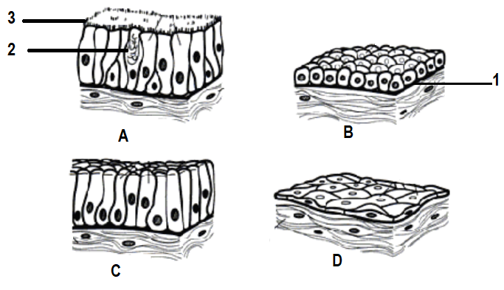

 | 2.1.1 | Identify tissues A, B, C and D. |  | (4)
 | 2.1.2 | Where in the body would you find the tissue labelled B? |  | (1)
 | 2.1.3 | Which labelled part secretes mucus? |  | (1)
 | 2.1.4 | Give the function of part labelled 3? |  | (1)
 | 2.1.5 | Name the part labelled 1. |  | (1)  (8)

2.2 | Study the diagrams of animal tissues and answer the questions that follow.
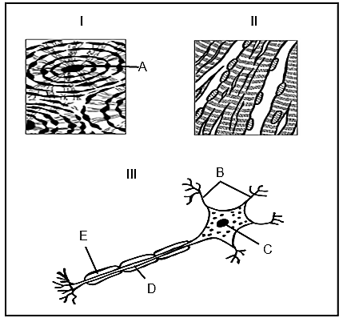
 | 2.2.1 | Name the groups of tissue to which II and III respectively belong to. |  | (2)
 | 2.2.2 | Name parts B to E. |  | (4)
 | 2.2.3 | Where in the body will tissue type II be found? |  | (1)
 | 2.2.4 | What is the function of the part numbered B in diagram III? |  | (1)  (8)  [40]

