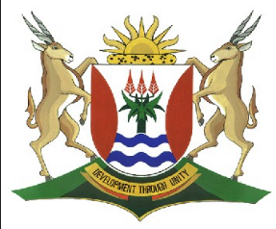
Province of the
EASTERN CAPE
EDUCATION

DIRECTORATE SENIOR CURRICULUM MANAGEMENT (SEN-FET)
HOME SCHOOLING SELF-STUDY WORKSHEET
SUBJECT | GEOGRAPHY | GRADE | 11 | DATE | 22/06/20
TOPIC | DEVELOPMENT GEOGRAPHY | TERM 3  REVISION | √√ | TERM 3 CONTENT | √√
TIME ALLOCATION | 1 HOUR | TIPS TO KEEP HEALTHY  - WASH YOUR HANDS thoroughly with soap and water for at least 20 seconds. Alternatively, use hand sanitizer with an alcohol content of at least 60%  2. PRACTICE SOCIAL DISTANCING – keep a distance of 1m away from other people.  3. PRACTISE GOOD RESPIRATORY HYGIENE: cough or sneeze into your elbow or tissue and dispose of the tissue immediately after use.  4. TRY NOT TO TOUCH YOUR FACE. The virus can be transferred from your hands to your nose, mouth and eyes. It can then enter your body and make you sick.  5. STAY AT HOME.

Role of development aid

What is Development Aid
Can I distinguish between the positive and negative impacts of aid on development .
Can I outline the advantages and disadvantages of receiving aid.
Can I outline between the different types of development aid?
- Technical aid.
- Conditional aid
- Humanitarian aid
What is Globalisation?
- How does Globalisatio impact on the LEDCs?
- How does a multinational company fuction.
What is export led development?
Development Issues and challenges
Do I understand the role of the state and business in the development in South Africa?
- Central control by the state
- Weak state control
- Public or private partnerships
Can I define terms of
trade ?
- Balance of trade
- Exports
- Imports
- Trade surplus
- Rtrade deficit
What are trade blocs?
Do understand the types of trading relationship?
- Free trade
- Trade barriers
- Subsidies
- Fair trade

Trade and Development
Frameworks for development

What is community based model?
What is a sustainability model?
Can I critically analyse the factors that affect development
What is an index?
- HDI
- Gino co-efficient
DEVELOPMENT GEOGRAPHY
Do I understand the various indicators of development?
- GDP
- GNP
- IMR
Terminology used in development:
- Developing vs developed
- First vs third world
- North – south divide
- LEDCs vs MEDs

What is Development
The concept of development
The concept of development
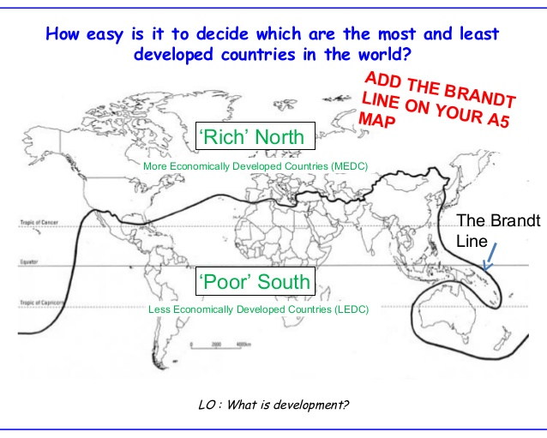

- Terminology associated with development – What is development?
Development shows that a country’s economic and social conditions have improved by good management of the natural and human resources to create wealth and to improve the quality of life of people living there.

- Developed Countries
First World
More economically developed countries
MEDCc
High Income

Developed Countries
North
Rich
Industrialised countries

(b) Developing Countries
Less Economically Developed countries
(LEDCs)
South
Low Income
Non industrialised Countries
Third World
Poor
Developing Countries

(c) What is Development Gap?
Development Gap The differences between LEDC stands for 'less economically developed country,' while MEDC stands for 'more economically developed country. ' Kenya, Afghanistan, and India are examples of LEDC's. The United States, Japan, and the UK are examples of MEDC's

Characteristics of MEDCs | Characteristics of LEDCs
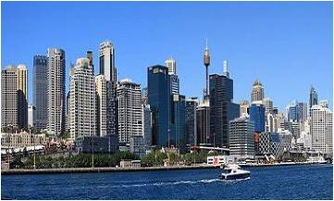 | 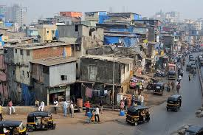
- Uses resources efficiently  - Export goods on global markets  - Highly industrialised  - High standard of living  - Stable goverments that can donate financial aid to LEDCs  - Have good education,health and transport systems | - Resources not used sustainably  - Export mainly raw materials to MEDCs, import manufactured goods  - Low levels of industrialization  - High levels poverty  - Receive financial aid from MEDCs and other organisations  - Have poor and inefficient education, health, and transport systems.

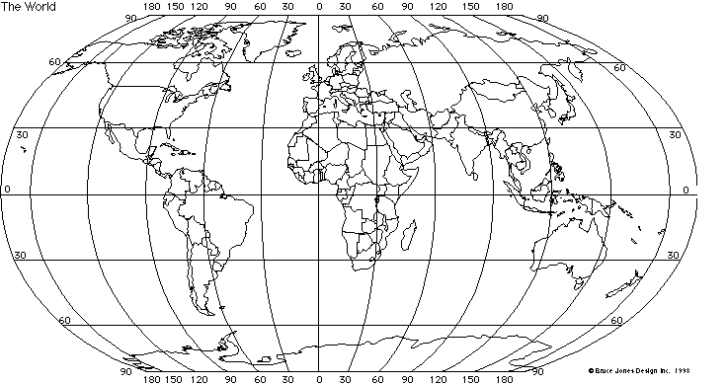
World Map highlights gap between the more developed countries in the North and less developed countries (in the South
More than 10 million children do not attend Primary School
Lesotho’s life expectancy is 45.9 compared to Sweden 81.3 years.
Japan has the highest life expectancy in the World(83.4years)
Africa – the most water scares continent in the World
Norway – the most developed country of the World
Most people educated at least through secondary school
Democratic republic of Congo-possibly the least developed country
The headquarters of most of the world’s Multinational companies are in the Northern hemisphere
75% of the world’s people live in the poor South
25% of the world’s people live in the Rich North

North | South
- 20% of the worlds people live here  - *0% of the World’s income is earned here.  - Life expectancy greater than 70 Years.  - Food security  - High levels of literacy  - Most people have access to safe water and sanitation | - 80% of the world’s population live here.  - 20% of the world’s income is earned here.  - Food security  - Low levels of literacy  - Limited access to safe water and sanitation.

The Concept of Development
- Development can be measured in terms of Economic Growth of a country, how has the economy, the welfare of the people and the environment improved over time.
- The aspect of development which can be statistically measured may be called an indicator of development as illustrated in the table below.

Demographic indicators | Social Indicators | Economic Indicators | Sustainable Development indicators
- Infant mortality rate  - Life Expectancy  - Population Growth rate  - % urbanised | - Levels of education and literacy rate  - Quality of life(HDI)  - Gender Inequality  - Access to basic services, such as water electricity and clinics  - Disease | - GDP  - GNP  - GNP per capita  - Poverty  - Electronic Structure  - Balance of Trade  - Gino-co-efficient | - All the previous indicators as well as environmental indicators.  - Energy consumption  - Water Quality  - CO2 emissions per Capita  - Greenhouse Gas emissions

Different concepts of Development
- GNP (gross national product) – a measure of the value of all goods and services produced from all the economic activities within a country for a particular year. This also reflects the income earned from goods and services sold to other countries, less any income earned by foreigners from domestic production
- GNP (gross domestic product) – represents the income earned from goods and services produced within a country for a particular year.
- Multinational Companies – companies that operate both across national and international boundaries such as Ford, Shell and Barclays Bank.
- GNP per capita – the GNP divided by the total number of people in a country. It can be used to determine the wealth of the population of a country.
- Indicator – a factor or aspect which can be measured, and which gives one an idea about what the country is like economically, socially even environmentally.
- Sustainable development – Implies the use of natural resources at a controlled rate to ensure that resources are not depleted. The environment should not be damaged by any development that takes place.
- Social Development – changes in access to basic services and quality of life as a country becomes developed.
Basic services of electricity,
sanitation and Health care.
Education
Shelter
Food and water
BASIC NEEDS
Each individual has the right to access:
Development Indicators at a Local or national Level looking at poverty
What is Poverty?
Poverty is used to describe the conditions under which poor people live
This means that people:
- Lack a source of income.
- Lack access to resources
- Are unable to to access or provide for their own basic needs

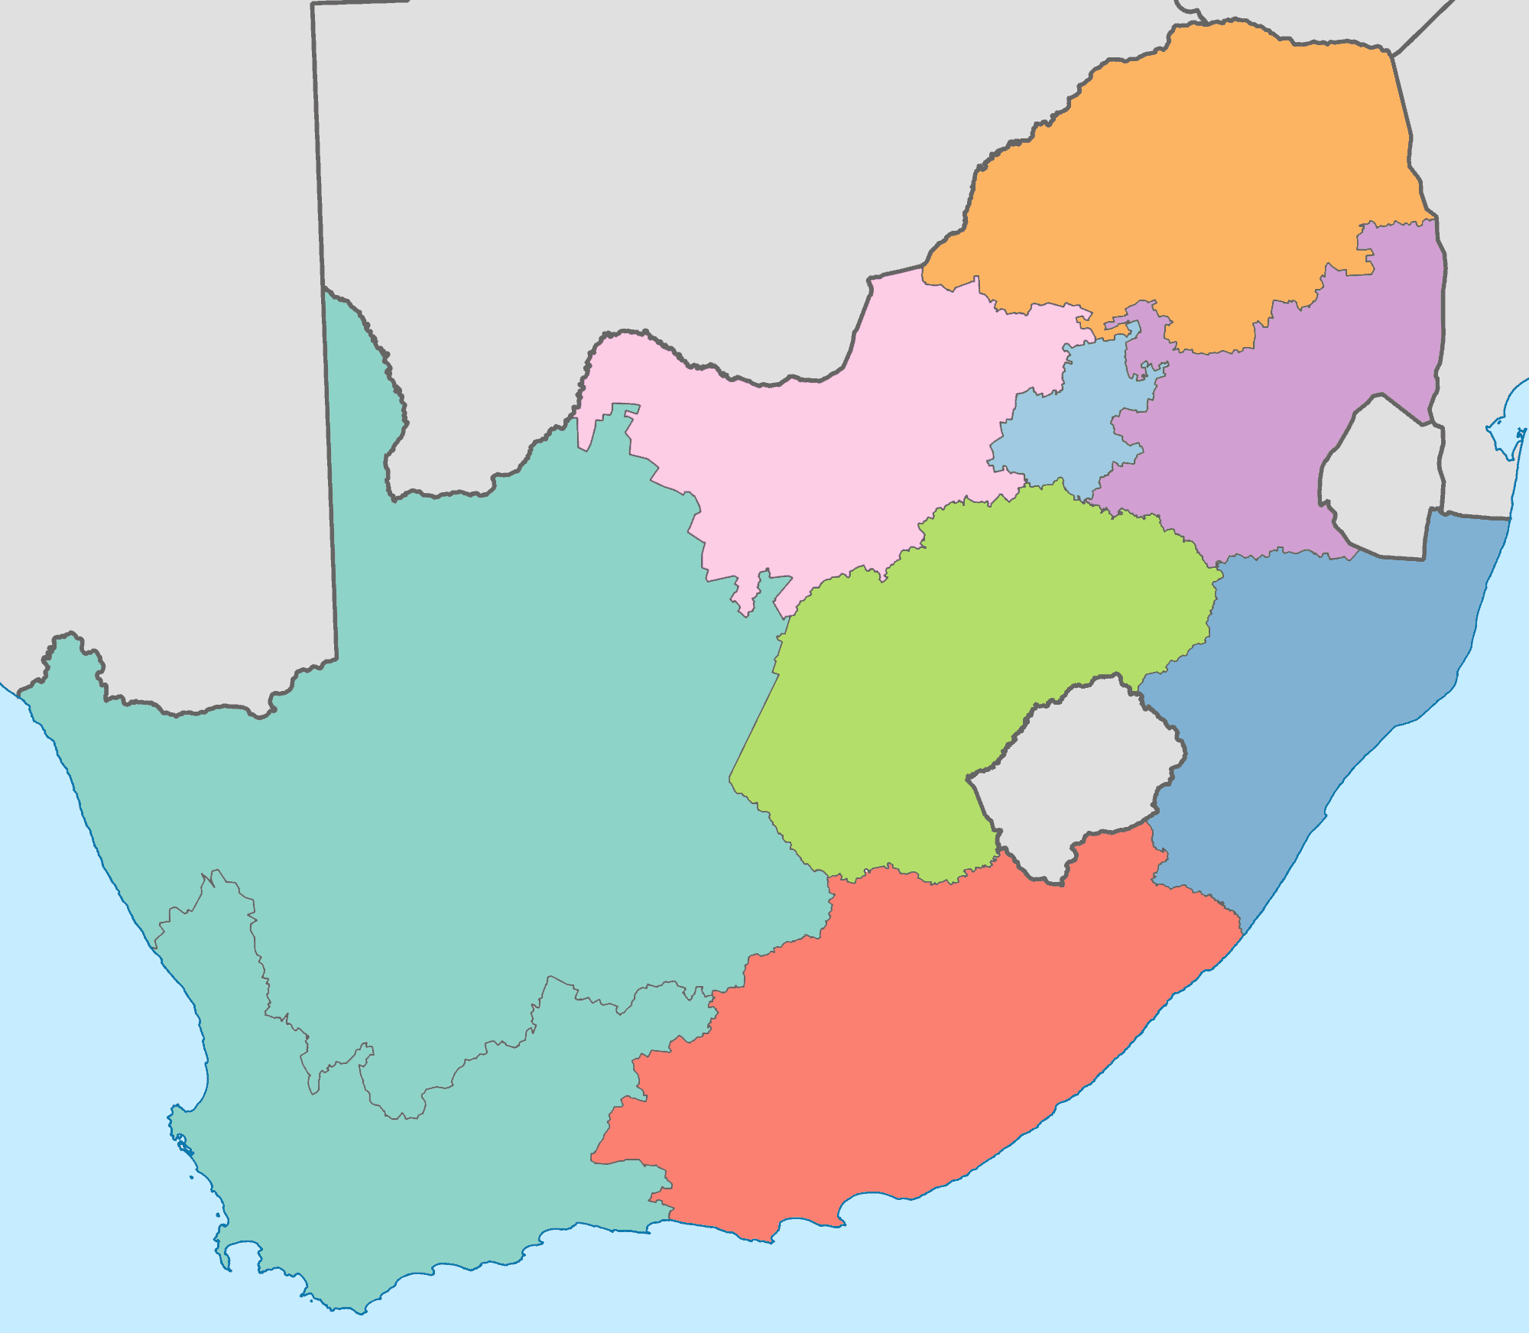
- PROVINCIAL WEALTH OR POVERTY (local)
North west Province-Platinum Province
GDP per capita:R49 744
Unemployment:25.3%
Access towater: 88% (households)
Literacy rate:84.2%
Infant mortality rate: 67 per 1000 under 5 years
Mpumalanga – Power House of South Africa
GDP per capita R 47 058
Unemployment 29.3%
Access to water 87%(households)
Literacy rate: 79.6%
Infant Mortalityrate:79 (per 1000 under 5 years)

Limpopo province-Untapped mining potential
GDP per capita R30 975
Unemployment 26.8%
Access to water:81% (households)
Literacy rate:81.5%
Infant mortality Rate:55 (per1000 under 5 year)

Gauteng- Financial and Industrial Engine-
GDP per capita -R72 544
Unemployment:27%
Access to water ;98% (Households)
Literacy rate: 94.9%
Infant Mortality Rate:52.2%(per 1000 under 5 Years)
Kwa – Zulu Natal- Most Diverse
GDP per capita: R36 161
Unemployment: 29.3%
Access to water: 84%(households)
84% )households)
Literacy Rate 89%
Infant Mortality rates:93 (per thousand under 5 years)
Eastern Cape: -Essentially underdeveloped
GDP per capita: R27 009
Unemployment: 29.8%
Access to water:75%(households)
Literacy Rates:85.1%
Infant mortality rates:89 (per 1000 under 5 years) It is expected that the new harbour development of Ngqura will create jobs and bring about economic developement

Western Cape – Best Tourism
Service
GDP per Capita : R64 363
Unemployment 20.3%
Access to water : 100%(households)
Literacy Rates 95.3%
Infant Mortality rate:39 per 1000 under 5 years)

Free State - bread basket of South Africa
GDP per capita : R46 362
Unemployment :27.2%
Access to water: 93% households
Literacy rates: 89.9%
Infant Mortality rate: 86 per 1000 under 5 years

Northern Cape- Most sparsely populated
GDP per capita :R48 552
Unemployment: 27.8%
Access to water: 95% (households)
Literacy Rate: 85.4%
Infant mortality rate: (50 per 1000 under 5 years)
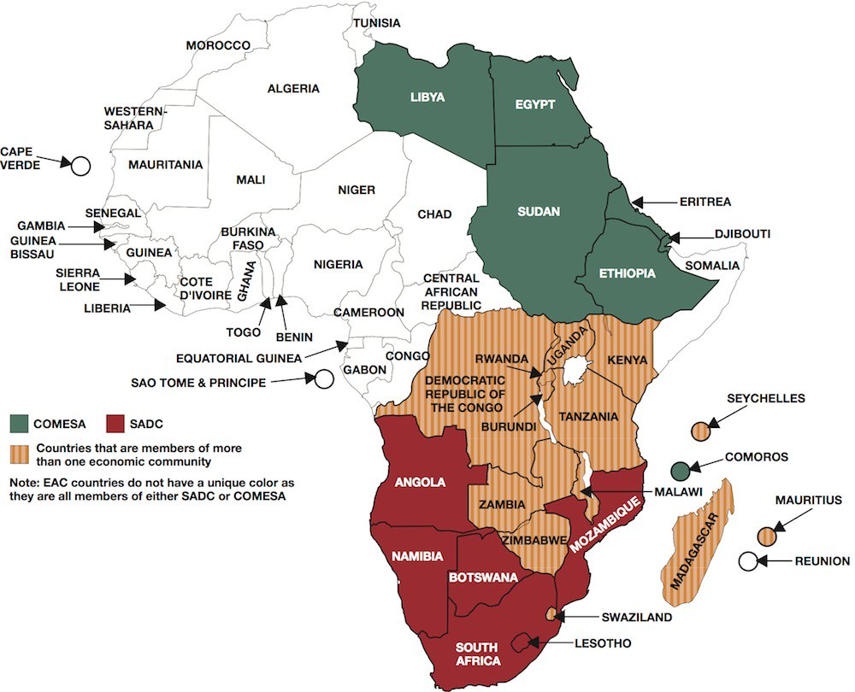
2. DEVELOPMENT AT A REGIONAL LEVEL

- Comesa (Common Market for East and Southern African) was formed in the mid 1960’s.It was formed to promote sub-regional economic integration and to create high living standards for its people. There are 20 member countries
- EAC – (East African Community) was formed at the end of 1999 and came into force in 2000 The EAC is a more homogenous trade bloc.
- SADC (Southern African Development Community) is the largest, most integrated of the African trade blocs, in tems of mutual benefit and regional co-operation of the members. SADC has been in existence since 1980.

- In 2008 the formation of the African Free Trade Zone (AFTZ) was announced by SADC, EAC and COMESA.
- This historic agreement would ease access to markets within the AFTZ and would create a trade zone from Cape Town to Cairo.
- All member countries would mutually benefit and develop from this regional trade bloc and would serve as a key building block for African unity.

The aims and goals of the regional blocs forming the AFTZ are as follows:
- Peace
- Security
- Free trade
- Common market
- Development
- Integration and co-operation
- Higher standard of living

3. Development at a Global Level
Gini co-efficient
It was invented by Corado Gini an Italian statistician
- It is an economic index to measure inequality of wealth or the gap in wealth and income between the richest and poorest people in a country
- Although the Gini co-efficient, is the best known measure of inequality ,it provides a useful insight into Geographical inequality.
- It is represented on the Lorenz curve, which is used to show inequalities in distribution.

