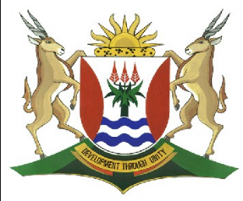
Province of the
EASTERN CAPE
EDUCATION

DIRECTORATE SENIOR CURRICULUM MANAGEMENT (SEN-FET)
HOME SCHOOLING SELF-STUDY WORKSHEET
SUBJECT | GEOGRAPHY | GRADE | 11 | DATE | 27/07/20
TOPIC | TRADE AND DEVELOPMENT | TERM 3  REVISION | √√ | TERM 3 CONTENT | √√
TIME ALLOCATION | 1 HOUR | TIPS TO KEEP HEALTHY  1. WASH YOUR HANDS thoroughly with soap and water for at least 20 seconds. Alternatively, use hand sanitizer with an alcohol content of at least 60%.  2. PRACTICE SOCIAL DISTANCING – keep a distance of 1m away from other people.  3. PRACTISE GOOD RESPIRATORY HYGIENE: cough or sneeze into your elbow or tissue and dispose of the tissue immediately after use.  4. TRY NOT TO TOUCH YOUR FACE. The virus can be transferred from your hands to your nose, mouth and eyes. It can then enter your body and make you sick.  5. STAY AT HOME.
INSTRUCTIONS

Development Geography
- International trade and world markets
- Types of trading relationships
- Globalisation
- Export led development

TRADE AND DEVELOPMENT
International Trade and world markets
- International trade is the exchange of capital, goods, and services across international borders.
- Once goods or capital are moved across borders there are additional costs, such as tariffs (taxes that are impose on imported goods)
- Commodities – goods or products which are produced to meet needs or wants. They are used or exchange in markets, for example fruit and cars
- Trade refers to the exchange of goods and services for money.
- This takes place between countries
- Trade plays an important role in developing the economy of a country as the demand for minerals, raw materials such as timber, fuel and food increases the need to exchange goods

Main export commodities | Description
Food Items | Animals, animal oils, cereals, vegetables and oils,fruits,sugar,honey,coffee, cocoa,spices,beverages and tobacco.
Other agricultural Products | Fertilizers, rubber, cork, wood, pulp, textile fibres, hides and skins
Oils and Minerals | Petroleum -related products, gas, crude oil, coal,coke,minerals,metals and lubricants
Manufactured Goods | Chemical products, machinery and transport equipment, iron and steel, various manufactured items such as leather, rubber, cork, and paper

A simple model of trade between developed countries (MEDCs and developing countries LEDCs is shown below

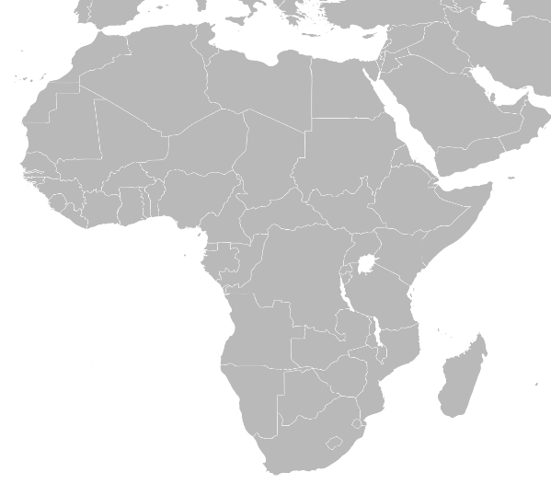
Exports from MEDCs to LEDCs 736$ bn
Commodities and manufactured goods
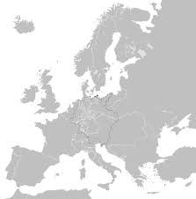

Raw materials and some manufactured goods

Exports from LEDCs to MEDCs 650$ bn

MEDCs make much more money from trade than LEDCs Why is this so?
- LEDCs export raw materials (crops, timber, metals and minerals ) to MEDCs
- MEDCs export manufactured and processed goods (processed food, vehicles, electronics) to LEDCs
- Raw materials have much less value than manufactured goods

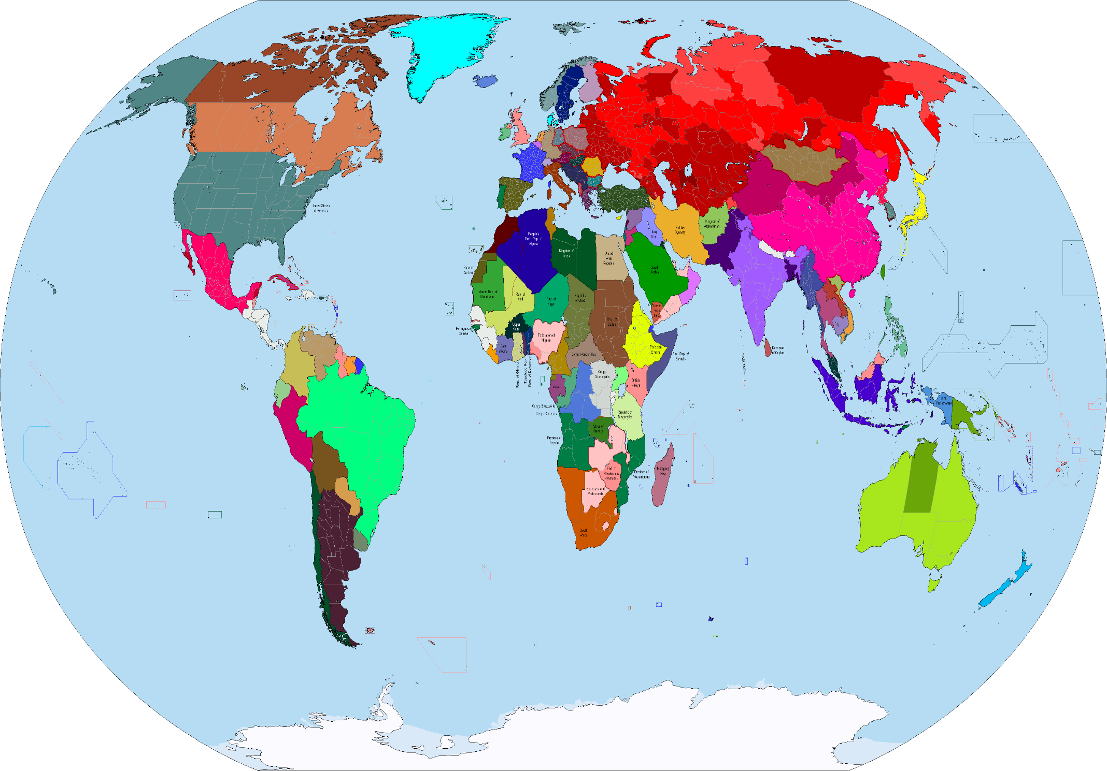
Main Global trading groups
BRICS
Brazil,Russia, India China and South Africa

EFTA- European Free Trade Association:
Iceland,Liechtenstein,Norway,
Sweden and Switzerland
EU – European Union:
Austria,Belgium,Finland,France,Germany,Greece,Ireland,Italy,Luxemborg,Netherlands,Portugal,Spain,Sweden and United Kingdom

Some International and Regional trading Blocs
Mercosur:
Southern Common Market
Argentina,Brazil,Paraguay and Uruquay

ASEAN – Asian Free Trade Area
Brunei,Indonesis,Thailand,Indonesia,Singapore and Vietnam
SADC- South African Development community
Angola,Botswana,,Democratic Republic of Congo(DRC) Lesotho,Madagascar,Malawi,mauritius,Mozambique,,Namibia,South Africa,Seychelles,Swaziland,Tanzania,Zambia and Zimbabwe
OPEC – Organisation of Petrol export Countries:
Algeria, Ecuador,Gabon, Indonesia,Iran,Kuwait,Libya,Nigeria,Qatar,South Arabia,The United Arab emirates and Venezuala
NAFTA:
North Atlantic Free trade association: Canada,Mexico and the United States of America
UEMOA
West African Economic and Monetry Union
Benin,Burkino Faso, C’ote divoire, Mali,Niger,Senegal and Togo
South Africa’s main commodities traded
Commodities are goods or products which are produced to meet the needs of a population and for use or exchange in markets, for example fruit and cars. They are usually traded in large quantities.
Imports | Exports
- Computers  - Vehicles  - Machinery  - Plastic Products  - Crude and refine oil  - Chemicals  - Electronic Equipment | - Raw materials such as Coal, gold,iron ore ,platinum.  - Agricultural Produce  - Chemical products  - Electrical appliances  - Vehicles

South Africa’s Main export market
- South Africa has developed from a farming community into a modern industrialised state.
- Today the economy is well diversified, and country can produce a wide variety of consumer goods and investment goods.
- The economy is also based on foreign trade.
- More than half of the gross national product (GNP) is achieved through exports.

Negative balance of trade
This happens when the value of imports is greater than the value of exports. A country will experience a trade deficit.
Positive balance of Trade
This occurs when the value of exports is greater than the value of imports A country aims to have a positive balance of trade thus a trade surplus.
Balance of Trade
This is when the value of exports is equal to the value of imports
Terms of Trade
This is the relationship between the prices a country sells its exports for and the price it pays for its imports.

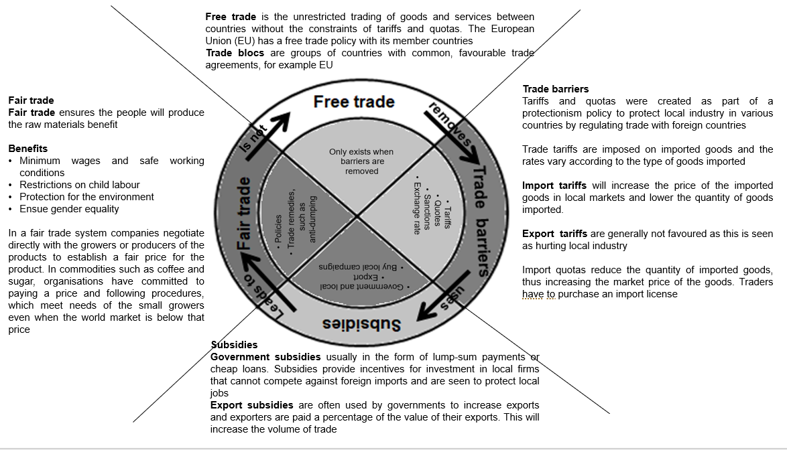
Types of Trade relationships
Globalisation
Is a process whereby the increased flow of goods services, capital, technology, ideas,information and people between countries leads to an integrated global economy and society.

Advantages of Globalisation
Multinational corporations (MNCs) which are companies that own or control production facilities in more than one country, increase employment opportunities and offer better salaries and working conditions in host countries.

Relaxation of trade barriers helps emerging economies (Brazil, Russia,India,China and South Africa – BRICS) to compete actively in the global economy
Global environmental awareness, responsibility and accountability improves.
Migrant workers send remittances of money that they have earned back to their home countries.
There is increased tolerance and appreciation for cultural diversity.
There is rapid and effective natural disaster response and relief.
There is increased access to information, spread of knowledge and innovation.
Poverty is reduced, life expectancy increases, and literacy rates increase.
There are increased markets and access to more consumers

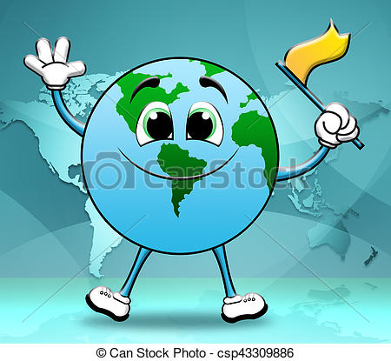
Advantages
Global associations such as the United Nations, the World Bank,the international Monetary fund and the World trade Organisation regulates international disputes and identify and disperse funds for development programmes

Outsourcing which involves companies employing workers in other countries to do some of their work, has increased employment opportunities in developing countries through call centres and clothing, shoe, and car manufacturing.

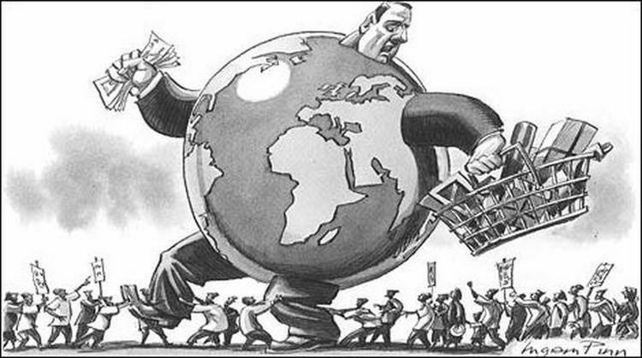
The Disadvantages of Globalisation
Increased trade and travel facilitate the spread of plant, animal, human diseases.
(COVID 19, avian Flu, AIDS etc) and human trafficking
Technological advances may destroy traditional agricultural systems or erode indigenous customs and language.
Great demand for raw materials leads to unsustainable use of natural resources
Brain drains may take place, whereby the skilled and educated migrate from LEDCs to MEDCs.
Government spending on infrastructure, education, health and welfare may decline due to loan repayments.
Rules and regulations of global associations influence policy and choice of governments

Disadvantages

avantages
Outsourcing creates unemployment in developed countries and may lead to sweatshops, in which people work in poor conditions for very low pay, in LEDSs
Employment in MNCs create an upper – middle class increasing income inequalities.
MNCs exert economic and political influence their host countries
Insufficient infrastructure to support technology excludes some nations from World events and advancements
Export Led development

Export development is an economic strategy used by developing countries to “catch up” with developing nations. The aim is to increase wealth by increasing exports through:
- Investing in industry, manufacturing, and education in order to create specialised export products, and then
- Re-investing the money earned in social and physical infrastructure

Case Study 1 : Africa Rising

(facts from Africa rising – lead article in the Economist 3 December 2011)
Over the past decade, 6 of the world’s 10 fastest growing countries were Asian. The growth recorded has been faster than that of Eastern Asia. The commodities boom has contributed to this growth as well as the development of the manufacturing and service-related economies that the African countries have started to enjoy.
Some factors contributing to Africa’s economic growth are:
- China’s contribution to Africa’s improved infrastructure and the manufacturing sector.
- Cross border trading with the removal of trade barriers and tariffs.
- Africa’s growth in cellular phone technology – this means there are more mobile phone users in Europe and North America (600 million)
- Mobile internet services which cover 1/10th of Africa, enabling mobile banking.
- Foreign investment has increased dramatically in the past decade.

Worksheet on Case Study 1: Africa Rising
Refer to Case Study 1 and answer the questions that follow.
1.1 | 1.1.1 | Give TWO reasons why Africa has been able to grow its export market. | (2x2) | (4)
 | 1.1.2 | What role has China played in Africa’s recent development? | (2x2) | (4)
 | 1.1.3 | What commodities do you think Africa has been exporting? | (1x2) | (2)

[10]

Possible examination questions.
TIP: Consult your textbook and notes to answer the following questions

Usually a case study is used to examine Development Geography Make sure that you know all concepts (Questions 1.1-1.16 AND can apply your knowledge on case studies.

Paragraph writing is an important skill that needs regular practice. Use the information regarding development in the above notes and write 4 full sentences to answer the questions.
1.1 Read through the case study in FIGURE 1.1 on the South African textile industry.

SOUTH AFRICAN TEXTILE INDUSTRY

The South African textile industry, which is an important industry in our four major industrial areas, namely PWV (Gauteng), Durban, Cape Town and Port Elizabeth has had to adapt to the global situation. The industry has imported fabrics to keep the marginalized factories open. Between 2003 and 2005 some 67 000 jobs were lost and many factories and businesses were forced to close down. The South African industry has had to face China’s dominance in the textile industry and the flood of cheap clothing being imported or sometimes entering the country illegally.
(Source: DTI and just- style.com)

 | 1.1.1 | Define the term globalisation. | (1x1) | (1)
 | 1.1.2 | List any TWO positive impacts of globalisation. | (2x2) | (4)
 | 1.1.3 | Provide reasons why the South African textile industry has had to close down so many factories and businesses. | (2x2) | (4)
 | 1.1.4 | Evaluate why China’s clothing exports has increased
 |  |  |  | [9]
FIGURE 1.2 (Levels of Development)
Indicator | Brazil | Russia | India | People’s  Republic of China | South Africa
Population | 5th | 9th | 2nd | 1st | 25th
GDP growth rate | 15th | 88th | 4th | 5th | 117th
GDP/capita | 53th | 56th | 138th | 94th | 71st
Number of mobile phone users | 5th | 4th | 2nd | 1st | 25th
Rail network | 10th | 2nd | 4th | 3rd | 12th
Exports | 18th | 11th | 16th | 1st | 36th
Electricity consumption | 9th | 4th | 5th | 1st | 14th
Human Development Index | 73rd | 65th | 119th | 89th | 110th

1.2 | 1.2.1 | Why are the BRICS countries classified as less economically developed countries? | (1x1) | (1)
 | 1.2.2 | Explain what you understand by GDP (Gross Domestic Product) per capita. | (1 x1) | (1)
 | 1.2.3 | Interpret why GDP growth rate rankings for India and China are so high. | (1 x2) | (2)
 | 1.2.4 | Suggest possible reasons why Russia would have the highest level of education among the BRICS countries. | (1 x2) | (2)
 | 1.2.5 | Name the development model shared by the BRICS countries | (1 x1) | (1)
 | 1.2.6 | Explain how the BRICS countries relate to this development model (your answer in QUESTION 4.4.5) on a global and national scale. | (2 x2) | (4)
 |  |  | [11]
1.3 Select from the list below a suitable term that matches the definition provided in
QUESTION 1.3.1– 1.3.7.Write only the number and correct answer.

Protectionism; Trade bloc; Terms of trade; Liberalisation of trade; Capitalism; Balance of trade; Balance of payments; Tariff; Economic development
1.3 | 1.3.1 | The relationship between the prices a country sells its exports for and the prices it pays for its imports
 | 1.3.2 | A financial summary of all the payments made by a country to the rest of the world
 | 1.3.3 | A group of countries that have agreed to trade with one another
 | 1.3.4 | Tax collected by government on goods coming into a country
 | 1.3.5 | A control that restricts, restrains or supports trade to look after the interests of a country
 | 1.3.6 | Allowing more freedom of trade | (7 x1) | (7)
1.4 Provide the term from the list below, which matches the descriptions with the questions that follow. Write ONLY the correct term next to the question number
(1.4.1 to 1.4.7), for e.g. 1.4.8 Development.

Embargo | Humanitarian aid | Import quotas
Balance of trade | Bilateral aid | Economic development
Protectionism |  | Balance of payment

1.4 | 1.4.1 | The balance between the monetary value of a country’s exports and imports.
 | 1.4.2 | Restrictions put on imported goods, regarding its weight, volume and amount.
 | 1.4.3 | The import of goods from other countries is restricted.
 | 1.4.4 | Trade blockages are used to prevent the influx of commodities that might threaten local production
 | 1.4.5 | Direct aid from one country to another.
 | 1.4.6 | Aid for individuals or countries in times of natural disasters or civil conflict. | (7 ×1) | (7)
1.5. Read the extract on Fair trade (FIGURE 1.5 and answer the following questions.
FIGURE 1.5 FAIR TRADE
Fair Trade is a global trade model and certification allows shoppers to quickly identify products that were produced in an ethical manner.
For consumers, Fair Trade offers a powerful way to reduce poverty through their everyday shopping.
For farmers and workers in developing countries, Fair Trade offers better prices, improved terms of trade, and the business skills necessary to produce high-quality products that can compete in the global marketplace. Through vibrant trade, farmers and workers can improve their lives and plan for their futures.
Today, Fair Trade benefits more than 1.2 million farming families in 70 developing countries across Africa, Asia and Latin America.
[Source: www.fairtradefederation.org]

1.5 | 1.5.1 | Define the term Fair trade. | (1 ×1) | (1)
 | 1.5.2 | Name ONE way in which fair trade benefits farmers in developing countries. (1 × 1) (1) | (1X1) | (1)
 | 1.5.3 | Explain how fair trade can help consumers reduce poverty, through everyday shopping, as stated in the extract. | (1X2) | (2)
 | 1.5.4 | Discuss TWO similarities between fair trade and free trade. | (2 ×2) | (4)
 | 1.5.5 | To be certified as fair trade, producers need to maintain good environmental protection when developing sustainable agriculture. In a paragraph of approximately eight lines, provide FOUR criteria that producers need to maintain, to uphold environmental standards in fair trade. | (4X2) | (8)
 |  |  | [16]

FIGURE 1.7 GLOBALISATION

 | Multinational corporations (MNCs) engage in very useful and morally defensible activities in Third World countries for which they frequently have received little credit. Significant among these activities are their extension of opportunities for earning higher incomes as well as the consumption of improved quality goods and services to people in poorer regions of the world. Instead, these firms have been misrepresented by ugly or fearful images by “dependency theory” advocates. Because many of these firms originate in the industrialised countries, they have been viewed as instruments for the imposition of Western cultural values on Third World countries, rather than allies in their economic development.  [Source:www.investopedia.com/term/m/multinational] | [Source: Google images]

1.7 The extract and map in FIGURE 1.7 shows contradictory viewpoints on globalisation and multinational corporations. Study these viewpoints carefully and answer the following questions.
 | 1.7.1 | What is a multinational corporation? | (1 x1) | (1)
 | 1.7.2 | Name TWO negative viewpoints that people have of multinational corporations according to the extract. | (2 x1) | (2)
 | 1.7.3 | Explain the contradictory (opposing) viewpoints regarding globalisation illustrated in the extract and map. | (2X2) | (4)
 | 1.7.4 | In a paragraph of approximately eight lines, evaluate the positive impact that multinational corporations might have on improving both the economy and services of Third World countries. | (4X2) | (8)
 |  |  | [15]
FIGURE 1.8 depicts a balance of trade situation.

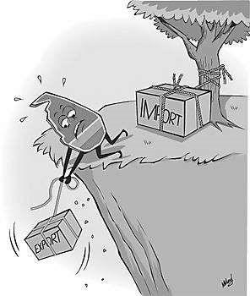
FIGURE 1.8:

BALANCE OF
TRADE

[
Source:
http://www.google
.co.za/images
]

1.8 | 1.8.1 | Define the term balance of trade. | (1 x1) | (1)
 | 1.8.2 | The cartoonist depicts a negative balance of trade.
 |  | - Why would you agree with the statement that the balance of trade is negative? | (1 x1) | (1)
 |  | - Provide TWO protectionist policies that more developed countries implement to restrict imports. | (2 x1) | (2)
 | 1.8.3 | Protectionist policies restrict fair trade. Explain how fair trade could help struggling countries to have a better balance in their trade. | (2 x2) | (4)
 | 1.8.4 | In a paragraph of approximately EIGHT lines, evaluate the importance of a positive balance of trade for countries. | (4 x2) | (8)
 |  |  | [16]

FIGURE1.9 : COMMUNITY-BASED DEVELOPMENT

Umsizi has established, together with Northpoint City Church, a Non-Profit Organisation called Impophomo, which focuses on the socio-economic development of impoverished communities.

Community development is at the heart of Umsizi, and as a result, we have long standing partnerships with the leading experts in the field of rural development. Within community development projects the aim is to significantly improve the well-being of households within rural communities. Projects are designed to be community specific so that upon implementation the positive impacts on the ground can be sustainable and widespread.

Agricultural crop production training is key to community development, and has been presented to many households in villages throughout Southern Africa, with an open invitation for any and all interested community members to attend. The training covers several modules on homestead agriculture and food security, including nutrition, soil fertility, crop rotation, rainwater harvesting and produce, marketing, etc.
[Source: http://umsizi.co.za/community-development]

1.9 | 1.9.1 | What is community development? | (1 x1) | (1)
 | 1.9.2 | Name ONE focus area and ONE aim from the extract of the community development projects organised by Umsizi. | (2 x1) | (2)
 | 1.9.3 | Mention why crop production training is sustainable and widespread within the Umsizi framework. | (1 x2) | (2)
 | 1.9.4 | Explain why monitoring of community-based projects is important to its success for sustainable development. | (2x2) | (4)
 | 1.9.5 | Provide reasons why community development is important to a country’s broader development aims. | (3 x2) | (6)
 |  |  | [15]
1.10 Refer to FIGURE 1.10 depicting the impact of globalisation.
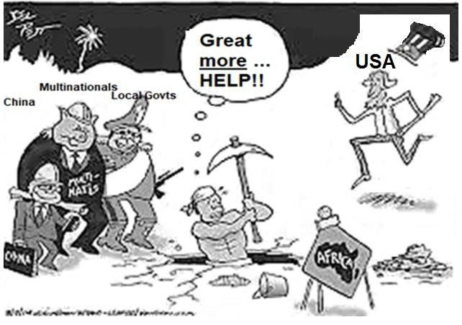

[
Source
:

www.google.co.z
a
/
anticap.wordprest.com
]

1.10 | 1.10.1 | What is globalisation? | (1 x1) | (1)
 | 1.10.2 | Explain why the worker does not seem very happy to be ‘helped’ by the USA. | (1x2) | (2)
 | 1.10.3 | Why do you think China is portrayed (showed) as the smallest in the cartoon? | (1 x2) | (2)
 | 1.10.4 | Refer to the characters representing multinationals and local governments.
 |  | - What are multinationals? | (1x1) | (1)
 |  | - Explain why multinationals and local governments seem to be very good friends. | (1x2) | (2)
 | 1.10.5 | In a paragraph of approximately EIGHT lines, comment  on the social impact of globalisation on developing  countries. | (4 x2) | (8)
 |  | [16]

FIGURE 1.11: EXPORT-LED GROWTH
Export-led growth is an economic strategy used by some developing countries. This strategy seeks to find a place in the world economy for a certain type of export. Industries producing this export may receive governmental subsidies and better access to the local markets. By implementing this strategy, countries hope to gain enough hard currency to import commodities manufactured more cheaply somewhere else.
There are essentially two types of exports used in this context: manufactured goods and raw materials.
[Source: Adapted from http://www.preservearticles.com/how-export-led-growth-is-used-as-a-developmentstrategy.html]

1.11
 | 1.11.1 | Define the term export-led development. | (1 x1) | (1)
 | 1.11.2 | Name ONE incentive that government can give industries to produce an export-led commodity. | (1x1) | (1)
 | 1.11.3 | What is the main aim of implementing an export-led growth strategy, according to the article? | (1 x1) | (1)
 | 1.11.4 | Beside the main aim of export-led growth, mentioned in  QUESTION 1.11.3, explain TWO reasons why export-led  growth is important for developing countries. | (2 x2) | (4)
 | 1.11.5 | Evaluate how manufactured goods can be a disadvantage to developing countries. | (2 x2) | (4)
 | 1.11.6 | Comment on the importance of earning foreign exchange from export-led commodities. | (2x2) | (4)
 |  |  | [15]
1.12. Choose the correct term in COLUMN B that matches the description in COLUMN A. Write the letter (A–I) next to the question number (1.1.1– 1.1.8 in your ANSWER BOOK, for example 1.1.1 J

 | COLUMN A |  | COLUMN B
1.1.1 | Allowing more freedom of trade | A | Terms of trade
1.1.2 | The relationship between the prices a country sells its exports for and the prices it pays for its imports | B | Balance of trade
1.1.3 | Tax collected by government on goods coming into a country | C | Protectionism
1.1.4 | A financial summary of all payments made by a country to the rest of the world | D | Liberation of trade
1.1.5 | The relationship between the value of a country’s exports and its imports | E | Balance of payment
1.1.6 | An official ban on trade or other commercial activity with a country | F | Trade bloc
1.1.7 | A control that restricts, restrains or supports trade to look after the interests of a country | G | Embargo
1.1.8 | The group of countries that have agreed to trade with one another | H | Free trade
 |  | I | Tariff
(8 x 1) (8)

FIGURE 1.13.1: CHINA’S TRADE WITH SUB-SAHARA AFRICA

1.13 FIGURE1.13 is an infographic showing the dependency of Sub-Saharan countries on Chinese trade.
 | 1.13.1 | Define the term export-led development. | (1 x1) | (1)
 | 1.13.2 | What do China mostly …
 |  | - import from sub-Saharan Africa? | (1 x1) | (1)
 |  | - export to sub-Saharan Africa? | (1x1) | (1)
 | 1.13.3 | Comment on the relationship between South Sudan and Angola regarding their trade exposure to China. | (1x2) | (2)
 | 1.13.4 | Describe the trade relationship between sub-Saharan Africa and China in 2010 and 2016, respectively. | (2x2) | (4)
 | 1.13.5 | Explain how development of manufacturing industries will benefit the Sub-Saharan countries’ local economy. | (3 x2) | (6)
 |  |  | [15]
1.14 Study FIGURE 1.14 showing a cartoon on trading relationships.

1.14 TRADING RELATIONSHIPS
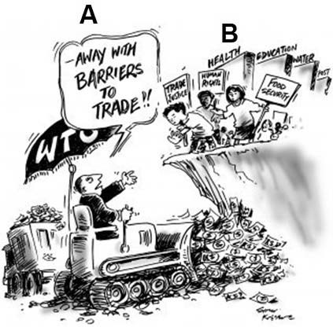

 | 1.14.1 | Define a trade barrier. | (1 x1) | (1)
 | 1.14.2 | Name TWO examples of trade barriers. | (2x1) | (2)
 | 1.14.3 | Why do you think the man at A wants to do ‘away with barriers to trade’? | (2x1) | (2)
 | 1.14.4 | Why is the group of people at B protesting against removing barriers to trade? | (2x1) | (2)
 | 1.14.5 | In a paragraph of EIGHT lines, discuss the positive impact that fair trade will have on a developing country. | (4x2) | (8)
 |  |  | [15]
FIGURE 1.15 shows globalisation.

GLOBALISATION AND MNCs
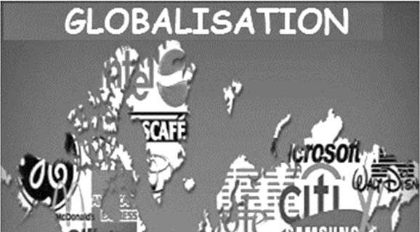

1.15
 | 1.15.1 | Define the term globalisation. | (1 x1) | (1)
 | 1.15.2 | Name ONE advantage that globalisation offers migrants. | (1 x1) | (1)
 | 1.15.3 | - What does the abbreviation MNC stand for? | (1x1) | (1)
 |  | - Name TWO examples of MNCs depicted in FIGURE 1.15 | (2 x1) | (2)
 |  | - Comment on the relationship between globalisation and MNCs | (1x2) | (2)
 |  | - Explain how developing countries benefit from MNCs which are established in their country | (2x2) | (4)
 | 1.15.4 | How do the economic effects of globalisation harm the environment? | (2 x2)  [15] | (4)
GLOBALISATION
1.16 | Read the extract about the link between globalisation and COVID-19.  Globalisation linkage to COVID-19  15 April 2020  By Seleman Yusuph Kitenge  Since the rise of globalisation, the world has now become like a small neighbourhood where people can easily interact with each other without facing any serious barriers. This has become both beneficial and detrimental to the social, political, and economic sphere as far as the welfare of the people is concerned.  Meaning despite the free movement of people, goods, and services led by globalisation being the stimulus to social-economic development, it has also become a source of spreading diseases. As a result, due to the technological development factor of globalisation, an outbreak such as COVID-19 has turned into a major pandemic disease that affected over million people around the world regardless of their geographical location differences.  This is simply because technological advancement which is one of the main forces for globalisation made it easier for people to travel by land, sea and even air from one part to the other without facing any obstacles. In that case, if these people have contacted the disease such as COVID-19 in the city or country (A), they can easily transmit it to the city or country (B) which had no infections if proper healthcare measures are not in place to prevent the spread to the general public.  [Source:https://www.un.org/africarenewal/news/coronavirus/globalisation-linkage-covid-19-how-africa%E2%80%99s-economy-impacted]
 | 1.16.1 | Define the term globalisation. (1 x 1) | (1)
 | 1.16.2 | What according to the article is the link between globalisation and the spread of the covid-19 pandemic? (1 x 2) | (2)
 | 1.16.3 | Explain how globalisation made it easier for locals to understand the covoid-19 pandemic. (2 x 2) | (4)
 | 1.16.4 | In a paragraph of approximately EIGHT lines, discuss the negative impact of globalisation on the economy of South Africa. (4 x 2) | (8)
 |  |  | [15]

