EC - LEARNER SUPPORT MATERIAL: CIVIL TECHNOLOGY:
CIVIL SERVISES: GRADE 11

CONTENT TO BE COVERED:
TOPIC:
- CONSTRUCTION ASSOCIATED WITH CIVIL SERVICES (Subject specific)
CONCRETE:
- Methods and purpose of curing of concrete
- Simple floor slabs e.g. slab for manhole
- Placing of concrete
- Compacting of concrete
- Levelling of concrete
BRICKWORK:
Drawings of: Front views, Sectional views,
Consecutive layers as seen from above T-junction of half brick wall and one brick wall in stretcher bond four courses high

- COLD WATER SUPPLY (Subject specific)

Installation and types of pipes used for cold water supply:
Uses, advantages, disadvantages, depths of water mains and service pipes
and the reasons for this.
- Copper pipes, Galvanized pipes and Steel pipes
- Non-metallic pipes (different classes of high-density polyethylene pipes that must be used for water supply)
Joints and fittings for:
- Copper pipes, Galvanized pipes and Non-metallic pipes (high density polyethylene pipes)
Valves: (Identify and label):
- Water meter
- Stop cock
- Full way valve
- Pillar tap
- Bib cock
- Ball valve
- Non-return valve
- Laying pipes
- Procedure and line diagrams showing all details of the installation of cold-water pipes underground.
- Explain the correct layout and installation of water supply to buildings as prescribed in the Code of Practice SABS 10252 Part 1. (Installation of water supply to buildings)
- Abbreviations and symbols used in cold water systems
- HOT WATER SUPPLY (Subject specific)
Abbreviations and symbols: Explain abbreviations and symbols used in hot
water systems

Explain the working principles, installation, regulations, advantages and
disadvantages of: High pressure geyser

- DRAINAGE (SEWARAGE) ABOVE AND BELOW GROUND (Subject specific)
Explain regulations governing drainage
Identify and explain abbreviations and symbols used in drainage systems Terms and definitions of:
- Waste water
- Waste water pipe
- Waste fixture
- Soil water
- Soil water pipe
- Soil fixture
- Sewage
- Drain
- Drainage installation
Pipe arrangements:
Explanation of pipe arrangements of: Single stack and stub stack systems
of plumbing, advantages and disadvantages

Terms and uses of sanitary fitments: Waste fixture:
- Sink
- Shower
- Bath
- Wash trough
Soil fixture:
- Water closet
- Urinal
- Bidet
Flushing devices:
Identify and label sectional sketches, location, purpose, advantages and disadvantages of:
- Cistern
- Flush valve
Water traps:
Explain the requirements for an efficient trap, identify and label sectional views and sketches, location and function as well as the loss of water seals of traps (causes and prevention):
- P-Trap
- S-trap
- Re-sealing trap
- Bottle trap
- Gulley trap
- Grease trap

- SANITARY FITMENTS (Subject specific)
Sanitary fitments:
Identification of working parts, the working principles and labeling of
sectional sketches and the uses of the following sanitary fitments

High- and low-level cisterns for water closets (advantages and disadvantages)

Identification of working parts, the working principles and labeling of
sectional sketches and the uses of the following sanitary fitments

High- and low-level cisterns for water closets (advantages and disadvantages)

EXAMPLE 1: QUESTION 1: CONSTRUCTION IN CIVIL SERVICES, COLD-WATER AND HOT-WATER SUPPLY

1.1 Explain the term placing of concrete. (2)

1.2 Name TWO methods that may be used to compact concrete. (2)

1.3 Motivate why it is necessary to cure concrete. (1)

1.4 FIGURE 1.4 shows the top view of two consecutive courses of the T-junction of a half-brick wall in stretcher bond. Project and draw from the given view the front elevation of the wall, as seen from the side of the branch wall. Show THREE brick courses. (6)

FIRST COURSE

FIGURE 1.4

1.5 FIGURE 1.5 below shows a system that supplies cold and hot water to a house. Polycop pipe is used for the cold-water supply and copper pipe for the hot-water supply. Study the drawing and complete the quantity list below to complete the plumbing installation. Write only he answer next to the question number (1.5.1–1.5.5)

4

3

2

1

1

7

6

5

6

FIGURE 1.5

ITEM | NAME OF SANITARY WARE OR FITTING | MATERIAL | SIZE | QUANTITY
1 | 1.5.1 | Brass | 22 mm | 2
2 | High-pressure geyser | --- | 150 litres | 1
3 | Temperature and pressure safety valve | Brass | 22 mm | 1
4 | Pressure reducing valve | Brass | 22 mm | 1
5 | Compression elbow | --- | 22 mm | 2
6 | Compression T-joint | 1.5.2 | 22 mm | 1.5.3
7 | Capillary T-joint | 1.5.4 | 22 mm | 1.5.5

(5)

1.6 State ONE advantage of copper pipe. (1)

1.7 State ONE disadvantage of high-density polyethylene pipes. (1)

1.8 You have to repair a copper pipe that is leaking and of which the water supply
cannot be totally shut off. Recommend the type of fitting that will be most
appropriate to join this pipe. (1)

1.9 FIGURE 1.9 below shows a valve.
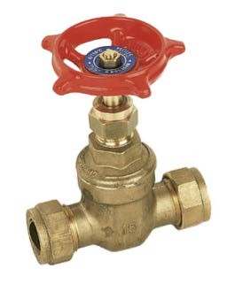

A

B

C

FIGURE 1.9

1.9.1 Identify the valve shown in FIGURE 1.9. (1)

1.9.2 Label A to C correctly. (3)

1.10 Explain TWO regulations that should be adhered to when installing
high-pressure electrical geysers. (2)

1.11 Make neat freehand drawings of the following symbols used in hot-water installations:

1.11.1 Non-return valve (2)

1.11.2 Stopcock (2)

1.12 State ONE disadvantage of solar geysers. (1)
[30]

ANSWER 1: QUESTION 1: CONSTRUCTION IN CIVIL SERVICES, COLD-WATER AND HOT-WATER SUPPLY

1.1 Placing of concrete refers to the pouring √, pumping √ or spraying of concrete
into place. (2)
  - • Mechanical compacting (poker and drive unit) √
- Hand compaction √ (2)

1.3 • To protect it from drying out too quickly. √
• To ensure that there is sufficient water in the concrete for the hydration process to continue to ensure that the concrete reaches its specified strength.
(1)
1.4
 |  |  |  | √
 |  |  | √ |  | √
 |  | √ |  | √ |  | √

(6)

  - 1.5.1 Vacuum breaker √ (1)

    - Brass √ (1)

    - 2 √ (1)

    - Copper √ (1)

1.5.5 1 √ (1)

1.6 • Rust resistant √
- Easy to bend
- Strong
- Does not fade in sunlight
- Easily and solidly joined using a soldered coupling
- Bacteria cannot grow in copper pipes
- Extremely durable (1)
1.7 • Sharp objects can penetrate the pipe √
- Constitutes a high fire hazard if it catches fire
- Cannot stack more than FIVE coils on top of each other
- Must be stored in the shadiest place on site
- If stacked incorrectly, the bottom coils may be damaged
- Cannot be thrown from a delivery vehicle
- Rodents and animals can easily damage the pipes (1)

  - A compression fitting √ will be the best option because it will be very difficult to solder a joint where the water cools down the copper because it cannot be totally shut off. (1)

  - 1.9.1 Full-way valve/Gate valve √ (1)

1.9.2 A- Hand wheel √
B- Gland nut √
C- Valve body √ (3)
1.10 • A drip tray has been compulsory since June 2001; it must be connected to a 50 mm drain pipe. √
- Vacuum breakers must be installed. 300 mm copper pipes above the geyser. √
- The temperature and the pressure safety valve must have a steel or a copper pipe connected to it.
- The pressure rating of this valve MUST match the pressure rating of the geyser.
- The weight of the geyser must be supported by the roof trusses and the geyser should have at least two legs.
- An electric isolator switch should be installed at least 1 metre from the geyser. The geyser must be earthed.
- There should be a cover over the thermostat and the element.
- The geyser inlet and outlet pipes should be lagged.
- The geyser must be SABS approved.

ANY TWO OF THE ABOVE (2)

1.11 1.11

√ √

(2)

1.1.2
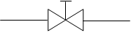
√ √

(2)

1.12• Safety hazard as the tubes can explode due to extra heat that cannot be pumped out in time √
- Low working ability because of less solar energy
- No guarantee that the water will be hot at all times
- Damage due to boiling conditions
- Corrosion of the components
- Initially requires high capital investment
- If one glass tube breaks, the system must be shut down

ANY ONE OF THE ABOVE (1)
[30]

EXAMPLE 2: QUESTION 2: DRAINAGE (SEWERAGE) AND SANITARY FITMENTS

2.1 Exposure to raw sewage is a health risk for workers. State TWO safety
precautions that must be adhered to, to prevent infections when working with
raw sewage. (2)

2.2 Name the hand tool that you would use to bevel the edges of pipes to ease connection of the pipes to pipe fittings, when laying uPVC drain pipes. (1)

2.3 FIGURE 2.3 below is the layout of a drainage (sewerage) system drawn to scale 1: 100. The diameter of the soil pipe is 110 mm and that of the waste pipes 50 mm. Study the drawing and complete the take-off list below to complete the plumbing installation.
For calculation of pipe lengths use scale 1 mm on the drawing = 100 mm of pipe.
Write down only the answers next to the question numbers (2.3.1–2.3.5)

1

1

3

2

4

5

6

6

8

7

7

7

7

FIGURE 2.3

ITEM | NAME OF SANITARY WARE/FITTING | MATERIAL | SIZE | QUANTITY | LENGTH
1 | 2.3.1 | 2.3.2 | --- | 2 | ---
2 | Kitchen sink double bowl | Stainless steel | 1 500 mm | 1 | ---
3 | Wash basin | --- | --- | 1 | ---
4 | Bath | --- | 1 800 mm | 1 | ---
5 | 2.3.3 | --- | --- | 1 | ---
6 | 2.3.4 | uPVC | 110 mm | 2.3.5 | ---
7 | Junction 135° | uPVC | 110 mm | 4 | ---
8 | Bend 135° | uPVC | 110 mm | 1 | ---
9 | Soil pipe (including branch pipes) | uPVC | 110 mm | --- | 2.3.6

(7)

2.4 Explain how you will join two pieces of 50 mm diameter uPVC waste pipe
using PVC adhesive. (3)

2.5 Distinguish between soil water and wastewater. (2)
2.6 What does EACH of the following abbreviations stand for?

2.6.1 IL (1)
2.6.2 uPVC (1)
2.6.3 WT (1)
2.6.4 WP (1)

2.7 Draw the symbol for EACH of the following:

2.7.1 Shower, as used for pipework (2)

2.7.2 Sink single (2)

2.8 FIGURE 2.8 below shows a group of sanitary fitments connected to a one-pipe system. Study the drawing and answer the questions that follow.

C

A
B

FIGURE 2.8

2.8.1 Explain what will happen in the total pipe system when water is discharged from C. (Refer to the correct names of pipes A and B, the discharge, syphon action and ventilation taking place in the system.) (5)

2.8.2 When a range of fitments is horizontally aligned, the system must be ventilated. What is the minimum diameter of the following in this respect?

- Soil pipes
- Wastewater discharge pipes (2)

2.9 Categorise the following sanitary fitments in terms of waste fixtures and soil fixtures in a table:
- Sink
- Bath
- Urinal (3)

  - List THREE requirements of an efficient water trap. (3)

  - Distinguish between a cistern and a flush valve in terms of the advantages
of each. Tabulate your answer. (4)
[40]

ANSWER 2: QUESTION 2: DRAINAGE (SEWERAGE) AND SANITARY FITMENTS.

2.1 • Always wear rubber gloves and rubber boots when working with raw sewage. √
- Always wear a respiratory mask when working with raw sewage to prevent inhalation of germs. √
- Wash your hands with soap and disinfectant after working with raw sewage. • Always cover open wounds and cuts with appropriate plaster to prevent contact with bacteria and germs.
- Always disinfect the area where raw sewage was spilled with a suitable disinfectant to prevent infections to people that may cross that area.
- Never smoke or use open flames in confined areas where raw sewage is present. (2)

  - Half round file √
Flat file (1)
    - Water closet √ (1)

    - Ceramic √ (1)

    - Gully √ (1)

    - Rodding eye √ (1)

    - 2 √ (1)

2.3.6 190 mm x 100 mm √ = 19 000 mm = 19 m √ (tolerance of 1 m to
either side) (2)

2.4 • Dry-fit parts first to make sure the pipes are fitted in the right direction. √
- Apply a light coat of PVC glue to the fitting and the pipe. √
- Slightly twist and push parts into position. √
- Remove all excess glue on the outside of the joint. (3)

  - Soil water is effluent that contains human excreta. √
Waste water is water that is discharged from a bath, shower, wash basin or
sink. √ (2)

  - 2 6.1 Invert level √ (1)

    - Unplasticised Polyvinyl Chloride √ (1)

    - Wash trough √ (1)

    - Waste pipe √ (1)

2.7

2.7.1

2.7.2

√

√

√

√

(2)
(2)

2.8 2.8.1 When water is discharged from fixture C the soil water will discharge into the discharge stack A. √ The vertical acceleration of the water in the discharge stack will cause a vacuum to form behind it √ sucking water from water traps in the same system.√ The vent stack B will allow air to enter the system √ to prevent the syphon action caused by the acceleration of water in the discharge stack. √ (5)
2.8.2 Soil pipes – 110 mm √
Waste-water discharge pipes – 50 mm √ (2)

 | WASTE FIXTURES |  | SOIL FIXTURES
Sink √ |  | Urinal √
Bath √
2.9
(3)
2.10 • Traps should be self-cleaning. √
- The interior surface should be smooth with no sharp angles. √
- The trap should function without any moving parts √
- The material the trap is made of should not deteriorate as a result of the liquids flowing through it.
- The seal should not be deeper than necessary to minimise resistance to the flow.
- It must be designed in such a way that water flowing through the trap should not build up a momentum sufficient to unseal the trap.
- The inlets and outlets should be connected easily to the fitting and outlet
waste pipe. (3)

CISTERN | FLUSH VALVE
- Parts are replaceable √  - Most parts are made of plastic √  - Strong flushing action  - Can be installed close to the wall • Neat appearance  - Can be manufactured in different colours if made from ceramics  - Mechanism can be adjusted to save water  - Easy to service  - Low noise levels | - Less pipework √  - Fewer components √  - Saves time as it is easy to install  - Easy flushing mechanism  - Look elegant  - Saves water  - Takes up little space  - Can be flushed repeatedly as there is no cistern that needs to fill up
2.11

(4)
[40]

EXAMPLE 3: QUESTION 3: COLD AND HOT WATER SUPPLY, DRAINAGE AND SANITARY FITMENTS (SPECIFIC)

3.1 Under which circumstances are stainless steel pipes used? (1)

3.2 Name THREE disadvantages of stainless-steel pipes. (3 x 1) (3)

3.3 Name THREE advantages of high-density polyethylene pipes. (3 x 1) (3)

3.4 Answer the following questions with regard to the valve in FIGURE 3.4.

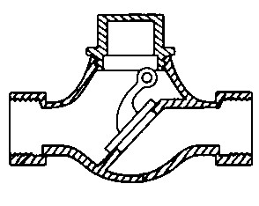

FIGURE 3.4

3.4
.A
3.4
. B

3.4
.C

3.4.1 What is the type of valve in FIGURE 3.4 called? (1)

3.4.2 What is part 3.4.A called? (1)

3.4.3 Which arrow point indicates the correct flow direction, arrow point
3.4.B or 3.4.C? (1)

3.4.4 In which circumstances is this type of valve used? (1)

3.5 Make neat sketches of the symbols for the following:

3.5.1 Draining tap (2)

3.5.2 Float valve (2)

3.5.3 External pipe (2)

3.5.4 Water meter (2)

3.6 What is the purpose of the thermostat in a geyser? (1)

3.7 Which part of the geyser allows air to enter the pipe when needed? (1)

3.8 Answer the following questions with regard to the hot-water reservoir system in FIGURE 3.8.

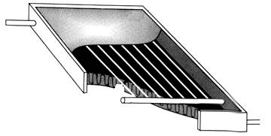

FIGURE 3.8

3.8
.A
3.8
.E
3.8
.F
3.8
.D

.C

3.8
3.8
.B

3.8.1 Name the parts 3.8.A to 3.8 F. (6)

3.8.2 Name TWO functions of part 3.8.F. (2 x 1) (2)

3.9 FIGURE 3.9 shows the side elevation of the incomplete schematic representation of the sanitary fittings which must be connected to a one-pipe system. Complete the following sanitary pipework by means of neat line sketches:
Discharge stack + vent pipe. Label | 2
Traps | 2
Waste water discharge pipes. | 2
Soil water discharge pipe. | 1
TOTAL | 7
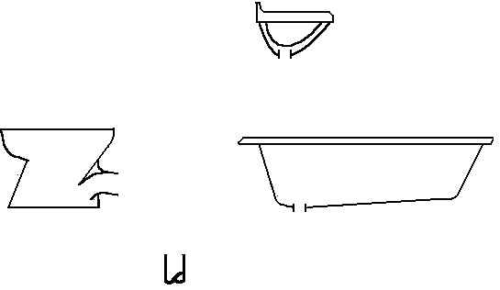
WB
B
WC
FIGURE 3.9

3.9.1 Discharge stack and vent pipe
Indicate the vent pipe by means of a neat label. (2)

3.9.2 Traps for the sanitary fitments (2)

3.9.3 Waste-water discharge pipes (2)

3.9.4 Soil-water discharge pipe (1)

3.10 Briefly describe how the following factors can cause the water locks in traps
to break:

3.10.1 Wavering (2)

3.10.2 Compression (2)
[40]

ANSWER 3: QUESTION 3: COLD AND HOT WATER SUPPLY, DRAINAGE AND SANITARY FITMENTS (SPECIFIC)

3.1 A Steam system / Industrial installation (1)

3.2 Any THREE disadvantages of stainless-steel pipes.
- Difficult to bend
- Very expensive
- Maintenance is expensive
- Special welding may be required (3 x 1) (3)

3.3 Any THREE advantages of high-density polyethylene pipes.
- Extended service life
    - Resistant to strong acids
    - Light
    - Resistant to rough handling
    - Easy to join
    - High rigidity and tensile strength
    - High flow capacity
    - No cracking or deformation
    - Elastic (3 x 1) (3)

3.4 3.4.1 Non-return valve (1)

3.4.2 Locking valve (1)

3.4.3 3.4.B (1)

3.4.4 To prevent backflow in pipe system that pumps water to a higher-
lying area (1)

3.5 3.5.1 Draining tap
(2)

3.5.2 Float valve
(2)

3.5.3 External pipe.
(2)

M
3.5.4 Water meter Or
(2)

3.6 Controls water temperature (1)

3.7 Vacuum breaker (1)

3.8 3.8.1 3.8.A – Outlet
3.8.B – Insulation
3.8.C – Flow tubes
3.8.D – Header
3.8.E – Inlet
3.8 F – Glazing (6)

3.8.2 Any TWO functions of part 6.8.F.
      - Keep dirt out
      - Keep heat in (2 x 1) (2)

3.9 FIGURE 3.9 shows the side elevation of the incomplete schematic representation of the sanitary fittings which must be connected to a one-pipe system. Complete the following sanitary pipework by means of neat line sketches.

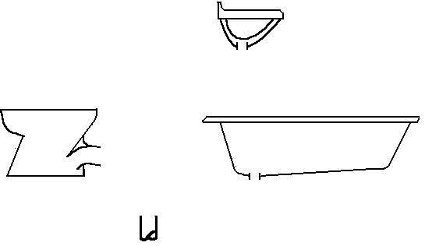

WB

B

WC

VENT PIPE

Discharge stack + vent pipe. Label | 2
Traps | 2
Waste water discharge pipes. | 2
Soil water discharge pipe. | 1
TOTAL | 7

3.9.1 Discharge stack and vent pipe
Indicate the vent pipe by means of a neat label. (2)

3.9.2 Traps for the sanitary fitments (2)

3.9.3 Waste water discharge pipes (2)

3.9.4 Soil water discharge pipe (1)

3.10 3.10.1 Wavering – (1) Wind passing over the top over the stack (2)
causes wavering out of the seal (2)

3.10.2 Compression – (1) When main pipe flow causes (2) a build-up of
pressure at lower levels (2)
[40]

EXAMPLE 4: QUESTION 4: COLD AND HOT WATER SUPPLY, DRAINAGE AND

SANITARY FITMENTS (SPECIFIC)
4.1 Identify the type of pipe which is connected by means of each of the following joining methods:
4.1.1 Soldering | (1)
4.1.2 Compression joint | (1)
4.1.3 Threaded joint | (1)
4.2 FIGURE 4.2 shows an incomplete sketch of a valve for cold water supply. Answer the following questions with regard to the valve.
4.2.1 Complete the sketch below by drawing in the TWO
missing parts of the valve.  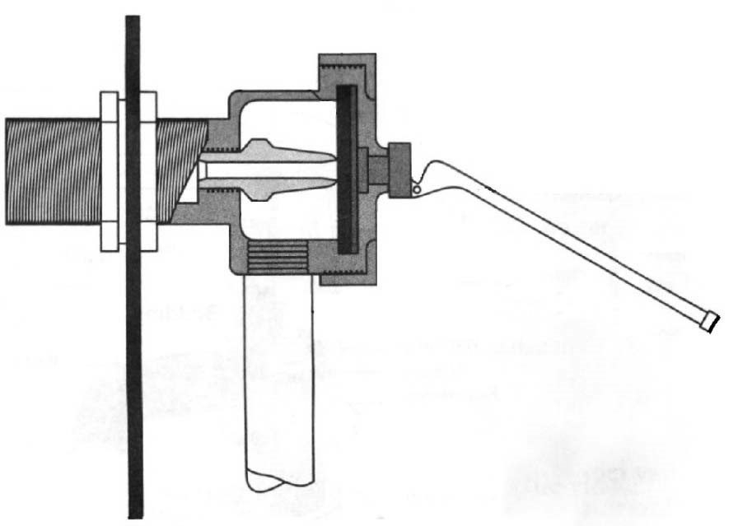  Lacking parts 2  TOTAL: 2 | (2)
4.2.2 What is this valve called? | (1)
4.2.3 Explain the purpose of the valve. | (2)
4.3 Briefly motivate why pipes below a building must be laid inside a sleeve. | (2)
4.4 Make neat sketches of symbols for the following hot water systems:
4.4.1 Automatic shut-off valve | (1)
4.4.2 Non-return valve | (1)
4.4.3 Pressure-relief valve | (1)
4.4.4 Vacuum-relief valve | (1)
4.5 Briefly motivate why the hot water outlet is on top of the high-pressure geyser. | (2)
4.6 Name TWO factors which cause pressure relief valves to discharge. (2 x 1) | (2)
4.7 FIGURE 4.7 shows a roof plan and the position of a solar hot water geyser.
Answer the following questions with regard to the position of the solar geyser.
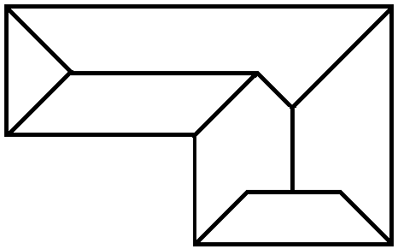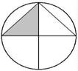

SOLAR GEYSER
 | FIGURE 4.7
4.7.1 | Motivate why the solar geyser in the FIGURE 4.7 is not in a good
 | position. | (2)
4.7.2 | Identify the correct placing for the solar geyser. | (1)

4.8 What is the purpose of the tank vent pipe of a solar geyser.  4.9 FIGURE 4.9 shows the cross-section of a high-pressure solar geyser. Identify | (1)
the parts 4.9.A to 4.9.C. | (3)

4.9.
A

4.9
.B
4.9
.C
FIGURE 4.9

4.10 Indicate whether the following statements are TRUE or FALSE. Write only the word ‘true’ or ‘false’ next to the question number (4.10.1–4.10.3)
4.10.1 Excess sewage must be discharged in stormwater channels. | (1)
4.10.2 Sanitary fittings must be made of impermeable material.  4.10.3 The water supply outlet to the waste appliances must be at least | (1)
120 mm above the flood level of the appliance. | (1)
4.11 Explain the consequence of siphonage in a sanitary pipe system. | (4)
4.12 How is siphonage in a sanitary pipe system eliminated?  4.13 What is the difference between a stub-stack sanitary system and a one-pipe | (1)
sanitary system? | (1)
4.14 Name TWO disadvantages of a one-pipe sanitary system. (2 x 1) | (2)
4.15 Name TWO materials from which cisterns are manufactured. (2 x 1) | (2)
4.16 Briefly explain the working of the outlet silencer pipe of a cistern. | (2)
 | [40]

ANSWER 4: QUESTION 4: COLD AND HOT WATER SUPPLY, DRAINAGE AND SANITARY FITMENTS (SPECIFIC)

4.1 4.1.1 Soldering – Copper pipe (1)

4.1.2 Compression joint – Copper pipe (1)

4.1.3 Threaded joint – Galvanized pipe (1)

4.2 4.2.1 Complete the sketch by drawing in the TWO lacking parts of the valve. (2)

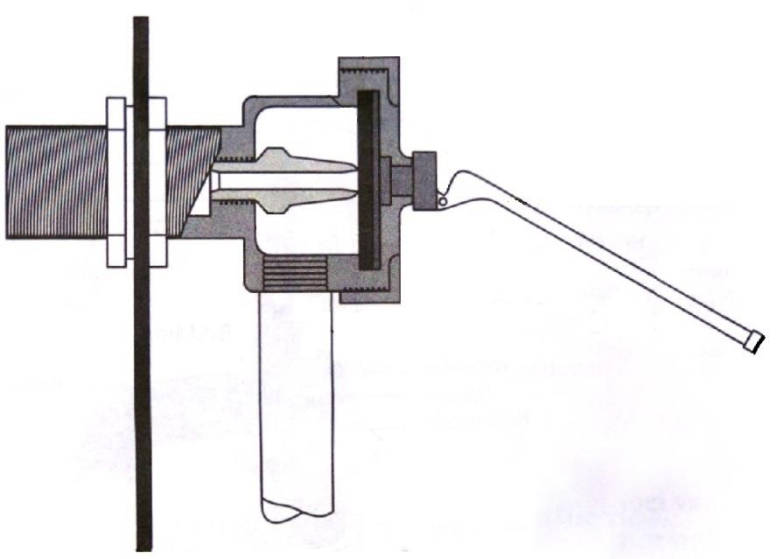

Lacking parts. | 2
TOTAL: | 2

4.2.2 Ball valve (1)

4.2.3 (1) Is used to control the water level in (2) cisterns and supply tanks. (2)

4.3 (1) Protection against external pressure / Allow movement because
(2) it is difficult to repair below the building. (2)

4.4 4.4.1 Automatic shut-off valve
PV

(1)

4.4.2 Non-return valve
(1)

4.4.3 Pressure-relief valve
(1)

4.4.4 Vacuum-relief valve
(1)

4.5 Similar answer:
(1) Water rise to the top of (2) the geyser when it is heated. (2)

4.6 Any TWO:
- Thermal expansion
- Excess system pressure
- Low temperature relief
- Too high setting on the water heater (Any 2 x 1) (2)

4.7 4.7.1 (1) South elevation does not get / water will not get hot (2) direct sun
light. (2)

    - Placing on north elevation. (1)
4.8 Ensure that the tank is not subjected to any pressure. (1)

  - 4.9. A – Radiation absorbing coating
4.9. B – Fluid tube
4.9. C – Inner glass tube (3)

4.10 4.10.1 False (1)

    - True (1)

    - False (1)

4.11 Similar description.
(1) It causes greater atmospheric pressure (2) which forces out (3) the water
locked (4) in the trap. (4)

4.12 Installing a vent pipe. (1)

4.13 Vent valves of a stub-stack sanitary system are lower than the valves of a
one-pipe sanitary system. (1)

4.14 Any TWO disadvantages of a one-pipe sanitary system. • Human waste could back up through the gully.
- Rapid flushing could cause the drainage of adjacent water seals.
- Larger waste pipes can be required. (2 x 1) (2)

4.15 Any TWO materials water closets are manufactured from.
- Glazed porcelain
- Ceramic
- Special clay
- Plastic
- Stainless steel (2 x 1) (2)

4.16 (1) The pipe is projected to the bottom of the cistern (2) and silences the
noise of the incoming water. (2)
[40]

