Province of the
EASTERN CAPE
EDUCATION

DIRECTORATE SENIOR CURRICULUM MANAGEMENT (SEN-FET)
HOME SCHOOLING SELF-STUDY WORKSHEET
SUBJECT | LIFE SCIENCES | GRADE | 12 | DATE | 1 June 2020
TOPIC | EAR STRUCTURE AND FUNCTION | TERM 1  REVISION |  | TERM 2 CONTENT
TIME ALLOCATION | 35 minutes | TIPS TO KEEP HEALTHY  1. WASH YOUR HANDS thoroughly with soap and  water for at least 20 seconds. Alternatively, use  hand sanitizer with an alcohol content of at least  60%.  2. PRACTICE SOCIAL DISTANCING – keep a  distance of 1m away from other people.  3. PRACTISE GOOD RESPIRATORY HYGIENE:  cough or sneeze into your elbow or tissue and  dispose of the tissue immediately after use.  4. TRY NOT TO TOUCH YOUR FACE. The virus  can be transferred from your hands to your nose,  mouth and eyes. It can then enter your body and  make you sick.  5. STAY AT HOME
INSTRUCTIONS | Read your textbook and Mind the Gap Study Guide before answering the questions.  Also study the notes provided with this lesson  Answer the questions on the Worksheets below

QUESTION 1

1.1 Give the correct biological term for each of the following descriptions

1.1.1 Part of the ear that allows air into the middle ear equalizing pressure on either side
of the tympanum.
……………………………………...……………………………………………………(1)
1.1.2 Captures and directs sound waves into auditory canal
…………………………………………………………….……………………………. (1)
1.1.3. Substance secreted by glands that prevents drying out of tympanic membrane.
……………………………………………………………………………………………..(1)
1.1.4 Footplate of this bone is attached to the oval window
……………………………………………………………..…………………………….(1)
1.1.5 The widened area at the bottom of semicircular canal
……………………………………………………………...……………………………(1)
(5)
1.2 Indicate whether each of the descriptions in COLUMN I applies to A ONLY, B ONLY,
BOTH A AND B or NONE of the items in COLUMN II.
 | Column I | Column II | Answer
1.2.1 | Amplify sound vibrations | A Oval window  B Tympanic membrane | ……………
1.2.2 | Transmits sound waves to tympanic membrane | A Auditory nerve  B Auditory canal | ……………
(4)
[9]
QUESTION 2
2.1 Study the diagram below and answer the questions that follow.
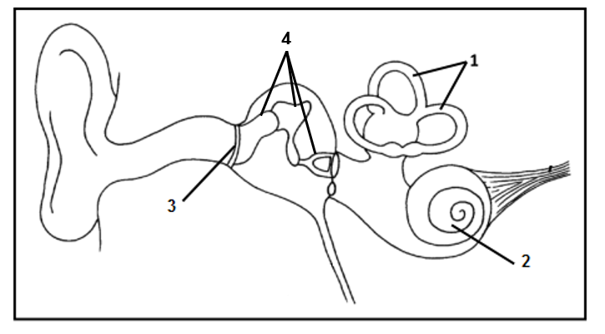
6
5
2.1.1. Identify and write the functions of the following parts:
(a) 1 ………………………………….
…………………………………………………………………………............
…………………………………………………………………………………(2)
(b) 2 …………………………………….
……………………………………………………………………………………….
……………………………………………………………………………………… (2)
(c) 3 …………………………………….
………………………………………………………………………………………
……………………………………………………………………………………… (2)
(d) 4 …………………………………….
………………………………………………………………………………………..
………………………………………………………………………………………. (3)
(e) 5 …………………………………….
……………………………………………………………………………………….
………………………………………………………………………………………(2)
2.1.2 Which part of the brain will receive impulses from part 2?............................(1)
2.1.3. What type of neurons occur in the nerve labelled 5? ………………………..(1)
2.1.4. State ONE advantage of the middle ear being filled with air.
…………………………………………………………………………………….
……………………………………………………………………………………(1)
2.1.5 Where does tube numbered 6 end?..............................................................(1)
2.1.6. Name the part of the ear where ear wax is produced
………………………………………………………………………………………(1)
2.1.7 Explain why hearing loss due to ear wax is usually temporary
……………………………………………………………………………………….
……………………………………………………………………………………….(2)
(18)
QUESTION 3

3.1 Study the following diagram and answer the questions that follow.
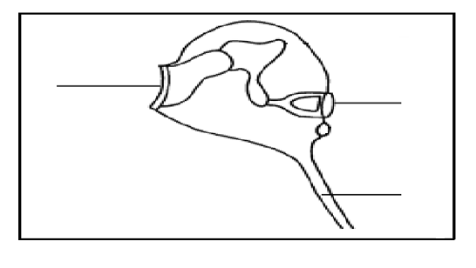
C
D
B
A
3.1.1 Give a caption for the diagram above (1)
……………………………………………………………………………………….
3.1.2 Provide labels for structures A and D. (2)
A…………………………………………………………………………………….
D…………………………………………………………………………………….
3.1.3 Explain why a passenger flying in an airplane, who suddenly experiences
pain and discomfort in the ear, can be relieved through swallowing or yawning. (2)
……………………………………………………………………………………….
……………………………………………………………………………………….
……………………………………………………………………………………….
……………………………………………………………………………………….
3.1.4 Explain how structures B and D contribute to the amplification of sound. (3)
………………………………………………………………………………………
………………………………………………………………………………………
………………………………………………………………………………………
………………………………………………………………………………………
(8)
[35]

