Province of the
EASTERN CAPE
EDUCATION
DIRECTORATE SENIOR CURRICULUM MANAGEMENT
(SEN-FET)
HOME SCHOOLING SELF-STUDY WORKSHEET ANSWER SHEET
SUBJECT | LIFE SCIENCES | GRADE | 12 | DATE | 04 April 2020
TOPIC | Introduction to human endocrine | TERM 1  REVISION |  | TERM 2 CONTENT

1. | Give the correct biological term for each of the following descriptions. Write only the term next to the question number.  - Glands which pour their secretion into the bloodstream.  1.2 The linking of various system and activities within the body.  1.3 A gland which secrets both hormones and digestive juices. | (3 x 1) | (3)
2. | The diagram below represents parts of the endocrine system in humans
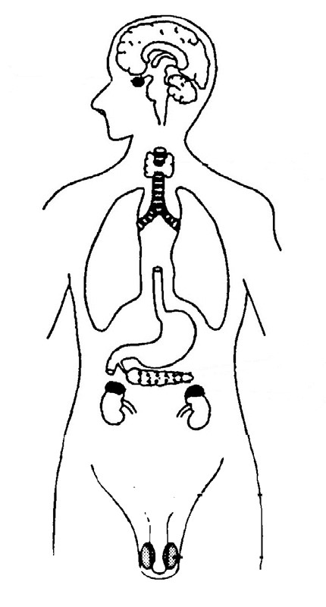
E

A

B

C

D

 | 2.1 Which letter represents a gland that plays a role in maintaining salt  balance in the body? |  | (1)
 | 2.2 Identify glands:  (a) C  (b) A |  | (1)  (1)
 | 2.3 What is the function of the gland labelled E? |  | (1)
 | 2.4 Write letters and names of three glands that will be affected if the  the metabolic rate needs to be lowered in the body of a normal  sleeping person. |  | (6)
3. | Study the following passage
 | Messenger substances are produced in endocrine glands of the human body and then transported to other parts of the body where they are involved in regulating the activity of particular parts. Slow, sustained  3.1 Write a biological term for each of the following phrases taken from  the passage:  - messenger substances.  - particular parts whose activities are regulated.  3.2 Name ONE system in the human body involved in co-ordination.  3.3 Tabulate TWO differences between the systems involved in co-  ordination. |  | (1)  (1)  (1)  (5)
4. | The effect of 50 g of glucose consumption on the concentration of blood glucose and insulin was measured for a healthy person. The results are recorded in the table below.  Effect of glucose consumption on the concentration of blood glucose and insulin over time.
 | Time (hours) Concentration of substances in blood (mg/100ml)  Glucose Insulin  07: 00 60 10  07: 15 60 10  07: 30 60 10  07: 45 60 10  08: 00 60 10  08: 15 70 10  08: 30 95 20  09: 00 92 75  09: 30 85 70  4.1 During which period was the person’s blood glucose level  constant? |  | (1)
 | 4.2 Glucose was given to a person at 08:00. What effect did this have  on each of the following during the next 15 minutes?  - The glucose concentration in the blood.  - The insulin concentration in the blood.  4.3 Explain why there is difference in time between two effects  mentioned in 4.2 (a) and (b).  4.4 Use the data to briefly describe the role of insulin in the glucose  metabolism. |  | (2)  (2)  (4)
5. | The diagram below shows the hormonal action during the menstrual cycle.
 | 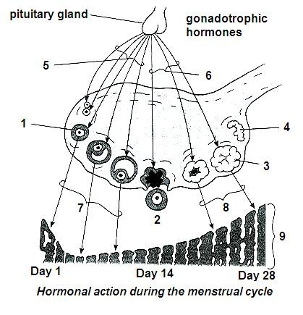
 | 5.1 Name two hormones labelled 5 and 6.  5.2 Name the main hormone produced at 3 after day 14 and state two  functions of this hormone.  5.3 Under what conditions will hormone 5 not be produced and secreted  in a healthy young woman? |  | (2)  (3)  (1)
6. | Endocrine system helps to protect the human body.
 | Using a suitable example, describe how this is achieved by the hormone  Adrenalin. |  | (4)

[40]

