Province of the
EASTERN CAPE
EDUCATION

DIRECTORATE SENIOR CURRICULUM MANAGEMENT (SEN-FET)
HOME SCHOOLING SELF-STUDY WORKSHEET
SUBJECT | LIFE SCIENCES | GRADE | 12 | DATE | 05 June 2020
TOPIC | NEGATIVE FEEDBACK | TERM 1  REVISION | (Please tick) | TERM 2 CONTENT
TIME ALLOCATION | 45 MINUTES | TIPS TO KEEP HEALTHY  1. WASH YOUR HANDS thoroughly with soap and water for at least 20 seconds. Alternatively, use hand sanitizer with an alcohol content of at least 60%.  2. PRACTICE SOCIAL DISTANCING – keep a distance of 1m away from other people.  3. PRACTISE GOOD RESPIRATORY HYGIENE: cough or sneeze into your elbow or tissue and dispose of the tissue immediately after use.  4. TRY NOT TO TOUCH YOUR FACE. The virus can be transferred from your hands to your nose, mouth and eyes. It can then enter your body and make you sick.  5. STAY AT HOME.
INSTRUCTIONS | Use the following resources to answer the worksheet:  - Textbook  - Mind The Gap Study Guide pg. 54-55  - Video Lesson on Negative Feedback Mechanisms  - PowerPoint Presentation on Negative Feedback Mechanisms

1.1 | The graph below shows the blood glucose concentration in a normal person and in a person with diabetes mellitus. Both persons ingested 100 mℓ of glucose solution at 30 minutes.
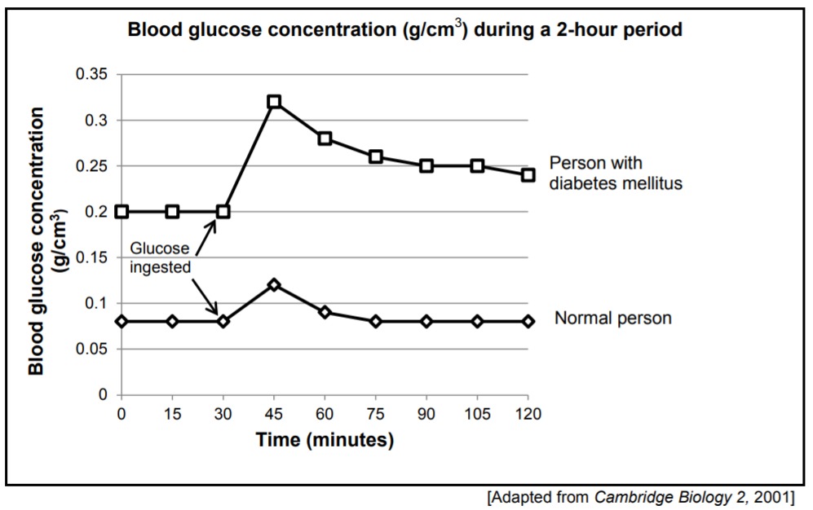

 | 1.1.1 | What is the blood glucose concentration (g/cm³) of the person with diabetes mellitus at 90 minutes? |  | (1)
 | 1.1.2 | How many minutes after the ingestion of glucose did the glucose concentration reach its highest level in the normal person? |  | (1)
 | 1.1.3 | Describe TWO differences in the pattern of the blood glucose concentration for the person with diabetes mellitus and a normal person |  | (4)
 | 1.1.4 | Explain the reason for the differences mentioned in QUESTION 1.1.3. |  | (2)
 | 1.1.5 | Name a hormone that has the opposite effect to that of insulin. |  | (1)  (9)

2.1 | Some people with type I diabetes cannot produce insulin and therefore need to inject themselves regularly (insulin-dependent).  An investigation was done to determine the action of two types of insulin (A and B). The glucose uptake rate of cells, when using each type of insulin, was measured over time
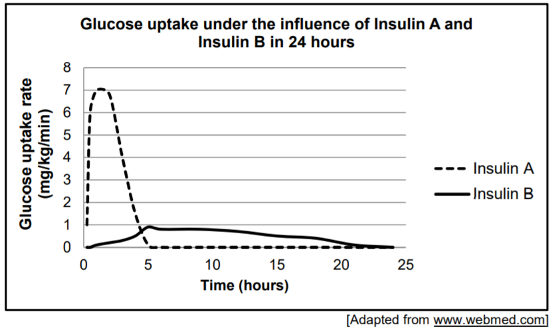

 | 2.1.1 | Name the human organ that produces insulin. |  | (1)
 | 2.1.2 | Using the information in the graph, state TWO differences in the functioning of insulin A and B. |  | (4)  (5)

2.2 | An investigation was conducted to compare the glucose concentration in the blood of two people, Mo and Thabiso, before and after ingesting glucose.  The following procedure was followed:  - The glucose concentration in their blood was measured at the start of the investigation and again 1 hour into the investigation.  - One hour into the investigation each of them was given 50 mℓ of a glucose solution to drink.  - For the next 4 hours after ingesting the glucose solution the glucose concentration in their blood was measured every 30 minutes.  The results are shown in the graph below.  The arrows indicate when they drank the glucose solution.  NOTE: The normal glucose concentration in blood is between 80 and 12  mg/100 cm³.
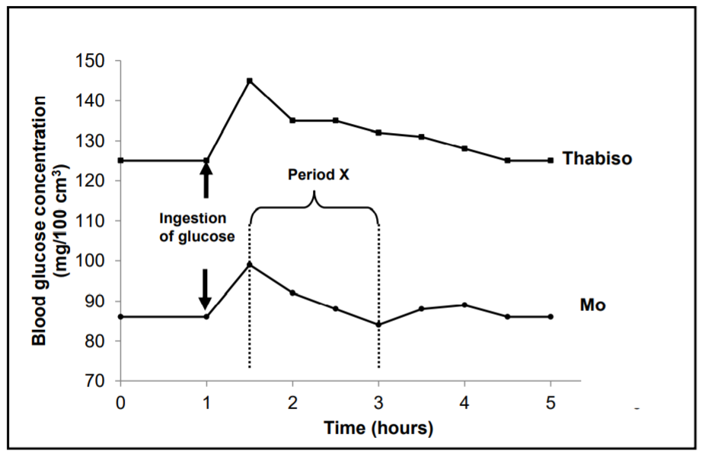
 | 2.2.1 | Provide a suitable title for this graph. |  | (2)
 | 2.2.2 | By how much did Thabiso's blood glucose concentration level increase (in mg/100 cm³) after drinking the glucose solution? Show ALL working. |  | (2)
 | 2.2.3 | How long did it take Mo's blood glucose concentration level to return to its original level after ingesting the glucose solution? |  | (1)
 | 2.2.4 | - Who (Thabiso or Mo) has diabetes mellitus? |  | (1)
 |  | - Give ONE observable reason for your answer to QUESTION 2.2.4 (a) |  | (1)
 | 2.2.5 | Explain the changes in Mo's glucose level during period X. |  | (4)  (11)

3.1 | TSH and thyroxin are both secretions of endocrine glands, namely the pituitary gland/hypophysis and the thyroid gland respectively.
 | 3.1.1 | Where will you look for evidence to detect the levels of TSH and thyroxin in the human body? |  | (1)
 | 3.1.2 | A high level of TSH is detected in the human body.  Explain TWO possible causes of high levels of TSH in the body. |  | (4)  (5)

3.2 | Describe the homeostatic control of blood glucose levels in a person who consumed a drink with a large amount of sugar. |  | (5)

3.3 | The diagram below represents a negative feedback mechanism.
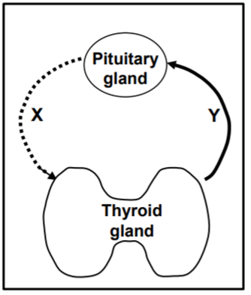
 | 3.3.1 | What is the role of any negative feedback mechanism in the human body? |  | (1)
 | 3.3.2 | Identify hormone X. |  | (1)
 | 3.3.3 | Explain the consequences for a person if hormone Y remained abnormally high for extended periods of time. |  | (3)  (5)  [40]

