Province of the
EASTERN CAPE
EDUCATION

DIRECTORATE SENIOR CURRICULUM MANAGEMENT (SEN-FET)
HOME SCHOOLING SELF-STUDY WORKSHEET
SUBJECT | ECONOMICS | GRADE | 12 | DATE | 10/06/2020
TOPIC | MICROECONOMICS & CONTEMPORARY ECONOMIC ISSUES | TERM 1  REVISION |  | TERM 2 CONTENT | X

QUESTION 1 MICROECONOMICS AND CONTEMPORARY ECONOMIC ISSUES 40 MARKS − 30 MINUTES
DBE/Feb.–Mar. 2018
1.1 | Answer the following questions.
 | 1.1.1 Give any TWO reasons why governments levy tax on tourism.  - To recover external costs √  - To increase revenue √  - To maintain infrastructure √  (Accept any other correct relevant response) (2 x 1) |  |  | (2)
 | 1.1.2 Why does the government sometimes set minimum prices (price floors) for certain products?  - To enable producer to make a profit and to encourage them to supply important essential goods √√  (Accept any other correct relevant response) (1 x 2) |  |  | (2)
1.2 | DATA RESPONSE
 | 1.2.1 Identify ONE example of a monopolistic competitor in the information above.  - Pizza hut √  - McDonalds √  - Burger King √  - KFC √  - Jollibee √  - Chowking √ |  |  | (1)
 | 1.2.2 Which word in the information above suggests that a monopolistic competitor is a combination of two  market structures?  - Hybrid √ |  |  | (1)
 | 1.2.3 Briefly describe the term normal profit.  - It is a profit that is sufficient to ensure the entrepreneur continues production/minimum earnings required to prevent the entrepreneur from leaving and using his/her production factors elsewhere √√  (Accept any other correct relevant response) |  |  | (2)
 | 1.2.4 Why is the demand curve of a monopolistic competitor more elastic than that of a monopoly?  - The products of a monopolistic competitor are good substitutes √ unlike a monopolist where the there are no close substitutes √ |  |  | (2)
 | 1.2.5 How does branding play a key role in a monopolistic competitive market structure?  Branding plays a key role in monopolistic competitive markets by:  - each business selling a slightly differentiated product. √√  - it is based on the opinion of consumers   - building customer loyalty where a consumer will choose one producer over another  e.g. Checkers no-name brand (2 x 2)  (Accept any other correct relevant response) (2 x 2) |  |  | (4)
1.3 | DATA RESPONSE
 | 1.3.1 Give the name of ONE city in the extract where climate change conferences were held.  - Kyoto √  - Berlin √  - Durban √ |  |  | (1)
 | 1.3.2 Identify the international organisastion in the extract above that initiates climate change conferences.  - United nations / UN √ |  |  | (1)
 | 1.3.3 Describe how greenhouse gases contribute to global warming.  - Forms a blanket that traps the heat within the earth's atmosphere / A stronger greenhouse effect will warm oceans and partially melt glaciers and other ice, increasing sea level √√  (Accept any other correct relevant response) |  |  | (2)
 | 1.3.4 How can a green fund help to reduce global warming?  - It can enable the establishment and use of renewable (clean/ecofriendly) energy √√  (Accept any other correct relevant response) |  |  | (2)
 | 1.3.5 Why is global warming increasing despite the many international conferences on climate change?  Global warming is increasing due to:  - Governments, as parties to international agreements, being unable or less interested in implementing the agreements √√  - rising conflict between the goal of reversing global warming and that of increasing economic development √√  - industries who are more interested in increase in profits, which is possible only when increase in production takes place √√  - increased production accompanied by emission of greenhouse gases, which leads to global warming √√  (Accept any other correct relevant response) Any (2 x 2) |  |  | (4)
1.4 | Briefly describe the fiscal measures that can be used to combat demand-pull inflation.  - An increase in direct taxes e.g. PAYE to reduce excessive demand in the economy √√  - An increase in indirect taxes e.g. VAT will reduce the demand for many goods √√  - A loan levy can be introduced to discourage borrowing √√  - Reducing government spending by postponing certain projects √√  - Imposing a surcharge on imported goods to reduce the demand √√  - Financing the budget deficit from the non-banking sector instead of the banking sector where borrowing rates are higher √√  (Accept any other correct relevant response) (4 x 2)  (A maximum of 4 marks may be allocated for the mere listing of facts/ examples)  (Monetary measures must not be accepted or allocated any marks) |  |  | (8)
1.5 | Draw a well-labelled graph to illustrate economic profit in a monopoly market.  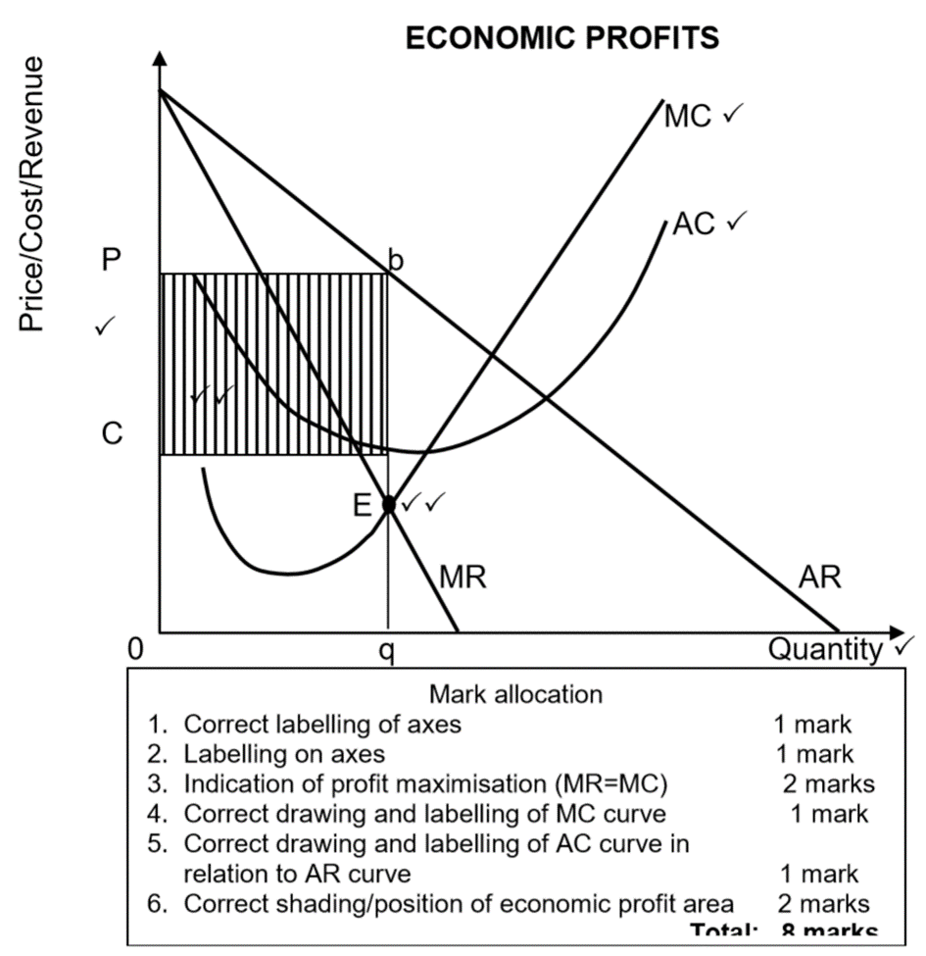
 | NOTE: If candidates drew the long term economic profit, allocate marks. |  |  | (8)  [40]

