Province of the
EASTERN CAPE
EDUCATION

DIRECTORATE SENIOR CURRICULUM MANAGEMENT (SEN-FET)
HOME SCHOOLING SELF-STUDY WORKSHEET
SUBJECT | ELECTRONICS | GRADE | 12 | DATE | JUNE 2020
TOPIC | SWITCHING CIRCUITS (SPECIFIC) | TERM 1  REVISION | () | TERM 2 CONTENT | (√)
TIME ALLOCATION | 2 hrs. | TIPS TO KEEP HEALTHY  1. WASH YOUR HANDS thoroughly with soap and water for at least 20 seconds. Alternatively, use hand sanitizer with an alcohol content of at least 60%.  2. PRACTICE SOCIAL DISTANCING – keep a distance of 1m away from other people.  3. PRACTISE GOOD RESPIRATORY HYGIENE: cough or sneeze into your elbow or tissue and dispose of the tissue immediately after use.  4. TRY NOT TO TOUCH YOUR FACE. The virus can be transferred from your hands to your nose, mouth and eyes. It can then enter your body and make you sick.  5. STAY AT HOME.
INSTRUCTIONS | SELF – STUDY ACTIVITY  (Answer all questions)
QUESTIONS
  - Refer to FIGURE 1.1 below and answer the questions that follow.
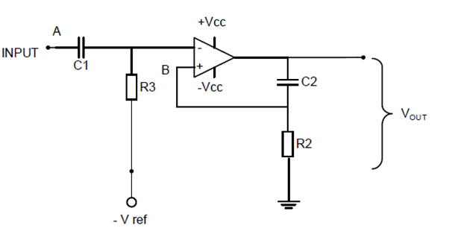
Figure 1.1 Multivibrator
1.1.1 Identify the multivibrator in FIGURE 1.1 above.
1.1.2 Name TWO characteristics of this multivibrator.
1.1.3 Explain the function of the network C2 and R2.
1.1.4 Analyse FIGURE 1.1 above and explain the THREE ways to change this circuit in order to have a variable time in the high state.
1.1.5 Explain the principle of operation of the circuit in FIGURE 1.1.
1.1.6 With reference to FIGURE 1.1, name ONE application of this multivibrator.

  - Refer to FIGURE 1.2 below and answer the questions that follow.
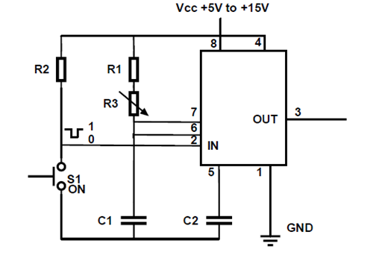
Figure 1.2 MULTIVIBRATOR
1.2.1 Explain the function of R1 in the circuit.
1.2.2 Name TWO methods to vary the time period of this circuit.
1.2.3 Explain the effect on the output waveform if R3 is changed from 10 kΩ to 27 kΩ.
  - Draw a fully labelled circuit diagram of an Op-Amp Astable multivibrator circuit.
  - With reference to the Schmitt trigger, draw a fully labelled hysteresis characteristic curve
  - Define the term hysteresis with reference to the Schmitt trigger.
  - Name TWO applications of the Schmitt trigger.
  - Draw a fully labelled circuit diagram of a temperature sensor circuit.
  - Draw a fully labelled circuit diagram of a summing amplifier with THREE inputs.

  - A summing amplifier has three input resistors with the following values:
R1 = 30 kΩ, R2 = 17 kΩ, R3 = 21 kΩ
The output voltage for this circuit is given as -2,7 V.
The known input voltages are V1 = 150 mV, V2 = 430 mV.

Calculate the value of V3 if this circuit has a 120 kΩ feedback resistor.

