Province of the
EASTERN CAPE
EDUCATION

DIRECTORATE SENIOR CURRICULUM MANAGEMENT (SEN-FET)
HOME SCHOOLING SELF-STUDY WORKSHEET ANSWER SHEET
SUBJECT | ELECTRONICS | GRADE | 12 | DATE | JUNE 2020
TOPIC | SWITCHING CIRCUITS | TERM 1  REVISION | (Please tick) | TERM 2 CONTENT | (√ )

ANSWERS TO QUESTIONS
1.1 THREE types of multivibrators.
- Monostable multivibrator
• Bi-stable multivibrator
• Astable multivibrator
1.2.1 Bi-stable multivibrator
1.2.2 Bi-stable multivibrator Circuit diagram operation.
- This op amp operates as a comparator. ✓
- Any difference between its two input causes its output to go into either positive saturation (+V_{SAT}) or negative saturation (-V_{SAT}). ✓
- The non-inverting input is fed by a fraction of the output voltage fed-back from the voltage divider pair of R₂ and R₃. ✓
- If the output voltage is high (+V_{SAT}) then the non-inverting terminal voltage will be a smaller positive voltage and if the output is low (-V_{SAT}) the non-inverting input terminal voltage will be a smaller negative voltage.

1.3 Two applications of a Mono-stable multivibrator
• De-bouncing
• Varying the time period

1.4 Schmitt trigger circuit diagram.

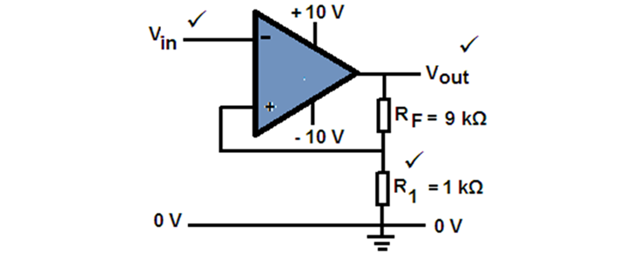

1.5 Four applications of a Schmitt trigger

- It is widely used in the first stages of many radio receivers, especially in digital applications where it is used to clean up a signal which has been distorted of which has had some noise added during its transmission through the air. ✓
- In digital circuitry noise is often introduced into a system via switch bounce which can cause a number of unwanted voltage spikes to appear during the switching-on period. ✓
- Varying input waveforms, for example a sine wave can be changed into a square or rectangular wave. ✓
- A signal can be successfully recovered using a Schmitt trigger even after having suffered severe distortion as the circuit will only sense a single level change, so eliminating all other noise spikes.

1.6 Draw a fully labelled circuit diagram of a monostable multivibrator.

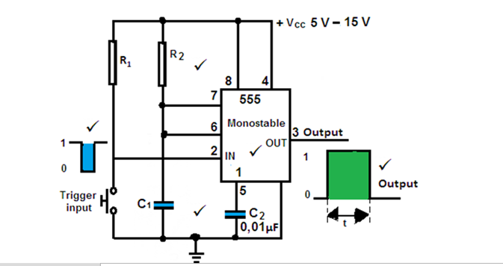

1.7 Sketch a fully labelled circuit diagram for a 555 IC Astable multivibrator circuit also showing input and output waveforms.

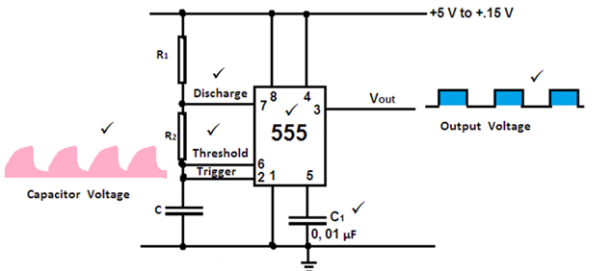

1.8 Summing amplifier diagram and calculation of the circuit output voltage.

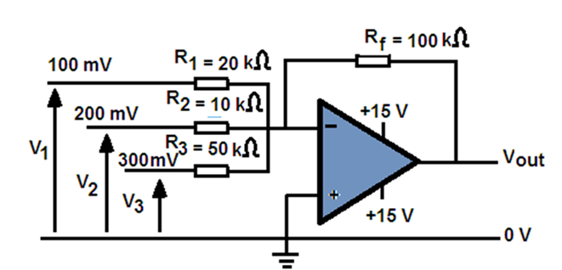

Circuit output voltage
$V_{out}= -(V_{1}\frac{R_{F}}{R_{1}}+V_{2}\frac{R_{F}}{R_{2}}+V_{3}\frac{R_{F}}{R_{3}})$✓

$V_{out}= -(100 mV×\frac{100 kΩ}{20 kΩ}+200 mV×\frac{100 kΩ}{10 kΩ}+300 mV×\frac{100 kΩ}{50 kΩ})$ ✓

$V_{out}= -3,1 V$✓

1.9 Given the circuit diagram below:

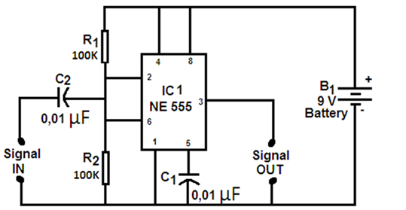

1.9.1 TWO full cycles of the input and output waveforms for the circuit above, if a sinusoidal waveform was added to its supply.

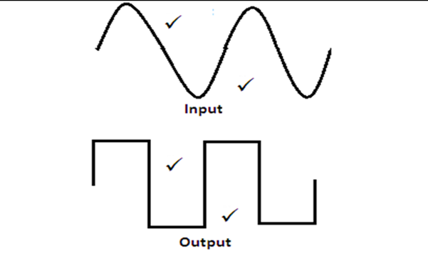

1.10 Passive RC differentiator
1.10.1 The output wave form.

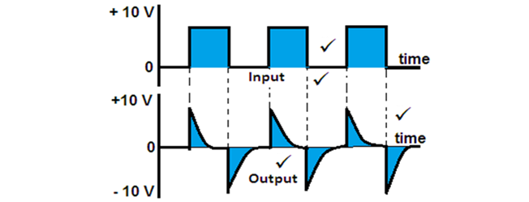

1.11 Operation of an integrator.
- The op-amp’s inputs draw zero current so any input current is passed through to the feedback circuit. ✓
- The op-amp’s two inputs are viewed as both possessing the same voltage at all times, ✓ if the lower input is connected to ground, this introduces the virtual earth concept. ✓
- When a constant current is fed to a capacitor, it will charge at a constant fixed rate rather than exponential.✓

1.12 A circuit diagram of an op-amp integrator.

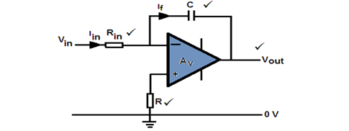

1.13 A 555 Astable multivibrator.

1.13.1 Charging time.

$Changing time=0, 693 (R_{1}+R_{2})×C$✓
$=0, 693(470×{10}^{3}+5×{10}^{3})×1×{10}^{-6}$✓
$=0, 33 sec$✓

1.13.2 Discharging time.

$Discharging time=0, 693 × R_{1}×C$
$=0, 693×5×{10}^{3}×1×{10}^{-6}$✓
$=3, 47milli seconds$✓

1.13.3 Time to complete one cycle.

$T= t_{1}+t_{2}$✓
$= 0, 33+ 3, 47×{10}^{-3}$✓
$=0, 33 sec$✓
1.13.4 Frequency of oscillation.

$f= \frac{1}{T}= \frac{1, 44}{(R_{1}- 2R_{2})×C}$✓

$=$ $\frac{1, 44}{(470×{10}^{3}×+2×5×{10}^{3})×1×{10}^{-6}}$✓

$= 3Hz$✓

