Province of the
EASTERN CAPE
EDUCATION

DIRECTORATE SENIOR CURRICULUM MANAGEMENT (SEN-FET)
HOME SCHOOLING SELF-STUDY WORKSHEET ANSWER SHEET
SUBJECT | ELECTRONICS | GRADE | 12 | DATE | JUNE 2020
TOPIC | SWITCHING CIRCUITS | TERM 1  REVISION | (Please tick) | TERM 2 CONTENT | (√ )

QUESTION 1
1.1 Multivibrator
1.1.1 Mono-stable multivibrator
1.1.2 TWO characteristics of this multivibrator.
- It has ONE input.
- It has ONE stable state.
1.1.3 Function of the network C2 and R2.
- The RC network in this circuit is the timing component of this circuit.
- The values of the resistor and the capacitor. determine for how long the circuit will be in the HIGH ✓state before it reverts back to its stable LOW state.
1.1.4 THREE ways to change this circuit in order to have a variable time in the high state.
- By changing R2 from a fixed resistor value to a variable resistor.
- By changing the value of C2 from a fixed value capacitor to a variable capacitor ✓
- By changing both R2 and C2 from fixed values ✓ to variable values ✓
1.1.5 Operating principle:
- When the circuit is in resting condition, the negative voltage of -V_{ref} on the inverting input serves to hold this inverting input low ✓
- This will cause the Op-Amp to saturate and the output to rise to and stay at +15 V
- The capacitor, C, charges up with the top plate to + 15 V, and the bottom plate to 0 V

- When the capacitor is charged, no current flows through R as there is no voltage over it. This holds the non-inverting input at 0 V.
- A positive trigger pulse larger than Vref applied to the inverting input terminal will raise the inverting input potential above the 0 V of the non-inverting input.

- The Op-Amp will now saturate and the output will go to -15 V.

- The capacitor will now immediately start discharging through the resistor R_{f.}

- The lower plate of the capacitor rises to 0 V and when the voltage is less negative than Vref, the output changes to +15 V again

1.1.6 Debouncing.

1.2 Multivibrator

1.2.1 At one end the potentiometer will be connected to 0 Ω. ✓ R1 will prevent the full supply flowing to pin 6 and 7, when the potentiometer is in the 0 Ω position

1.2.2 By changing the value of C1 ✓
By changing the value of R3 ✓

1.2.3 The time period will increase ✓

1.3 A fully labelled circuit diagram of an Op-Amp Astable multivibrator circuit.

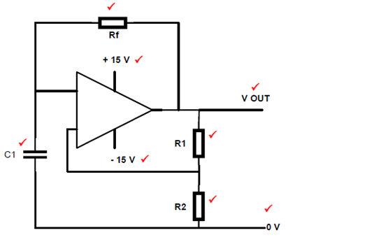

1.4 A fully labelled hysteresis characteristic curve

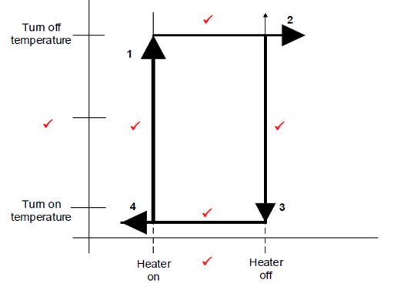

1.5 The time lag (delay) between cause ✓ and effect ✓

1.6 TWO applications of the Schmitt trigger.

- First stage of many radio receivers to clean up noise ✓
- To eliminate switch bounce in digital circuits ✓
- Varying input waveforms, for instance sine wave changed into square wave or rectangular wave
- Signal recovery after experiencing severe distortion

(Any 2)

4.7 A labelled circuit diagram of a temperature sensor circuit.

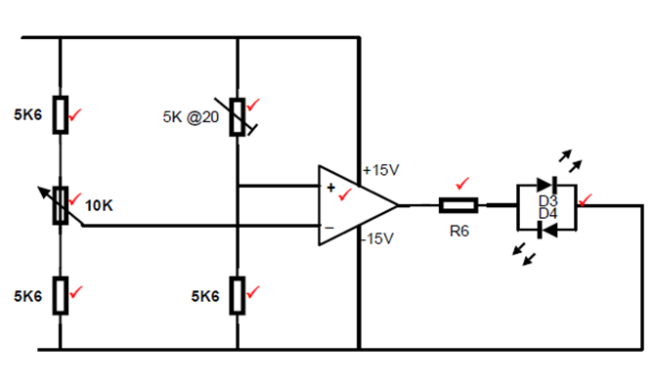

4.8 A summing amplifier with THREE inputs.

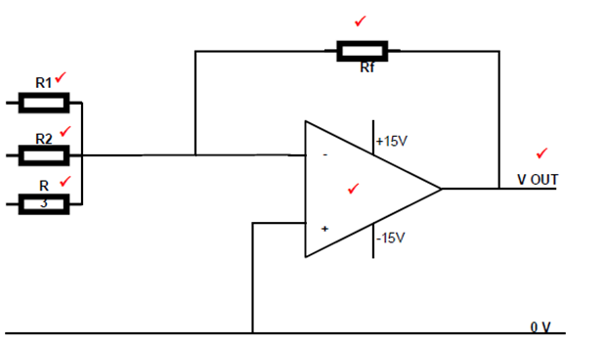

1.9 A summing amplifier has three input resistors with the following values:

