MARITIME ECONOMICS NOTES FOR GRADE 10, 11 & 12
PORT ECONOMICS
Port is a commercial harbour designed and organized for commercial use. They are also gate ways between sea and land.
Their main purpose is to interchange cargoes and passengers.
A harbour is the place where a vessel can shelter for protection against unfavorable weather conditions and can undergo repairs or food provisions.
Types of harbour
1. Natural - these types of harbour does not require any artificial aid. i.e. Sydney harbor
2. Artificial harbour - they are man made harbors breakwater ways dry dock, berths, quay and wharf.
Functions of ports
- traditional
- transport and transit
- industrial
- network
- supply chain

FUNCTION | Characteristics
- Traditional | Act as a link in the transport chain (trucks , rail, vessels)  They provide storage facilities for goods until they are transported to their destination.
2. Transport | The goods stored in ports are then loaded in various types of transport trucks, vessels barges  This characterized by the mode of transport used
3. Industrial | This will be mainly referred to the ports that are bulk oriented. Involves processing of raw materials.  They are linked with cargo owners
4. Network | These are hub and spoke ports. They main focus is the container trade.  Used by vessels from different routes either to load or discharge hence becoming the centre of distribution.

Factors influencing Trade
PESTEL
Political Factors
Economic Factors
Social factors
Technological factors
Environmental factors
Legal factors (laws and regulations)
ECONOMIES OF SCALE
An economy of scale occurs when the firm’s cost per unit decreases as more products are produced. This mainly applies to manufacturing firms that obtain advantage from large scale production.
It can be demonstrated by assuming that a firm must incur some large fixed costs in equipment in order to start producing but can thereafter produce at a constant marginal cost.

Graph
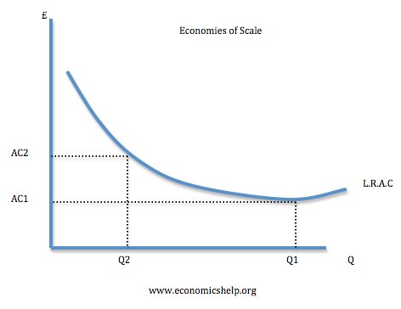
AC – Average Cost
Demand and supply
Supply and demand are fundamental concepts in economics.
Demand can be addressed as the need or want for goods and services, while maintaining the ability to purchase or acquire them.
Supply represents how much the market can offer or providing the goods or services in demand.
LAW OF DEMAND
It states that all other factors being equal, as the price of goods or services increases, the consumer demand for such goods or services decreases. (Vise versa).
The quantity demanded is inversely proportional to the price of the goods.

Graph
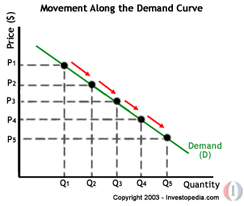
The law of supply
The law of supply states that all other factors being equal, as the quantity supplied increases, the cost of goods or services supplied will increase, (vise versa).
The quantity of goods or services supplied is directly proportional to the cost of goods or services supplied.

Graph – Showing the Supply Curve

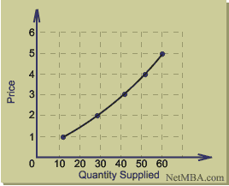

Equilibrium price
This is the point where the demand and supply meets / are equal. At this point we assume that the consumer (buyer) and supplier (seller) are happy with the price and quantity.
- If the quantity supplied is greater than the quantity demanded the price will fall over. Thus, that point is referred to as a surplus
- If the quantity demanded is greater than the quantity supplied then the price will increase. This is known as shortage
- If the quantity demanded is equal to the quantity supplied then the price will remain stable for a period. This is known as the equal Librium price.

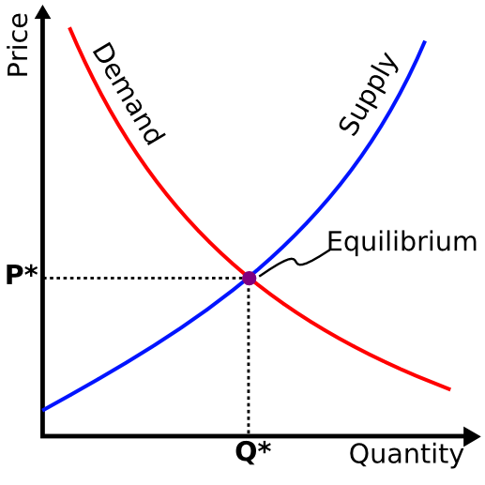

ABSOLUTE AND COMPARATIVE ADVANTAGE
Where one country or firm has no other choice but to import the goods demanded due to lack of resources to produce the goods demanded. Goods like Oranges in Spain and SA, Yams from Ghana, some countries have no choice but to import such goods when demanded. The countries supplying those goods have the Absolute advantage.

When dealing with different types of goods or services and considering the cost of production, one would prefer to purchase than to produce. A Country, firm or a person has a Comparative advantage at producing something if he can produce it at lower cost than anyone else. Concept in economics that a country should specialize in producing and exporting only those goods and services which it can produce more efficiently (at lower opportunity cost) than other goods and services (which it should import). Comparative advantage results from different endowments of the factors of production (capital, land, labor) entrepreneurial skill, power resources, technology, etc. It therefore follows that free trade is beneficial to all countries, because each can gain if it specializes according to its comparative advantage.
Imports: Goods or services that were produced abroad.
Exports: Goods or services produced locally and sold abroad.
If you are planning to bring controlled goods, used goods, second-hand goods, waste or scrap into the country, you first need to register as an importer with the South African Revenue Service (SARS) and then apply to the International Trade Administration Commission (ITAC) for an import permit. Same procedure applies to exporting of goods.
An import permit ensures that the goods you intend importing, conform to the safety, quality, environmental and health requirements of the country. They must also comply with the provisions of international agreements.
Import permits also help to control the inflow of goods of a strategic nature or smuggled goods. The policy that applies to the importation of goods differs from one sector to another. Most new goods are exempt from import control measures.
Not all goods are subject to import control. However, all used goods, second-hand goods, waste and scrap are subject to import control measures.

