Province of the
EASTERN CAPE
EDUCATION

DIRECTORATE SENIOR CURRICULUM MANAGEMENT
(SEN-FET)
HOME SCHOOLING SELF-STUDY WORKSHEET ANSWER SHEET
SUBJECT | LIFE SCIENCES | GRADE | 12 | DATE | 28 May 2020
TOPIC | Pupillary Mechanism & Accommodation | TERM 1  REVISION |  | TERM 2 CONTENT

QUESTION 1
    - B

    - C (2 × 2) = 4
QUESTION 2

2.1 2.1.1 A (1)
2.1.2 2 (1)
2.1.3 - The ciliary muscle contracts and moves closer to the lens
- the ciliary body moves forward
- the tension on the suspensory ligament decreases and
- the tension on the lens is released
- the elastic lens now bulges and becomes more convex
- the refractive power of the lens is increased
- a clear image of the object is now formed on the retina . (Any 4)(4)
[6]
QUESTION 3

3.1 3.1.1 The further from the light source, the wider the diameter of the pupil.

OR

As the light intensity increases/decreases the diameter of the
pupil increases/decreases. (2)

3.1.2 - Position of the face/person
- The intensity of light
- Time allocated for the light source at each distance
(Any 2) (2)
3.1.3 (a) Independent factor – The position of the lamp/light source
(b) Dependent factor – Diameter of the pupil (2)

3.1.4 Accept. /Reject (Mark the response in correspondence with
hypothesis given by the learner in QUESTION 3.1.1) (1)

3.1.5 The size (diameter) of the pupil increases when the light intensity decreases.

OR

The further from the light source, the wider the diameter of the pupil

OR

The closer the right source, the diameter of the pupil becomes smaller
(2)

3.1.6 - The circular muscles will relax while the radial muscles
contract.
- As a result the diameter of the pupil will increase/dilate.
(Max 4) (4)

3.1.7 Pupillary mechanism (1)

3.1.8
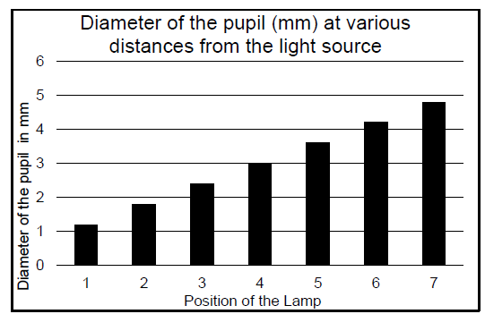
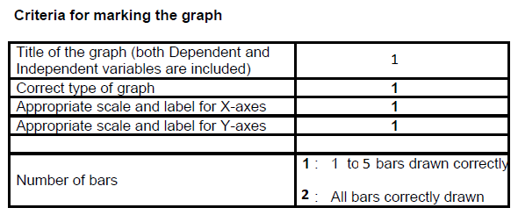
(6)
[20]
TOTAL: 30

