Province of the
EASTERN CAPE
EDUCATION

DIRECTORATE SENIOR CURRICULUM MANAGEMENT (SEN-FET)
HOME SCHOOLING SELF-STUDY WORKSHEET
SUBJECT | LIFE SCIENCES | GRADE |  | DATE | 29 MAY 2020
TOPIC | RESPONDING TO THE ENVRIONMENT: (HUMAN EYE)  (EYE DEFECTS) | TERM 1  REVISION |  | TERM 2 CONTENT

QUESTION 1: MULTIPLE CHOICE QUESTIONS
Various options are provided as possible answers to the following questions. Choose the answer and write only the letter (A to D) next to the question numbers (1.1 to 1.4) in the ANSWER BOOK e.g. 1.3 D.

1.1 Some people cannot see distant objects clearly without spectacles. This defect is called
A. Accommodation
B. Stress
C. Farsightedness
D. Nearsightedness

1.2 The inability of the eye to see the image of the objects is called
A. Defect of vision
B. Near point
C. Far point
D. Accommodation

1.1.3 The disability of the eye to form distinct images of nearby objects on its retina is known as
A. Short sightedness
B. Long sightedness
C. Stress
D. Accommodation

1.4 Myopia and hypermetropia can be corrected by
A. Concave and plano-convex lens
B. Concave and convex lens
C. Convex and concave lens
D. Plano-concave lens for both defects. (4 x 2)
[ 8]
QUESTION 2
Study the following diagrams showing visual defects and answer the questions that follow.
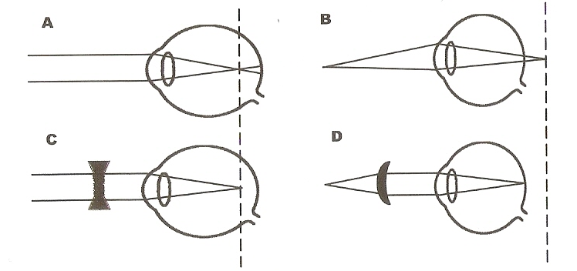

2.1 Which diagram (A or B) illustrates
(a) short-sightedness (1)
(b) long –sightedness (1)

2.2 Compare short-sightedness and long-sightedness by completing the table below. (8)

 | Short sightedness | Long sightedness
Shape of eyeball
Focal point on retina for nearby objects
Corrective type of lens
Corrective corneal laser surgery

2.3 What type of lenses will be used to correct your visual defect if you can:
  - Read the road signs clearly, but not the road map on your lap? (1)
  - Do fine needlework, but cannot read the number plate of the car ahead of you? (1)
QUESTION 3
A class of 40 Grade 12 learners’ boys and girls, were tested for eye defects. The results are shown below.
 | SHORT SIGHTEDNESS | LONG SIGHTEDNESS | ASTIGMATISM | CATARACTS | NONE
BOYS | 4 | 3 | 3 | 0 | 10
GIRLS | 3 | 1 | 2 | 0 | 8

3.1 Which eye defect is the most common? (1)
3.2 Mention 2 ways in which this defect may be corrected. (2)
3.3 Draw a bar graph for boys and girls on the same set of axes to show the number of learners with the different visual defects. (7)
3.4 What is a cataract? (2)
3.5 What is a lens mainly made up of? (2)
3.6 Mention a possible reason why none of the learners in the table have cataracts. (2)
Question 4
In astigmatism name:
4.1 The two types of this defect. (2)
4.2 Name 3 possible causes of astigmatism. (3)
4.3 Mention 2 ways in which Astigmatism may be corrected. (2)
QUESTION 5
Matisimela is taking his learner’s driving test. He has to take an eye test and he needs to read the letters on the eye chart. Matisimela is only able to read the top two lines. The lady conducting the eye test tells him that he is probably short sighted and will need to get prescription spectacles for driving.
5.1 What does short sighted mean? (2)
5.2 Why would it be dangerous for Matisimela to drive without glasses? (2)
5.3 Name TWO possible problems Matisimela could have with his eyes that would result in him being short-sighted. (2)
5.4 What shape will the lenses be which the optometrist may prescribe. (1)

Activities adapted from:
- Clitheroe, F. Dempster, E. Doidge, M. Marsden, S. Singleton, N. Van Arde, I. (2013). Focus on Life Sciences Grade 12. Maskew Miller Longman.
- Isaac, T. Chetty, S. Manganye, H.T. Mpondwana, N.L. White, L. (2013). Understanding Life Sciences Grade 12. Pulse Education Services.
- Mouton,G. Cilliers, J. Myburgh, A. Van der Berg, E. Steyn,H. (2010) Life Sciences. Future Managers (Pty) Ltd.
- Gerber, J. and J. Goliath. Material adapted from Learner Tutoring Resource & Answer series (2014)
- Grogan, J. and Suter, R. (2015). Mind Action Series Life Sciences Textbook and Workbook.

