

**GRADE 1 WORKSHEET**

**Week 1 31-04 September 2020**

**Name _______________________________________**

**Grade -------------------------------------------------**

**Date ----------------------------------------------------------------------**

Look at the picture and talk to a friend about what is happening in the picture. Then, answer questions that follow.



1. Name the tansport people use to go to town.
2. Which transport is th slowest and wich I the fastest?
3. Which transport would you like to use?
4. Where would you like to go?

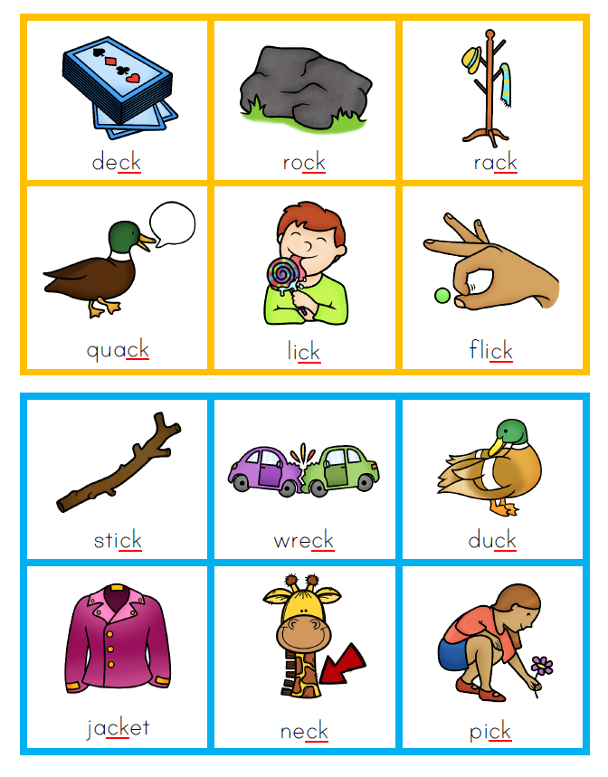

|  |  |  |  |  |
| --- | --- | --- | --- | --- |
|  | s | o | ck | sock |
|  | s | i | ck |  |
|  | k | i | ck |  |
|  | n | e | ck |  |
|  | cl | o | ck |  |
|  | d | u | ck |  |
|  | br | i | ck |  |

3. Write the full words at the end of each row. The first one has been completed for you.

4. Writing

Look at the picture and talk to your friend about where you want to go.



Draw yourself in a transport you want to go with. Complete the sentence below.

|  |
| --- |
|  |

I want to go to--------.

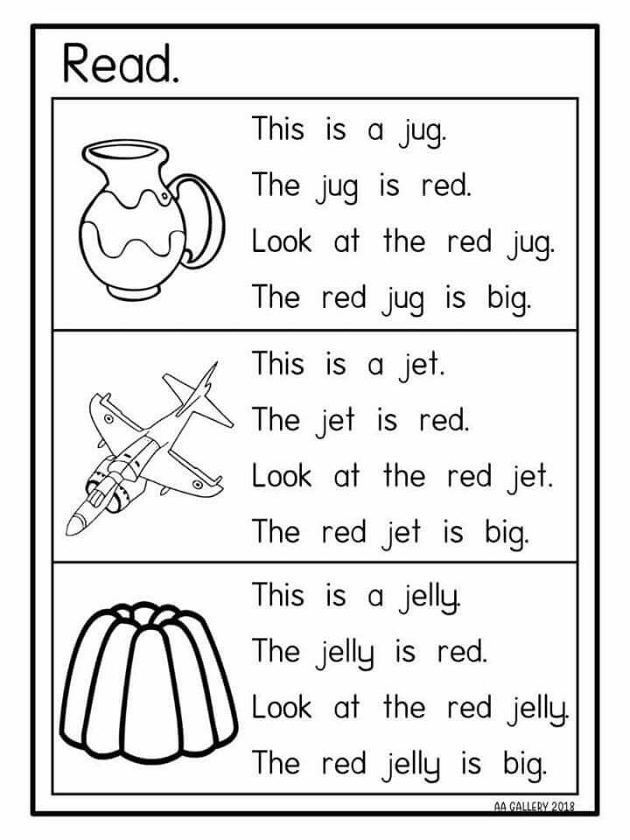

Vocabulary words list

|  |  |  |  |  |
| --- | --- | --- | --- | --- |
| taxi | passenger | town | street | Bus stop |
| school | clinic | important | drive | driver |
| drove | hurry | petrol | full | empty |
| petrol | Full | empty | station | walk |
| foot | path | sidewalk | around | all |

Phonics word list

|  |  |  |  |
| --- | --- | --- | --- |
| sack | sick | sock | back |
| lack | lock | lick | pack |
| brick | Jack | chick | neck |
| bucket | jacket | kick | rock |
| rocket | knock | duck | truck |
| clock | brick | block | flock |
| shack | pick | luck | check |

/28