GRADE: 1 MATHEMATICS Name: ____________________

Date: 18 to 22 May 2020

TIME ALLOCATION (1 hour)  - 5 minutes for counting each day  - 10 minutes for mental mathematics each day.  - 45 minutes for concept of the day. | TERM 2 CONTENT
TIPS TO PARENT  - Use worksheets below  - Use DBE workbook  - Use relevant real objects from home with caution.  - Use correct mathematical language as indicated in the worksheets and DBE Workbook.  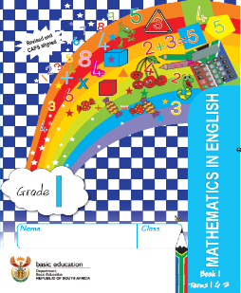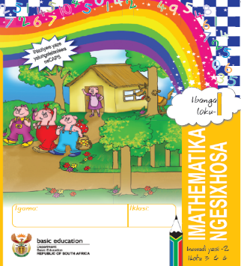 | TIPS TO KEEP HEALTHY  1. WASH YOUR HANDS thoroughly with soap and warm water for at least 20 seconds. Alternatively, use hand sanitizer with an alcohol content of at least 60%.  2. PRACTICE SOCIAL DISTANCING keep a distance of 1m away from other people.  3. PRACTISE GOOD RESPIRATORY HYGIENE: cough or sneeze into your elbow or tissue and dispose the tissue immediately after use.  4. TRY NOT TO TOUCH YOUR FACE. The virus can be transferred from your hands to your nose, mouth and eyes. It can then enter your body and make you sick.  5. STAY AT HOME.  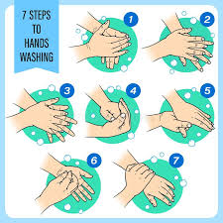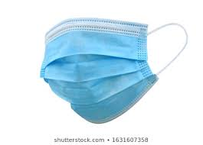

Day 1 and 2 ADDITION AND SUBTRACTION
Activity 1 Counting
Count real objects up to 20 (use any objects from home like beans, stones, bottle tops etc.)
Count forwards in 1s and 2s from 0 to 50
Count backwards in 1s and 2s from 50 to 0
Activity 2 (a) Mental Mathematics
What is | Answer
- 7 less than 7?
- 3 less than 5?
- 1 less than 9?
- 0 more 1?
- 4 more than 1?

Activity 2 (b) Mental Mathematics
Fill in less than or more than
- 4 is_____ 7
- 5 is ____ 6
- 9 is ____ 3
- 0 is____ 10
- 10 is ____ 4

Activity 3
Match the numbers that total up to the given number on top
6  2 0  3 6  5 3  1 1  6 5  4 2  0 4 | 8  2 8  5 5  1 4  7 7  4 3  6 6  8 2  0 1  3 0

Activity 4
Use colours to show the following
0 0 0 0 0 0 0 0 0 0 2 + 8 = _____
0 0 0 0 0 0 0 0 0 0 6 + 4 = _____
0 0 0 0 0 0 0 0 0 0 10 - 5 = _____
0 0 0 0 0 0 0 0 0 0 10 - 9 = ______
0 0 0 0 0 0 0 0 0 0 4 + 6 = ______

Activity 5
Read the word problems below and solve
- Zuko has 4 oranges. Rob has 5 oranges. How many oranges are there altogether?
Show your calculations in the box

- Puma has 3 bananas. Saul gave him 5 more. How many bananas less does Puma have than Saul?
Show your calculations in the box below

- Lulu had 8 scones. She gave some to her friends and was left with 3 scones. How many scones did she give away?
Show your calculations in the box below

Activity 6
DBE Workbook pages 96 and 97

Day 3 DOUBLING AND HALVING
Activity 1 Counting
Count real objects up to 20 (use any objects from home like beans, stones, bottle tops etc.)
Count forwards in 1s and 2s from 0 to 50
Count backwards in 1s and 2s from 50 to 0
Count in 2s from 36 to 16
Activity 2 (a)
Mental Mathematics
What is the number between the two given numbers?
- 2 and 4
- 5 and 5
- 8 and 10
- 6 and 8
- 5 and 7

- 7 and 9

Activity 2 (b) Mental Mathematics
Think of any number, write it down.
- What is 2 more than your number?
- What is 2 less than your number?
- Add 4 to your number
- Subtract 3 from your number
- Add the same number to your number.

Activity 3
Answer the questions in the table:
How many girls do you see?  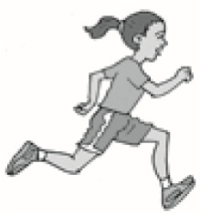 | How many girls do you see now?  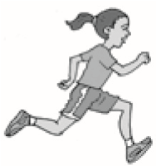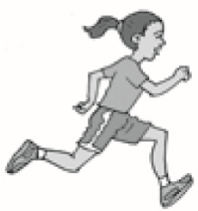Double 1 is 2.  What will half of 2 be? | How many feet do you see? | How many feet do you see now?  We say double 2 is 4.  What will half of 4 be?
How many wheels do you see?  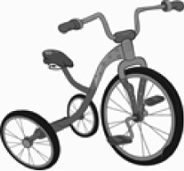  see? | How many wheels do you see?  We say double 3 is _____  What will half of 6 be? | How many legs are there?  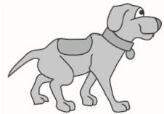 | How many legs do you see now?  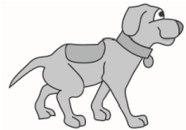  We say double 4 is _____.  What will half of 8 be?

Activity 4
DBE workbook pages 96 and 97

Day 4 COLLECTING AND ORGANISING DATA
Activity 1 Counting
Count real objects up to 20 (use any objects from home like beans, stones, bottle tops etc.)
Count forwards in 1s and 2s from 0 to 50
Count backwards in 1s and 2s from 50 to 0
Count in 2s from 50 to 18

Activity 2 Mental Mathematics

 | What is? | Answer |  |  | What is? | Answer
1. | 1 less than 9? |  |  | 6. | 6 more than 4?
2. | 2 less than 10? |  |  | 7. | 2 more than 1?
3. | 3 less than 4? |  |  | 8. | 5 more than 3?
4. | 8 less than 10? |  |  | 9. | 0 more than 2?
5. | 0 less than 1? |  |  | 10. | 1 more than 6?

Activity 3 COLLECTING AND ORGANISING DATA

Sort the above objects as indicated in the table below

- How many objects altogether? ___________
- How many red objects? _______________
- Which colour has the least? ____________
Activity 4
DBE Workbook pages 92 and 93

DAY 5 2- D shapes
Activity 1 Counting
Count real objects up to 20 (use any objects from home like beans, stones, bottle tops etc.)
Count forwards in 1s, 2s and 10s from 0 to 50
Count backwards in 1s, 2s and 10s from 50 to 0
Activity 2 Mental Mathematics
What is: 1 less than 2? ________________
1 more than 8? ______________
Half of 4? _______________
Double 2? ________________
Lebo has 7 hats, Sethu has 3 hats. How many hats are there altogether?

Activity 3 Colour the big shapes red, small shapes blue
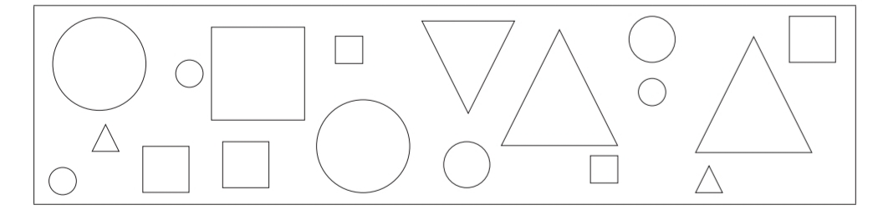

Activity 4 Names of 2-D shapes

Triangle Square Circle

- A square has ________ sides
- A circle has _________ sides
- A triangle has ________ sides

Activity 5
Colour all squares red, circles yellow and triangles blue

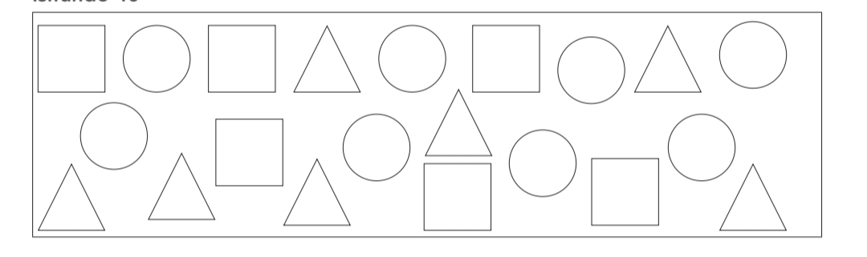

Activity 6
DBE Workbook pages 100- 103

