GRADE: 1 MATHEMATICS Name: ____________________

Date: 25 to 29 May 2020

TIME ALLOCATION (1 hour)  - 5 minutes for counting each day  - 10 minutes for mental mathematics each day.  - 45 minutes for concept of the day. | TERM 2 CONTENT
TIPS TO PARENT  - Use worksheets below  - Use DBE workbook  - Use relevant real objects from home with caution.  - Use correct mathematical language as indicated in the worksheets and DBE Workbook.  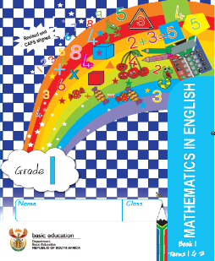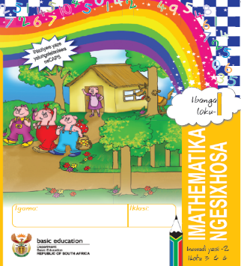 | TIPS TO KEEP HEALTHY  1. WASH YOUR HANDS thoroughly with soap and warm water for at least 20 seconds. Alternatively, use hand sanitizer with an alcohol content of at least 60%.  2. PRACTICE SOCIAL DISTANCING keep a distance of 1m away from other people.  3. PRACTISE GOOD RESPIRATORY HYGIENE: cough or sneeze into your elbow or tissue and dispose the tissue immediately after use.  4. TRY NOT TO TOUCH YOUR FACE. The virus can be transferred from your hands to your nose, mouth and eyes. It can then enter your body and make you sick.  5. STAY AT HOME.  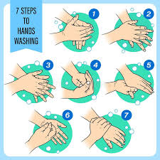

Day 1 2s PATTERN
Activity 1 Counting
Count real objects up to 20 (use any objects from home like beans, stones, bottle tops etc.)
Count forwards 2s from 0 to 50
Count backwards 2s from any number between 50 to 0
Activity 2 (a) Mental Mathematics
Double | Answer
- 2
- 4
- 3
- 0
- 5

Activity 2 (b) Mental Mathematics

Half of | Answer
- 6
- 4
- 10
- 2
- 8

Activity 3
Look at the following number board and answer the accompanying questions.
1 | 2 | 3 | 4 | 5 | 6 | 7 | 8 | 9 | 10
11 | 12 | 13 | 14 | 15 | 16 | 17 | 18 | 19 | 20

1. Complete the pattern by colouring the multiples of 2
2. Fill in the omitted numbers in a pattern
4, 6, ____, ____, 12, _____, ____, 18, 20.
Activity 4
Looking at the hops on the following number lines, write the pattern represented

a)

6 8 10 12 14
Counting forwards in __________ from _________ to ____________
b)

10 12 14 16 18 20
Counting forwards in _______ from __________ to ______________

Activity 5
DBE Workbook pages 108 and 109

Day 2 GROUPS OF 2
Activity 1 Counting
Count real objects up to 20 (use any objects from home like beans, stones, bottle tops etc.)
Count forwards 2s from 0 to 50
Count backwards 2s from any number between 50 to 0
Activity 2 Mental Mathematics

 | What is? | Answer |  |  | Add 2 | Answer
1. | 2 more than 7? |  |  | 6. | 9
2. | 7 more than 7? |  |  | 7. | 6
3. | 9 more than 1? |  |  | 8. | 5
4. | More than 8? |  |  | 9. | 10
5. | 5 more than 1? |  |  | 10. | 8

Activity 3
Look at picture below and answer questions that follow
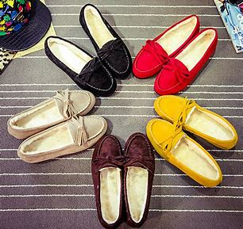
- How many shoes are there? Count in twos. _____________________
- Write the number sentence ____________________________________
- How many groups of 2? _____________________________________

Activity 4
I have 3 groups of 2 cupcakes on a tray, how many cupcakes are there altogether? ____________________________________

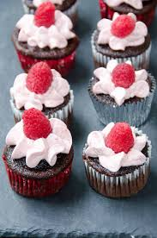

Activity 5
Draw circles around the stars to make 4 groups of 2

Day 3 SOUTH AFRICAN COINS
Activity 1 Counting
Count real objects up to 20 (use any objects from home like beans, stones, bottle tops etc.)
Count forwards 2s from 0 to 50
Count backwards 2s from any number between 50 to 0

Activity 2 Mental Mathematics
Give the number between (when counting in 2s)
- 13 and 17
- 9 and 13
- 10 and 14
- 8 and 12
- 2 and 6
- 13 and 15
- 15 and 13
- 10 and 6
- 11 and 7
- 20 and 16

Activity 3
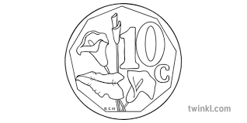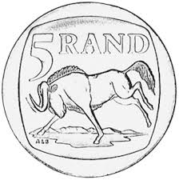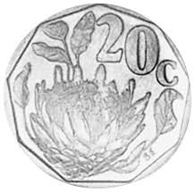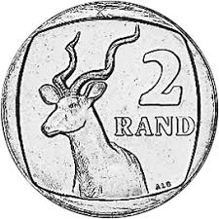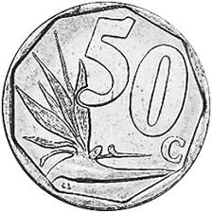

- Colour all 10c coins blue.
- Colour all 50c coins red.
- Colour all 20c coins yellow.
- Colour all R2 coins green.
- Colour all R1 coins orange.
- Which coins can make up R3? (Show 3 different ways) ______________________________________________
Activity 4
DBE Workbook pages 126 to 129

Day 4 and 5 ADDITION USING COINS
Activity 1 Counting
Count real objects up to 20 (use any objects from home like beans, stones, bottle tops etc.)
Count forwards 2s from 0 to 50
Count backwards 2s from any number between 50 to 0
Activity 2 Mental Mathematics
What number is (counting in 1s)
- After 7? _____
- After 14? _____
- After 10? _____
- After 13? _____
- After 8? ______
Order these numbers from the smallest to the biggest
- 9 ,14 ,7,16, 17 _________________________
- 15,18, 9,13 ,8 __________________________
- 10 ,14 ,5 ,13 ,11 ________________________
- 12 ,18 ,20 ,9 ,15 ________________________
- 6,14 ,17 ,8 ,13 __________________________

Activity 3
Look at the picture below and answer the questions that follow
Watermelon Mango
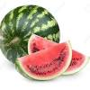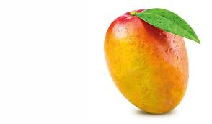

Apple
Banana
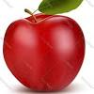
(each)
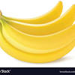

Orange
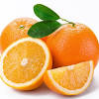(each)
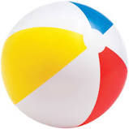(each)

- How much is 1 banana? _________________________
- How much will you pay for 3 Bananas? _____________________
- If you buy an Apple, Mango and a Banana, how much will you pay? __________________________________________________
- Look at the items above and select two items you can buy for
- R3 _________________________________
- R1.50 _______________________________
- 60c _________________________________

- Which 2 items cost the same amount? ________________________
- Sibeko bought 2 Bananas an Orange and an Apple, how much is he going to pay? Show your calculations

Activity 4

From the picture above:
- Choose 3 different coins that make up R2.
- Choose 4 different coins that make up R1.50.
- Which 4 coins can add up to R4? _________________________
- Breakdown R5 into 3 different ways. ____________________________________________________
- Add up all the 10c, 20c, 50c, R1 and R2 coins from the picture. _____________________________________________

