**GRADE: 2 MATHEMATICS Name: ____________________**

**Date: 15 to 19 June 2020**

|  |  |
| --- | --- |
| **TIME ALLOCATION (1 hour)**   * **5** minutes for counting each day * **10** minutes for mental mathematics each day. * **45** minutes for concept of the day. | **TERM 2 CONTENT** |
| **TIPS TO PARENT**   * Use worksheets below * Use DBE workbook * Use relevant real objects from home with caution. * Use correct mathematical language as indicated in the worksheets and DBE Workbook.     Maths: DBE LEARNER WORKBOOK English Grade 2 Book 2 | WCED ePortal | **TIPS TO KEEP HEALTHY**  1. **WASH YOUR HANDS** thoroughly with soap and warm water for at least 20 seconds. Alternatively, use hand sanitizer with an alcohol content of at least 60%.  2. **PRACTICE SOCIAL DISTANCING** keep a distance of 1m away from other people.  3. **PRACTISE GOOD RESPIRATORY HYGIENE**: cough or sneeze into your elbow or tissue and dispose the tissue immediately after use.  4. **TRY NOT TO TOUCH YOUR FACE.** The virus can be transferred from your hands to your nose, mouth and eyes. It can then enter your body and make you sick.  5. **STAY AT HOME.**  Cartoon Washing Hands Stock Illustrations – 1,188 Cartoon Washing ... **C:\Users\School EC\AppData\Local\Microsoft\Windows\INetCache\Content.MSO\82EAADC.tmp** |

**Day 1**

**Fractions**

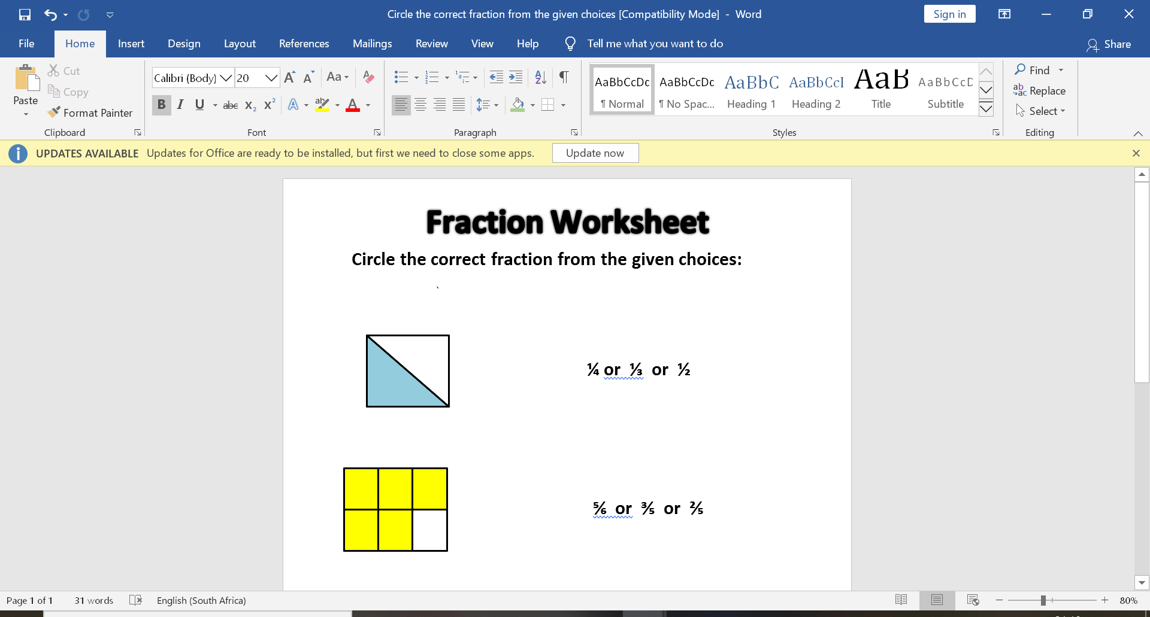

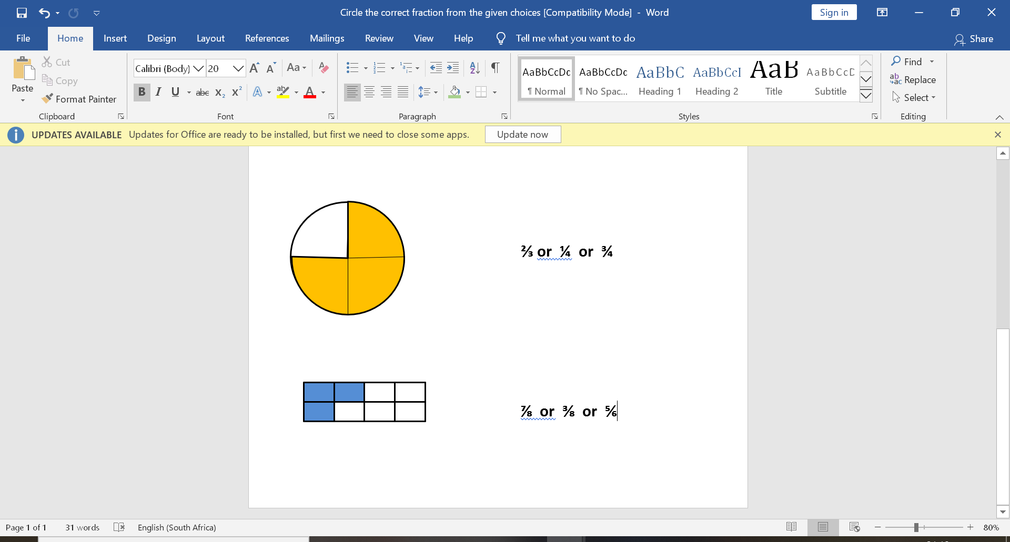



**Activity 1: Counting (orally)**

**Count forwards in 4’s from 20 to 100.**

**Count forwards and backwards in 3s between 0 and 99**

**Count forwards and backwards in 2s, 5s and 10s between 0 and 150.**

**Activity 2: Mental Mathematics**

|  |  |  |  |  |
| --- | --- | --- | --- | --- |
|  | Double |  |  | **Half of:** |
| 1. | 14 = | 6. | 30= |
| 2. | 10 = | 7. | 20= |
| 3. | 16= | 8. | 16= |
| 4. | 15= | 9. | 8 = |
| 5. | 7= | 10. | 12 = |

**Activity 3**

|  |  |
| --- | --- |
| **Fraction** | **Drawing to show the fraction** |
| **1 whole** |  |
| **1 half** |  |
| **1 quarter** |  |
| **1 third** |  |

**Activity 4:**

**Use bigger than, less than and equal to**

* **1 half is ____ 1 whole**
* **1 quarter is _____ 1 half**
* **2 quarters are ____ 1 half**
* **2 halves are _____ 1 whole**
* **2 halves are _____ 3 quarters**

**Activity 5:**

**Let us solve fraction problems:**

Miles, Hannah, Mathew and Ndaweni share 5 fruit bars. How can they share them equally? Draw a picture to show your answer. (One and one quarter.)

* **How many people? (4)**
* **How many fruit bars to share? (5)**
* **Give each person 1 fruit bar, how many fruit bars are left? (1 fruit bar)**
* **Share it among 4 people (cut it to have 4 equal parts: quarters)**
* **How many will each get? (1 and a quarter fruit bar)**

**For you to do:**

1. I have 6 biscuits and I want to share them among 3 learners. What fraction of the biscuits will each learner get? How many biscuits will each of them get? Use drawings if necessary

|  |
| --- |
|  |

1. I have 2 small cakes to share among 3 friends. What fraction of the cakes will each learner get? How many cakes will each of them get?

|  |
| --- |
|  |

**Activity 6**

**DBE workbook pp. 134 and 135**

**Day 2 and 3**

**Time**

**What time is it?**

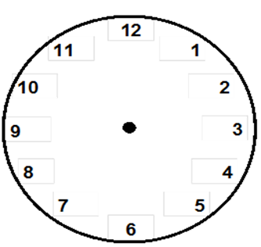

**Activity 1: Counting**

**Count forwards in 4’s from 32 to 100.**

**Count forwards and backwards in 3s between 0 and 99**

**Count forwards and backwards in 2s, 5s and 10s between 0 and 150.**

**Activity 2: Mental Mathematics**

* How many minutes are there in 1 hour?
* How many minutes are there in half an hour?
* The long arm is pointing at 12 and the short arm is pointing at 7, what time is it?

**Activity 3**

**Take note:**

***am* refers to morning**

***pm.* refers to afternoon**

1. Name two things that you can do during *am* time.

__________________________________________

1. Name two things that you can do during *pm* time

__________________________________________

**Activity 4**

1. You leave for school at half past 6 in the morning. You get to school at 7 o’clock. How long did you take to get to school?

____________________________________________________________________________________________________________

1. On Saturday your Granny comes to tea. She arrives at 10 o’clock and leaves at half past 12. How long was she at your house?

______________________________________________________________________________________________________________________

1. It is 3 o’ clock. You do your homework until half past 4. How long did you take to do your homework?

____________________________________________________________________________________________________________

**Activity 5**

**DBE Workbook pp. 116 and 117**

Day 4

Position and orientation



 





**Activity 1: Counting**

• Count forwards and backwards in 10s between 0 and 200.

**Activity 2:** **Mental Mathematics**

|  |  |  |  |  |  |  |
| --- | --- | --- | --- | --- | --- | --- |
|  | **Which is more?** | **Answer** |  |  | **Which is more?** | **Answer** |
| 1. | 12 or 15? |  | 6. | 31 or 33? |  |
| 2. | 48 or 49? |  | 7. | 14 or 41? |  |
| 3. | 3 or 14? |  | 8. | 7 or 17? |  |
| 4. | 5 or 6? |  | 9. | 0 or 1? |  |
| 5. | 21 or 40? |  | 10. | 5 or 4? |  |

**Activity 3**

Choose the correct word for the position of the ball in relation to the box

Choose from: **on top of, in front of, behind, left, right, down**





 

**Activity 4**

Use real objects at home to practice

Behind, on the left, on the right, inside

**Day 5**

**Line of symmetry**

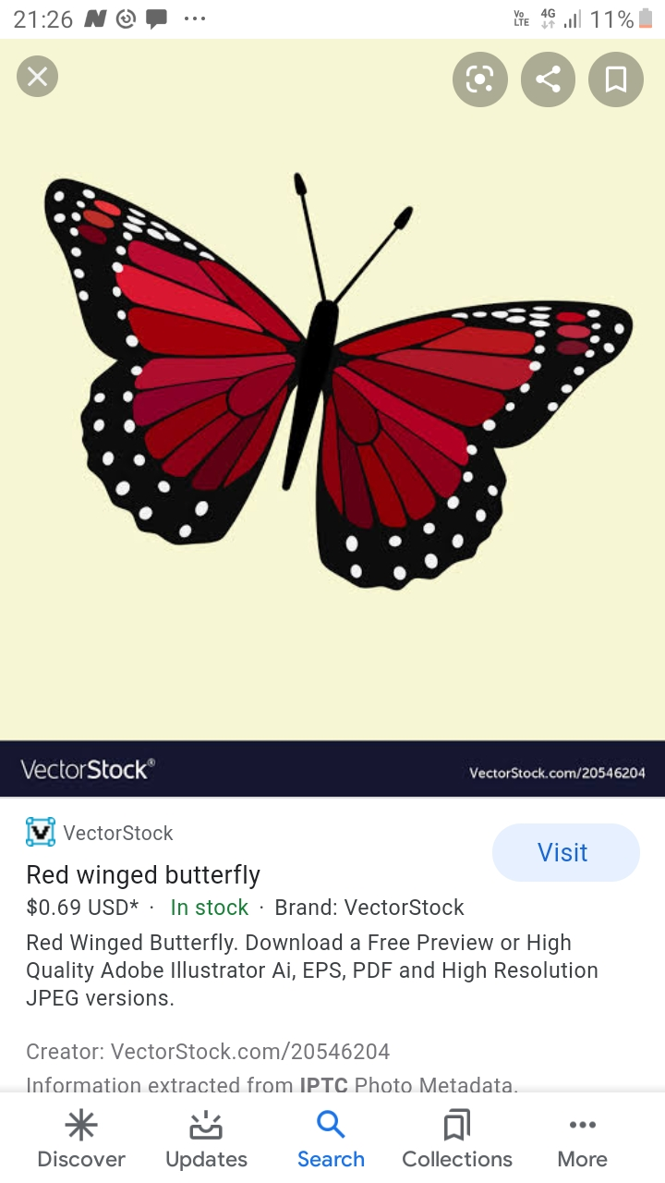

**Activity 1: Counting**

**Count forwards in 4’s from 20 to 100.**

**Count forwards and backwards in 3s between 0 and 99**

**Count forwards and backwards in 2s, 5s and 10s between 0 and 150**

**Activity 2: Mental Mathematics**

|  |  |  |  |  |  |  |
| --- | --- | --- | --- | --- | --- | --- |
|  | **Calculate:** | **Answer** |  |  | **Calculate:** | **Answer** |
| 1. | 20 - 6 = |  | 6. | 26- 5 = |  |
| 2. | 19- 4 = |  | 7. | 24 + 4 = |  |
| 3. | 14 + 4 = |  | 8. | 28 + 4 = |  |
| 4. | 15 + 2 |  | 9. | 30 + 10 |  |
| 5. | 21- 1 |  | 10. | 20- 10 = |  |

**Activity 3**

* Take a sheet of paper, fold it to have 2 halves (to have a line of symmetry)
* How many lines of symmetry can you find?
* Draw lines of symmetry in each shape below

How many lines of symmetry can you draw in each shape?

**Activity 4**

**DBE Workbook pp. 102 and 103**