**GRADE: 3 MATHEMATICS Name: ____________________**

**Date: 15 to 19 June 2020**

|  |  |
| --- | --- |
| **TIME ALLOCATION (1 hour)**   * **5** minutes for counting each day * **10** minutes for mental mathematics each day. * **45** minutes for concept of the day. | **TERM 2 CONTENT** |
| **TIPS TO PARENT**   * Use worksheets below * Use DBE workbook * Use relevant real objects from home with caution. * Use correct mathematical language as indicated in the worksheets and DBE Workbook.     Mathematics Grade 3 English Book 2 Term 3 & 4 | WCED ePortalMathematics Grade 3 Xhosa Book 1 Term 1 & 2 | WCED ePortal | **TIPS TO KEEP HEALTHY**  1. **WASH YOUR HANDS** thoroughly with soap and warm water for at least 20 seconds. Alternatively, use hand sanitizer with an alcohol content of at least 60%.  2. **PRACTICE SOCIAL DISTANCING** keep a distance of 1m away from other people.  3. **PRACTISE GOOD RESPIRATORY HYGIENE**: cough or sneeze into your elbow or tissue and dispose the tissue immediately after use.  4. **TRY NOT TO TOUCH YOUR FACE.** The virus can be transferred from your hands to your nose, mouth and eyes. It can then enter your body and make you sick.  5. **STAY AT HOME.**  Cartoon Washing Hands Stock Illustrations – 1,188 Cartoon Washing ... **C:\Users\School EC\AppData\Local\Microsoft\Windows\INetCache\Content.MSO\82EAADC.tmp** |

**Day 1**

**2s Number pattern**

6

4

2

8

10

20

**Activity 1: Counting (orally)**

**Count forwards and backwards between in 2s, 4s and 5s between 0 to 500.**

**Activity 2: Mental Mathematics**

|  |  |  |  |  |
| --- | --- | --- | --- | --- |
|  | **Calculate:** |  |  | **Calculate:** |
| 1. | __ - 2 = 22 | 6. | 34 - __ = 32 |
| 2. | __ - 2 = 50 | 7. | 16 - __ = 14 |
| 3. | __ - 2 = 17 | 8. | 34 - __ = 32 |
| 4. | __ - 2 = 9 | 9. | 23 - __ = 21 |
| 5. | - 2 = 0 | 10. | 15 - __ = 13 |

**Activity 3:**

* Use number chart **(See attachment 1).**
* Place counters on the multiples of 2, starting from the number 2 and ending at 100 (4, 8, 12, to 100).
* Place counters on the number sequence by adding 2 starting from the number 21 and ending at 99

When we think of what we just did, we will see that the first board shows the multiples of 2, the other boards show numbers sequence by adding 2.)

**Attachment 1: Number chart**

|  |  |  |  |  |  |  |  |  |  |
| --- | --- | --- | --- | --- | --- | --- | --- | --- | --- |
| 1 | 2 | 3 | 4 | 5 | 6 | 7 | 8 | 9 | 10 |
| 11 | 12 | 13 | 14 | 15 | 16 | 17 | 18 | 19 | 20 |
| 21 | 22 | 23 | 24 | 25 | 26 | 27 | 28 | 29 | 30 |
| 31 | 32 | 33 | 34 | 35 | 36 | 37 | 38 | 39 | 40 |
| 41 | 42 | 43 | 44 | 45 | 46 | 47 | 48 | 49 | 50 |
| 51 | 52 | 53 | 54 | 55 | 56 | 57 | 58 | 59 | 60 |
| 61 | 62 | 63 | 64 | 65 | 66 | 67 | 68 | 69 | 70 |
| 71 | 72 | 73 | 74 | 75 | 76 | 77 | 78 | 79 | 80 |
| 81 | 82 | 83 | 84 | 85 | 86 | 87 | 88 | 89 | 90 |
| 91 | 92 | 93 | 94 | 95 | 96 | 97 | 98 | 99 | 100 |
| 101 | 102 | 103 | 104 | 105 | 106 | 107 | 108 | 109 | 110 |
| 111 | 112 | 113 | 114 | 115 | 116 | 117 | 118 | 119 | 120 |
| 121 | 122 | 123 | 124 | 125 | 126 | 127 | 128 | 129 | 130 |
| 131 | 132 | 133 | 134 | 135 | 136 | 137 | 138 | 139 | 140 |
| 141 | 142 | 143 | 144 | 145 | 146 | 147 | 148 | 149 | 150 |

**Activity 4: Answer the questions**

* Look at this number chart and answer the following questions.

(In this chart the multiples of 2 starting from **20** to **80** are coloured in.)

|  |  |  |  |  |  |  |  |  |  |
| --- | --- | --- | --- | --- | --- | --- | --- | --- | --- |
| 1 | 2 | 3 | 4 | 5 | 6 | 7 | 8 | 9 | 10 |
| 11 | 12 | 13 | 14 | 15 | 16 | 17 | 18 | 19 | 20 |
| 21 | 22 | 23 | 24 | 25 | 26 | 27 | 28 | 29 | 30 |
| 31 | 32 | 33 | 34 | 35 | 36 | 37 | 38 | 39 | 40 |
| 41 | 42 | 43 | 44 | 45 | 46 | 47 | 48 | 49 | 50 |
| 51 | 52 | 53 | 54 | 55 | 56 | 57 | 58 | 59 | 60 |
| 61 | 62 | 63 | 64 | 65 | 66 | 67 | 68 | 69 | 70 |
| 71 | 72 | 73 | 74 | 75 | 76 | 77 | 78 | 79 | 80 |
| 81 | 82 | 83 | 84 | 85 | 86 | 87 | 88 | 89 | 90 |
| 91 | 92 | 93 | 94 | 95 | 96 | 97 | 98 | 99 | 100 |

1. How many multiples of 2 are there between 2 and 80? _____
2. Make 2s number pattern from 80 to 100 ___________________
3. Extend the pattern 41, 43, ___, ___, ___, 51.
4. Extend 482, ___, ___, ____, ____, 500
5. Extend the pattern 335, 337, ___, ___, ___, ___, 347
6. Complete the pattern 228, 226, __, ___, ___, _____.
7. Complete the pattern ___, _____, 99, 97, ____, ___, ___.

**Activity 5**

**DBE Workbook pp. 116 and 117**

**Day 2 and 3**

**Grouping and sharing**

**Activity 1: Counting**

* **Count forwards and backwards in 2s and 5s from 200 to 500 and 500 to 200**
* **Count in 10s from 351 to 401**
* **Count in 10s from 500 to 100**

**Activity 2: Mental Maths**

**How many groups of 2 in?**

* **36**
* **48**
* **60**
* **2**
* **50**

**Activity 3**

**Take note:**

**Grouping**

**We know the number of items in each group, but we do not know the number of groups. We are looking forward to find the number of groups.**

**For example:**

**Grade 3 class has 30 learners. She wants to put the leaners in groups of 2. How many groups can she make?**

**30 ¸ 2= ___**

**Sharing**

**We know the number of groups but we do not know the items in each group.**

**We are looking forward to find the number of items in each group**

**For example:**

**Grade 3 has 30 learners. She wants to share the learners equally in 2 classes. How many learners can each class have?**

**30 ¸ 2= __**

**For you to do:**

**Use any strategy to solve the following**

* **Thoko has 18 oranges. She made bunch of 2 oranges each. How many bunches of oranges did she make?**

|  |
| --- |
|  |

* **A farmer has 24 eggs. How many egg trays that take 2 eggs each does he need to pack all the eggs?**

|  |
| --- |
|  |

* **There are 50 mangoes. 2 families get mangoes equally. How many mangoes can each family get?**

|  |
| --- |
|  |

**Day 4 and 5**

**Money**

**How much?**

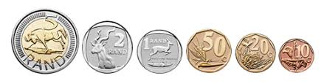

|  |
| --- |
|  |

**Activity 1: Counting**

**Count forwards and backwards in 100s between 0 and 1000**

**Count forwards and backwards in 2s, 3s, 4s, 5s, 10s between 0 and 500.**

**Activity 2: Mental Mathematics**

**Look at the collection of money below. Answer the questions that follow.**

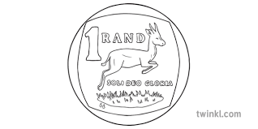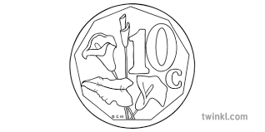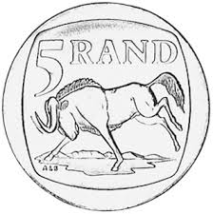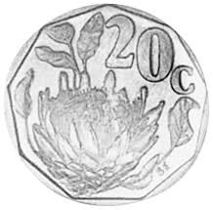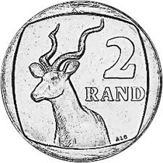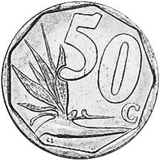

1. Add the coins, write the number sentence, what is the total? ______________________________________________
2. How much do R5 coins add up to?

_____________________________________________________

1. Take away the R2 coins, how much will the coins left add up to?

______________________________________________________

**Activity 3**

Convert the following money to rands

* 386c __________
* 1104c __________
* 509c __________
* 200c __________

Convert the following money into cents

* R2, 75
* R146, 34
* R80, 00

**Activity 4**

Give all the South African bank notes

**___________________________________________________**

**Activity 5**

* If want to buy a game that costs R60. How much should I need if I have R50?

|  |
| --- |
|  |

* My mother bought sugar for R25, 00, bread for R15 and fruit for R8, 00. How much did she pay?

|  |
| --- |
|  |

* Luvo paid with R100 for his books that costed R67, 50. How much was his change?

|  |
| --- |
|  |

* I paid with R50 for my shopping. My change was R1. How much did my shopping cost?

|  |
| --- |
|  |

**Activity 6**

**DBE Workbook pp. 126 and 127**