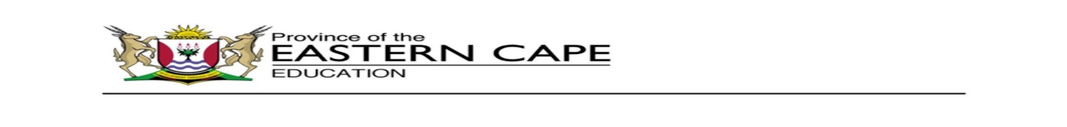

**DIRECTORATE: PRIMARY CURRICULUM MANAGEMENT**



|  |  |  |
| --- | --- | --- |
| **31 - 4 September KEREITI 3** | | |
|  |  |  |
| **Ho mamela le ho bua** | **Ati o a hlwekisa**     |  |  |  | | --- | --- | --- | | Ati le Mosi ba qoqetse titjhere ya bona ka ditshila toropong ya bona. Titjhere wa bona a ba kgothalletsa ho mema metswalle ya bona ho ba thusa. Ba ile ba etsa setshwantsho se setle se bontshang letsema la ho hlwekisa. Bana ba ile ba phallela ho tla hlwekisa. Ba ile ba thonaka dibotlolo tse tjhwatlehileng, makotikoti le dipampiri tse tabohileng. |  | **SETSHWANTSHO**  Re tlamehile ho dula bakeng se hlwekileng. Ditshila di mpe, ebile di a kudisa. Hlwekisa dinoka le moo re phomolang teng. Ha re kopanyeng matsoho ho boloka naha ya rona e hlwekile.  **Kenya letsoho letsemeng la ho hlwekisa.**  E mong le e mong o tla fumana selae sa borotho le senomaphodi.  **Neng? Ka Moqebelo mohla la 21 Hlakubele ka hora ya leshome.**  **Hokae? Kiddy Park.**  Bese e tla le kgutlisetsa malapeng ka hora ya bobedi. |  |  | | --- | | Araba dipotso tse latelang ka molomo. (orally)  1. Ke mang ya thusitseng Ati ho etsa setshwantsho?  2. Bana baba babedi ba ikemiseditseng?  3. Na ho ne ho le bohlokwa hore ba hlwekise? Hobaneng?  4. Ba qadile ho hlwekisa neng? | | DBE  Page 120 |
|  | | |
| **Medumo** | Bala mantswe ana, ho latele pitsetso.   |  | | --- | | 1. ntshaba  2. ntjheba  3. ntshosetsa  4. ntjhapa  5. ntjhesa  6. ntshosa  7. ntjhebisa  8. ntshela  9. ntshella  10. ntsheba | |  |
|  | | |
| **Mongolo** | Ngola polelo tsena ka mongolo o kopaneng:  oy oy  ntsh, ntjh  ntshweba, ntjhebisa  Mme o pheha nama. Ntate o lema masimo. | . |
|  | | |
| Ho ngola | Qetella dipolelo ka ho kenyeletsa mantswe a latelang:  **ntjhapa, ntjhebisa, ntshela, ntjhesa, ntjheba, ntshaba**  1. Hobaneng .................... hampe.  2. Itjhu se ka .................... .  3. O.................... ka metsi.  4. Dineo o re wa .................... .  5. Lerato o .................... founu yah ae.  6. Ke llile habohloko ha ntate a .................... . | . |
|  | | |
| Ho bala | **Ati oya hlwekisa**   |  |  | | --- | --- | | Ati le Mosi ba qoqetse titjhere ya bona ka ditshila toropong ya bona. Titjhere wa bona a ba kgothalletsa ho mema metswalle ya bona ho ba thusa. Ba ile ba etsa setshwantsho se setle se bontshang letsema la ho hlwekisa. Bana ba ile ba phallela ho tla hlwekisa. Ba ile ba thonaka dibotlolo tse tjhwatlehileng, makotikoti le dipampiri tse tabohileng. | **SETSHWANTSHO**  Re tlamehile ho dula bakeng se hlwekileng. Ditshila di mpe, ebile di a kudisa. Hlwekisa dinoka le moo re phomolang teng. Ha re kopanyeng matsoho ho boloka naha ya rona e hlwekile.  **Kenya letsoho letsemeng la ho hlwekisa.**  E mong le e mong o tla fumana selae sa borotho le senomaphodi.  **Neng? Ka Moqebelo mohla la 21 Hlakubele ka hora ya leshome.**  **Hokae? Kiddy Park.**  Bese e tla le kgutlisetsa malapeng ka hora ya bobedi. | |  |