**GRADE: 3 MATHEMATICS Name: ____________________**

**Date: 25 to 29 May 2020**

|  |  |
| --- | --- |
| **TIME ALLOCATION (1 hour)**   * **5** minutes for counting each day * **10** minutes for mental mathematics each day. * **45** minutes for concept of the day. | **TERM 2 CONTENT** |
| **TIPS TO PARENT**   * Use worksheets below * Use DBE workbook * Use relevant real objects from home with caution. * Use correct mathematical language as indicated in the worksheets and DBE Workbook.   Mathematics Grade 3 English Book 2 Term 3 & 4 | WCED ePortalMathematics Grade 3 Xhosa Book 1 Term 1 & 2 | WCED ePortal | **TIPS TO KEEP HEALTHY**  1. **WASH YOUR HANDS** thoroughly with soap and warm water for at least 20 seconds. Alternatively, use hand sanitizer with an alcohol content of at least 60%.  2. **PRACTICE SOCIAL DISTANCING** keep a distance of 1m away from other people.  3. **PRACTISE GOOD RESPIRATORY HYGIENE**: cough or sneeze into your elbow or tissue and dispose the tissue immediately after use.  4. **TRY NOT TO TOUCH YOUR FACE.** The virus can be transferred from your hands to your nose, mouth and eyes. It can then enter your body and make you sick.  5. **STAY AT HOME.**  Cartoon Washing Hands Stock Illustrations – 1,188 Cartoon Washing ... **C:\Users\School EC\AppData\Local\Microsoft\Windows\INetCache\Content.MSO\82EAADC.tmp** |

**Day 1 PATTERNS OF 2**

**Activity 1 Counting**

Fill in the missing numbers

103, 105, ____, ______, _____, 113, ____, ______,

201, 206, ______, ______, 221, ______, 231, ______, 241, ______

399, 389, ______, ______, _____, 349, _____, ______, 319

1000, 900, ____, ______, ______, ______, 400,

**Activity 2 (a) Mental Mathematics**

1. How many numbers are there between 415 and 420? (When counting in 1s)
2. Which number is the greatest: 358, 383, 338,385?
3. Which number is the smallest: 464, 404, 414, 406?
4. What is 5 more than 285?
5. What is 10 less than 300?

**Activity 3**

**Look at the following number board and answer the questions.**

|  |  |  |  |  |  |  |  |  |  |
| --- | --- | --- | --- | --- | --- | --- | --- | --- | --- |
| **201** | **202** | **203** | **204** | **205** | **206** | **207** | **208** | **209** | **210** |
| **211** | **212** | **213** | **214** | **215** | **216** | **217** | **218** | **219** | **220** |
| **221** | **222** | **223** | **224** | **225** | **226** | **227** | **228** | **229** | **230** |
| **231** | **232** | **233** | **234** | **235** | **236** | **237** | **238** | **239** | **240** |
| **241** | **242** | **243** | **244** | **245** | **246** | **247** | **248** | **249** | **250** |
| **251** | **252** | **253** | **254** | **255** | **256** | **257** | **258** | **259** | **260** |
| **261** | **262** | **263** | **264** | **265** | **266** | **267** | **268** | **269** | **270** |
| **271** | **272** | **273** | **274** | **275** | **276** | **277** | **278** | **279** | **280** |
| **281** | **282** | **283** | **284** | **285** | **286** | **287** | **288** | **289** | **290** |
| **291** | **292** | **293** | **294** | **295** | **296** | **297** | **298** | **299** | **300** |

1. Count in 2s starting from 202, place a bottle top on all the multiples of 2 as you go along.
2. What do you notice? ___________________
3. Count in 2s starting from 201, place bottle tops on every second number.
4. What do you notice? ____________________________

**Activity 4**

**Fill in the empty boxes**

|  |
| --- |
| +  2    – 2  2    +  – 2  2    +  – 2  2    +  125  + 2 |

**Activity 5**

**DBE Workbook pages 116 and 117**

**Day 2 Grouping and sharing in 2s**

**Activity 1 Counting**

|  |  |  |  |  |  |  |  |  |  |  |  |  |  |  |
| --- | --- | --- | --- | --- | --- | --- | --- | --- | --- | --- | --- | --- | --- | --- |
| 121 | 123 |  |  |  | 131 |  | 135 |  |  |  | 143 |  |  |  |

|  |  |  |  |  |  |  |  |  |  |  |  |  |  |  |
| --- | --- | --- | --- | --- | --- | --- | --- | --- | --- | --- | --- | --- | --- | --- |
| 298 | 296 |  |  | 290 | 288 |  |  | 282 |  |  |  |  | 272 |  |

|  |  |  |  |  |  |  |  |  |  |  |  |  |  |  |  |  |
| --- | --- | --- | --- | --- | --- | --- | --- | --- | --- | --- | --- | --- | --- | --- | --- | --- |
| 312 | +2 |  | +2 |  | +2 |  | -2 |  | -2 |  | +2 |  | -2 |  | -2 |  |

**Activity 2 (a) Mental Mathematics**

|  |  |  |  |  |  |  |
| --- | --- | --- | --- | --- | --- | --- |
|  | **What is 2?** | **Answer** |  |  | **Add 2** | **Answer** |
| 1. | more than 218? |  | 6. | 119 |  |
| 2. | more than 399? |  | 7. | 116 |  |
| 3. | less than 104? |  | 8. | 215 |  |
| 4. | less than 400? |  | 9. | 304 |  |
| 5. | less than 111? |  | 10. | 498 |  |

**Activity 3**

**Look at picture below and answer questions that follow**

1. **How many groups of 2 can you find? ___________**
2. **Write the number sentence for the above. __________________________________________**
3. **How many stars altogether? __________________**
4. **If you share all the stars between 2 people, how many will each get?**

**__________________________**

1. **Write the number sentence for your answer above**

**_________________________________________**

**Activity 4**

**Mom baked 28 nice cupcakes. She shared them between 2 children. How many cupcakes did each receive? Show your calculations**

|  |
| --- |
|  |

**Sam had some oranges. He put them into 2 bags. Each bag had 38 oranges. How many oranges did he have? Show your calculations.**

|  |
| --- |
|  |

**Day 3 VALUE FOR MONEY**

**Activity 1 Counting**

**Count forwards in 2s ,5s and 10s between 0 and 500**

**Count backwards in 2s, 5s and 10s from any number between 200 to 0**

**Activity 2 Mental Mathematics**

Give the number between (when counting in 2s)

* 113 and 117
* 209 and 213
* 100 and 114
* 208 and 212
* 2 and 6
* 219 and 225
* 15 and 13
* 416 and 410
* 311 and 307
* 201 and 195

**Activity 3**

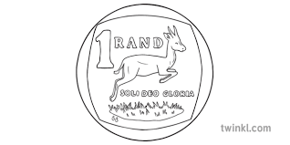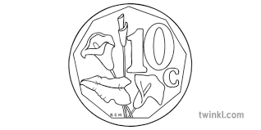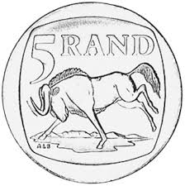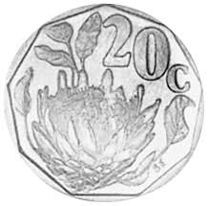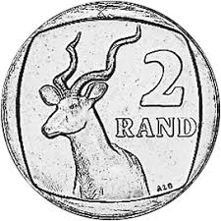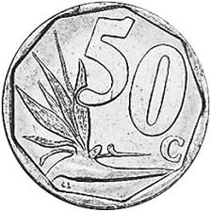

1. Add the coins, write the number sentence, what is the total? ______________________________________________
2. Write 5 different ways to break R25 using the coins

______________________________________________________________________________________________________________________________________________________________________________________________________________________________________________________________________________

1. Convert 268c to rands. _________________

**Activity 4**

|  |
| --- |
|  |

1. Add the bank notes show, write number sentence and total

______________________________________________

1. Give two South African bank notes that are not represented

_________________________________________________

1. Show at least 4 ways to make R400 using the bank notes shown

________________________________________________________________________________________________________________________________________________________________________________________________________________________

1. One pair of shoes costs R2, 50. How much will 2 pairs of shoes cost? Show your calculations

|  |
| --- |
|  |

**Day 4 and 5 BUYING AND SELLING**

**Activity 1 Counting**

**Count forwards in 2s ,5s and 10s between 0 and 500**

**Count backwards in 2s, 5s and 10s from any number between 200 to 0**

Order these numbers from the smallest to the biggest

* 119 ,114, 117,116, 115, 118 _____________________________________
* 215,108, 129,313 ,482 _____________________________________
* 100 ,104 ,105 ,103 ,101 ____________________________________
* 412 ,418 ,420 ,499 ,415 ____________________________________

Convert the following into cents

* R305
* R198
* R200
* R472
* R20

**Activity 2 Mental Mathematics**

**Activity 3**

**Look at the picture below and answer the questions that follow**

|  |
| --- |
| Watermelon R24, 00 Mango R 2, 45      Apple R1, 50  Banana R3, 80          Oranges R36, 20  Ball R18, 25 |

1. How much will you pay for 3 Bananas? Use any strategy to solve ________________________________________________________________________________________________________________________________________________________________________________________________________________________
2. If you want to buy all the items how much should you have? ____________________________________________________________________________________________________________________________________________________________________________________________________________________________________________________________________________________________________________________________________
3. The shop owner sold 3 balls a day. How much did he receive after 2 days?

________________________________________________________________________________________________________________________________________________________________________________________________________________________

**Activity 4**

There are 5 chocolates in a packet. One packet costs R10. Mr. King needs 50 chocolates.

1. How many packets of chocolate should he buy?

____________________________________________________________________________________________________________________________________________________________________________________________________________________________________________

1. How much will he pay?

______________________________________________________________________________________________________________________________________________________________________________________________________________________________________________________________________________________________________

**Activity 5**

Pepe bought 3 books at R90 each. How much will she get if she pays with R300?

________________________________________________________________________________________________________________________________________________________________________________________________________________________________________________________________________________________________________________________________