Name:
Grade 1
Parts of the body
Fill in the parts of the body. Choose from the list below
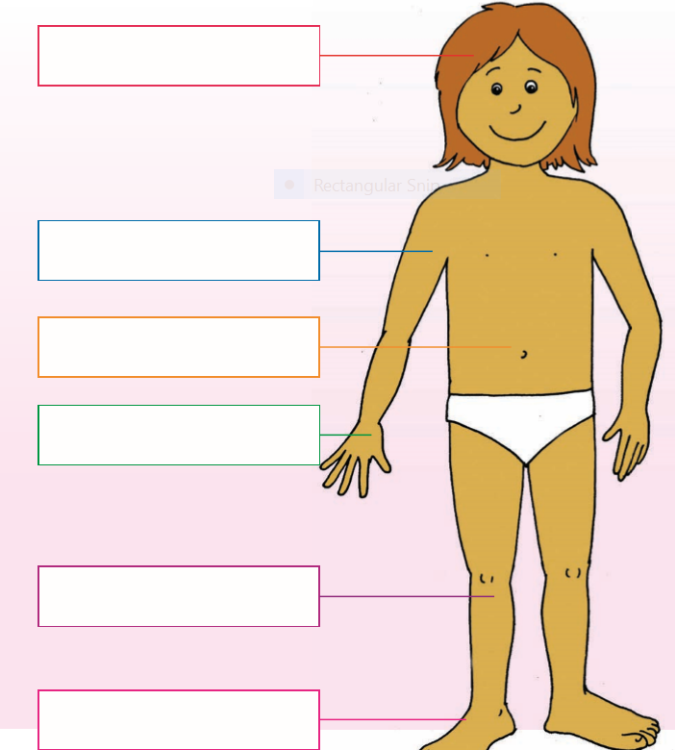

Stomach, hand, knee, foot, arm, head

