IBANGA - 4
ISICATSHULWA
IMIZUZU: 30

Bhota mfundi-ntsapho
Qaphela :

- Injongo yesifundo: Ufundisa abafundi indlela yokufunda isicatshulwa ngononelelo bafumane ulwazi ngomxholo wesicatshulwa

- Okuqulathwe yitekisi:

- Isihloko sesicatshulwa
- Imifanekisi ekwisicatshulwa
- Umxholo obhaliweyo kwisicatshulwa
- Imibuzo ebuzwa kumfundi mayibonakalisa amazinga okuqiqa ngokukaCAPS ( iphepha 95-96)

UNtsika noLinam eBhayi.
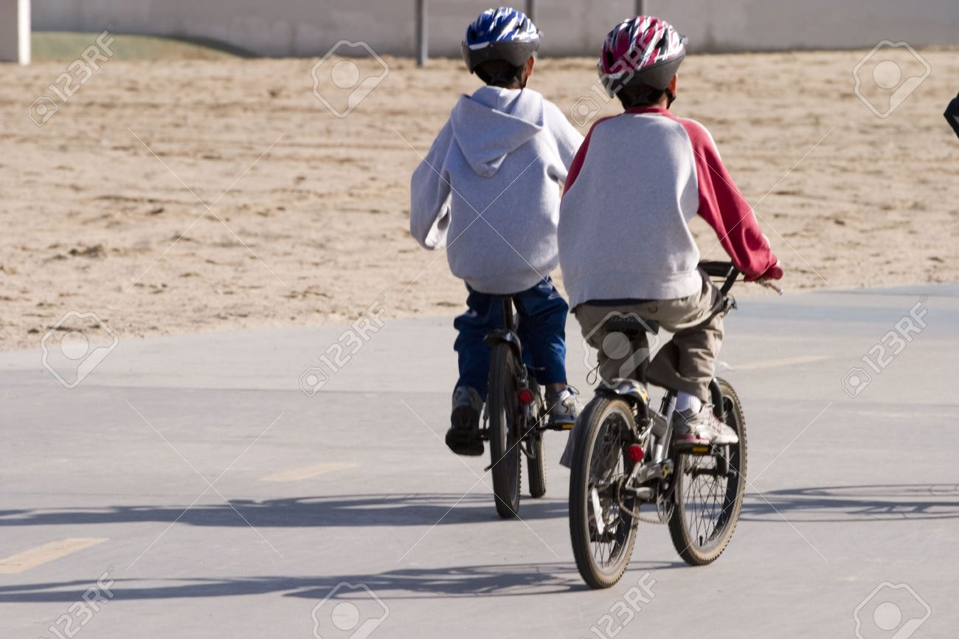

Ukuvalwa kwezikolo ngesiquphe ngenxa yokuqhambuka kwesifo sekhorona kube lithuba elimnandi lokutyelela eBhayi kuNtsika noLinam. Ngentsasa elandelayo beva endleleni esinga eBhayi kwaMagxaki kwadade boyise. Iveki yokuqala ihambe kakuhle behamba kwiindawo zolonwabo bekhwela iibhayisekile. Kwalile kwiveki elandelayo uMongameli wawisa intetho eqamangela wonke umntu ukuba ahlale endlwini ukunqanda usuleleko lwesifo iKhorona. Yhuu!! Yinto esizakuyithini na le ngoku? Ubuzile uNtsika ebudana. “Ithi kaloku asisakwazi ukuqhubeka ukukhwela iibhayisekile.”
Batshintsha ke ubomi ngesiquphe, kume umyalelo othi: “Hlala endlwini uphume xa kunyanzelekile.”
Ngosuku lweshumi kuvalwe yonke indawo, udabawo waya edolophini, ebashiye behleli endlwini. Bave ngelizwi likhwaza egeyithini. “Ntsika, nceda undiboleke impompo.” Utshilo uAnovuyo ongumhlobo wabo. Endaweni yokunikezela ngempompo baphume nezabo iibhayisekile, yekake ukulandelelana, yonke lento inengxolo, amakhwelo nabanye abantwana, yanguwashiywa ukulandelelana.

Gqi, ngenqwelo yamapolisa. “Wiwuu-wiwuu!” ncaa emva kwabo. Gqabu ivili ibhayisekile kaNtsika, phaxa-phaxa. Afika amapolisa onda ngaye, amehlo selewakhuphe azingqanda. Yhoo! Yhini! “ndixoleleni.
Abahlobo bathe phinyi phinyi abasabonakali nangetshengele. Iinyembezi zazinqumle umbombo kuye. Ufike esitishini kukho nabanye abantu ababenjelwe ukwaphula imiqathango yovaleleko. Kwathunyelwa emzalini ukuba aze kumthatha.

Qhwayi -qhwayi, kwavakala izihlangu epasejini kanti ngudabawo wakhe. Uthe akumbona wakhe wamfika ngozipho kanobom apha kwiintungo. Wangxengxeza kwanzima sele ecenga ukuba angabisaxelelwa unina noyise.
“Xwaa! bendikuxelele ukuba masingalandeli abanye, jonga ngoku uphantse ukuvalelwa kwesimnyama isisele.” Uxwaxwe watsho uLinam. Emva koko bayakulala sele beyihleka bobabini oorheme.
Emva kokuphulaphula ibali elingentla. phendula le mibuzo ilandelayo :

- Nika isizathu sokuba izikolo zivalwe ngesiquphe. (1)
- Ngoobani amagama ala makhwenkwana kuthethwa ngawo kweli bali? (2)
- Ingaba ngokucinga kwakho yayilithuba elifanelekileyo lokutyelela eBhayi eli? Xhasa impendulo yakho. (2)
- Yintoni ikhorona? (1)
- Ukuwiswa komqathango wokuba kuhlalwe endlwini kwakuza kunceda entweni?
(1)
6. Kwenzeke ntoni kuNtsika emva kokuba efunyenwe ngamapolisa? (1)
7. Ingaba ufunde ntoni kwesi sehlo sikaNtsika? (2)

[10 Amanqaku]
***********************************

