IBANGA - 4
UMBONGO
IMIZUZU: 30
Bhota mfundi-ntsapho
Qaphela :

- Injongo yesifundo: Ufundisa abafundi indlela yokufunda umbongo ngononelelo bafumane ulwazi ngomxholo wombongo

- Okuqulathwe yitekisi:

- Isihloko sombongo
- Imifanekisi okumbongo
- Umxholo obhaliweyo kumbongo nezitanza
- Uphinda-phindo
- Imvano-siqalo
- Izafobe
- Imibuzo ebuzwa kumfundi mayibonakalisa amazinga okuqiqa ngokukaCAPS ( iphepha 95-96)

UNOTHEMBA
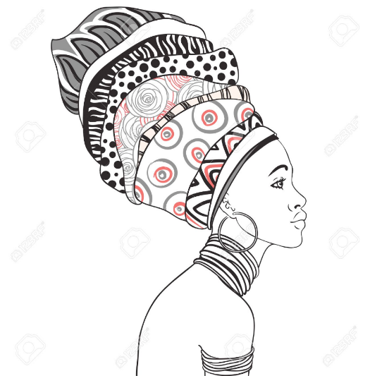
Lithemba labazali bakhe
Uyintwazan’ ehlal’ichubekile
Kuba kaloku sisibane sosapho
Themb’elihle likamama

Uthandwa ngumntu wonke
Unoncumo kuluntu lonke
Ntyatyamb’eqaqambileyo sikubuka sonke
Themb’elihle likamama

Ukwangumhlobo kwabo badakumbileyo
Ungumhlobo othembekileyo
Ungumhlobo kwabo bangafunwa mntu
Themb’elihle likamama

Emva kokufunda umbongo ongentla, phendula imibuzo elandelayo;
1. Zingaphi izitanza ezenze lo mbongo? (1)
2.Ulithemba likabani uNothemba? (1)
3. Chonga amagama amabini anemvano siphelo kulo mbongo (1)
3. Ungumhlobo onjani uNothemba (1)
4. Ufaniswa nantoni uNothemba kwisitanza sesibini? Kuba kutheni ? (2)
5. Safobe sini esibhalwe ngqindilili kulo mbongo sithetha ukuthini? (2)
7.Ungathanda ukufana noNothemba? Xhasa impendulo yakho (2)
Amanqaku ewonke (10)

**************************

