Province of the
EASTERN CAPE
EDUCATION
________________________________________________________________________________________________________
Assessment and Examinations, Bundy Park, Buffalo Road, Schornville, KWT
* Private Bag 4571*KWT * 5600* REPUBLIC OF SOUTH AFRICA
* Enquiries: Mr V A JOSEPH Tel: +27436047810/9 Fax:043 604 7789/08654664627
* Email:Varkeychan.Joseph@edu.ecprov.gov.za
____________________________________________________________________________________________________________________

CHIEF MARKER’S REPORT
INSTRUCTIONS

1. The Chief Markers are required to complete this report during the marking session. The aim of the report is to provide a feed back and to help subject advisors and educators to improve teaching and learning.
2. The report should be informed by discussions between the Chief Marker, moderator, senior markers and markers of the particular subject. NB: There should be one report per subject per paper.
3. The report must be detailed, informative and indicate question by question performance of the candidates and mark distribution of centres.
4. Reference may be made to the topics identified below as well as any aspect the Examiner wishes to bring to the attention of the subject advisors and educators.
5. The report must be submitted in hard copy and an electronic version to the centre manager at the marking centre.
6. All markers reports must be handed in with the hard copy.
7. The electronic report should be emailed to varkchan.joseph@edu.ecprov.gov.za
6. The centre managers then forward the reports to the Directorate of Assessment and Examination (Att: Mr. V A Joseph) in King William’s Town.

SUBJECT: | Religion Studies

GRADE: | 12 | PAPER: | One

DATE OF EXAMINATION: | November 2009 | DURATION: | 2 Hours

1. ANALYSIS OF QUESTION BY QUESTION PERFORMANCE OF THE CANDIDATES

Give a detailed account of how the candidates performed in each question. In doing this, the following steps should be followed:

1.1 The aim/objective for setting the question (what skills, knowledge, values and attitudes were being tested by asking the question)

1.2 Relevance or relation of the question to the Los and Ass.

How did the candidates perform in the question?

1.3 Where did candidates lack expertise or fail in giving an appropriate answer to score high marks in the question?

QUESTION 1

Knowledge, skills and values were tested. Fair Question.
  - Average performance by learners on this question.
  - Most of the learners did not rewrite the sentence. This is because the learners do not read the whole question.
  - As in 2008, most learners could not explain the law of karma.
  - Most learners refer to Halaal as a form of greeting in Islam.
  - and 1.6 Performance were good.

1.7 Most learners could not name this two sources.

1.8 Very good response

1.9 Most learners could name it.

QUESTION 2

2.1 LO1 AS1 recall knowledge
Some learners give the general meaning of the concepts, the teacher must emphasise to learners to define concepts in the context of religion.
2.2 LO1 AS2 Fairly answered
Most learners concentrate on the differences
2.3 LO1 AS2 Poorly answered.
Learners does not analyse internal differentiations.
They give a general description of beliefs of the religion.

QUESTION 3.

  - LO2 AS1 Recall Knowledge

Again, learners describe their concepts in general.
  - LO4 AS4 Fairly answered

Most learners did not adhere to the sub-headings

Learners could not five their own view on Marx Statements.
  - Some learners have no idea what this secular world view believe.
  - LO1 AS4 Well answered.

QUESTION 4

  - LO3 AS3 Fairly answered
Most learners could not give examples of actual events.
They describe general relations between media and religion
  - LO3 AS1 Fairly answered.
  - LO3AS1 Fairly answered
Some learners discuss only one religion
  - LO4 AS1 use of the word “area” in 4.4.1 confuse learners.
Learners did not adhere to sub-headings

QUESTION 5

  - LO2 AS2
Learners perform very well in this question.

QUESTION 6

QUESTION 7

QUESTION 8

QUESTION 9

QUESTION 10

QUESTION 11

QUESTION 12

7. ANY ADVICE THAT YOU COULD GIVE TO EDUCATORS TO HELP
LEARNERS TO REACH THE EXPECTED LEVELS.

- Teaching, learning and assessment must include all the LO’s and AS’s.
- Questions in class tests and controlled tests must be exam – orientated.
- Importance of concepts cannot be over emphasized.
- Practical investigation and application must form part of teaching, learning and assessment to develop learners skills.
- Learners must use all relevant sources (text books, internet, guest speakers, sacred books, library books, media)

8. ANY OTHER COMMENTS

- Teachers must get hold of Provincial and National exam paper and memorandums.
- Exam Papers must, from Grade 10, be set in accordance of the Grade 12 external paper.
- Standard of exam and test questions must be throughout the year in line with Grade 12 final paper.
- I recommend that Grade 10 must also have 2 papers (Paper1 and Paper2).
- Marking of internal papers must be in accordance to the marking of external papers.
- There was and improvement of the results in the subject in 2009.
- The department must launch a campaign to promote this subject to all schools in the Province.
- It is clear that most learners have a lack of interest in the media.

SIGNATURE OF EXAMINER/MODERATOR: _____________________________

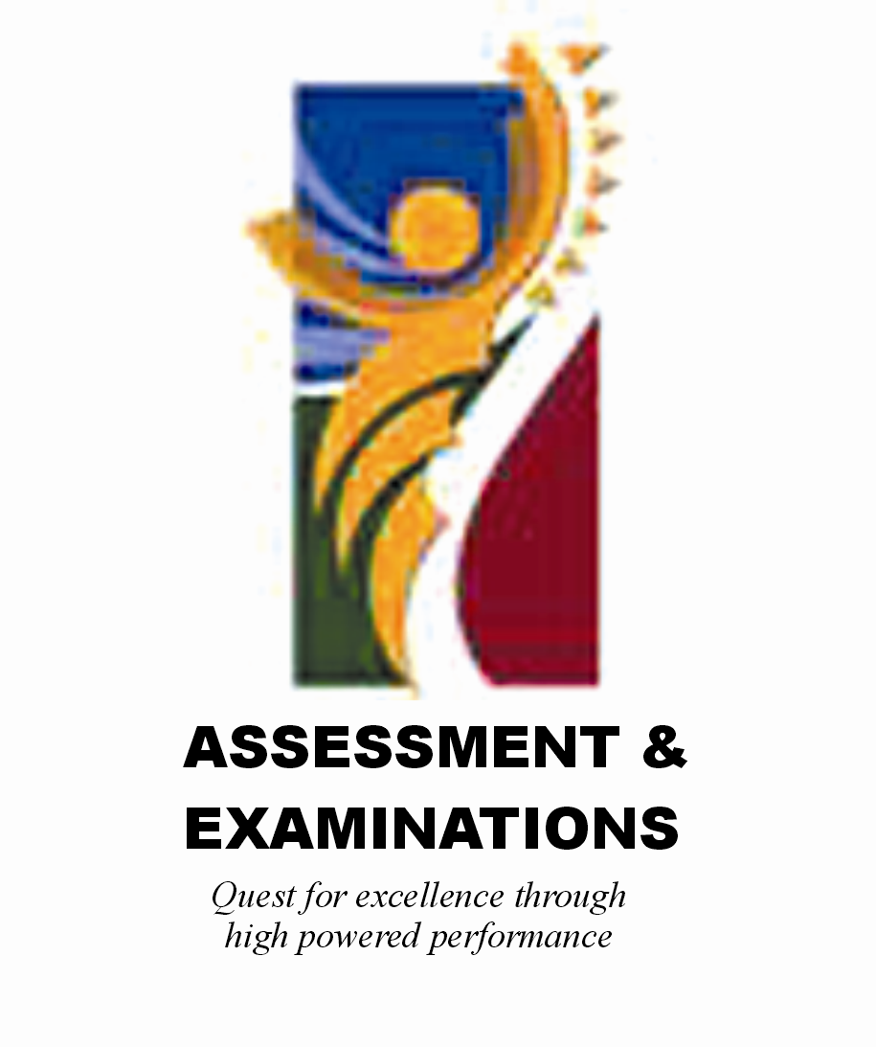 | SIYASEBENZISANA/ WORKING TOGETHER/ SAMEWERKING  Quest for Excellence through high powered performance

