h

IMISEBENZI Yokuhlaziya abafundi

Ukufunda kuyaqhubeka . Sonke sinakho
  - IBANGA LE-7

INTSHAYELELO
Kutitshala ,umzali nomfundi
mfundi

- Eli lilinge lokusondela kumfundi webanga lesiXhenxe. Kukuncedisana naye ukuze ahlakule oko ebekufundisiwe kwikota yesibini neyesithathu.
Abanye abafundi abakwazanga ukuqala esikolweni, abanye bayeka esithubeni ngenxa yeemeko ezingaphezu kwamandla
wabo.
Oku kulandelayo kuza kuncedisa wonke umfundi webanga lesiXhenxe nokuba ukweyiphi na imeko kwezi zingentla.
- Eyona nto ibaluleke kakhulu ekufundweni kolwimi KUKUFUNDA NGOKUQONDA ( Reading with understanding)
- Umfundi unikwa iintlobo-ntlobo zeetekisi ukuphuhlisa isakhono SOKUFUNDA NGOKUQONDA
- Isakhono Sokufunda sihamba nokubukela ( Reading and Viewing) asikwazi kohlulwa kwezi zakhono zilandelayo:
- Isakhono sokumamela nokuthetha( Listening and Speaking)
- Isakhono sokubhala nokunikezela(Writing and Presenting)
- Imigaqo yokusetyenziswa kolwimi(Language use)
- Apha ngezantsi zibonisiwe iitekisi ekufuneka umfundi esebenze ngazo NGOKWESAKHONO NGASINYE
Qhaphela
mfundi

Umfundi usoloko ekhuthazwa ukuba asoloko efunda iitekisi ezahlukileyo ukuze alole izakhono zakhe zolwimi.

IMIBUZO YOKUQONDA YETEKISI ( IBALI, INQAKU LEPHEPHANDABA, INQAKU LIKANOMATHOTHOLO, INGXELO, IINTSOMI)
Umfundi makaphendule le mibuzo ilandelayo emva kokuphulaphula nasemva kokufunda itekisi.
- Xa ubona imifanekiso ekule tekisi ucinga ukuba kuza kuqhubeka ntoni apha etekisini ?
- Sithini isihloko setekisi?
- Ngubani umbalisi?
- Yintoni okanye ngubani ekuthethwa ngaye kule tekisi?( kufunwa abalinganiswa)?
- Yenzeka phi le nto? ( kufunwa indawo)
- Yenzeka xesha lini ? ( kufunwa ixesha)
- Abantu bahlala njani, bephila njani? (kufunwa isimo sentlalo)
- Ingaba iziphumo zale nto yenzekayo zihle okanye zibi? Cacisa ukuba kutheni usitsho.( kufunwa uluvo lwakho)
- Ukuba wena wawulapho yintoni owawuza kuyenza? (uluvo lwakho)
- Le nto yenzeka kule tekisi ingaba uyakwazi ukuyifanisa nento eyayike yehla apha ebomini bakho? (unxulumano)
- Shwankathela itekisi ngawakho amazwi.(isishwankathelo)
- Sithini isifundo osifundileyo wena? ( imfundiso)
Mfundi lungela ukusebenza

- Eli lixesha lokusebenza ngokuzinikela ulungiselela ukuphumelela ibanga lesikhenxe.
- Xa uza kwenza umsebenzi wakho khangela indawo oza kusebenza ngokufanelekiyo kuyo.
- Khangela iphepha nosiba lokubhala ukuze ubhale amanqaku abalulekileyo ngeli xa uphulaphule okanye ufunda.

Mfundi sebenza

Apha ngezantsi nazo iitekisi zebanga lesiXhenxe.
Zibhalwe phantsi kwesakhono ngasinye
Xa ungaqondi cela uncedo.
- UZA KUMAMELA ukugqiba kwakho uphendule imibuzo yokuqonda
- UZA KUFUNDA wakugqiba uphendule imibuzo yokuqonda.
- UZA KUBUKELA emva koko uphendule imibuzo yokuqonda.

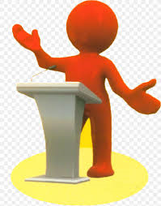
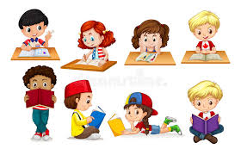
Ufunde ntoni esiXhoseni !!
Ibanga -7 kwikota 2&3
UKUBHALA
- Isincoko esibalisayo
- Ipowusta
- Umbongo
- Inoveli/idrama
- Ukuzaliswa koxwebhu lemibuzo(questionnare)
- Udliwano-ndlebe olubhaliweyo
- Isimemo sentlanganiso,agenda nemizuzu
- Inqaku lephepha-ndaba
- Isincoko esichazayo

UKUFUNDA NOKUBUKELA
- Itekisi ebalisayo inoveli/ikhathuni
- Isibhengezo/inoveli
- Itekisi yemiyalelo-iresiphi
- Uxwebhu lwemibuzo
- Umdlalo kanomathotholo
- Umbongo
- Ajenda nemizuzu
- Inqaku lephepha-ndaba
- Irivyu yesicatshulwa

UKUPHULAPHULA NOKUTHETHA
- Ukubalisa ibali
- Ukwenza isibhengezo/ipowusta
- Ukuphulaphula iindaba zikamabonakude
- Intetho elungiselelweyo/ engalungiselelwanga
- Ukufunda uxwebhu lwemibuzo
- Ukuphulaphula udliwano -ndlebe
- Inqaku lephephandaba
- Ukufunda ngokuvakalayo

IZAKHI NEMIGAQO YOKUSETYENZISWA KOLWIMI
Izibizo ezimbaxa, isivisa, injongosenzi,izibizo ezintsingiselo mbini, izenzi, izichazi intloko,isivisa,isivumelanisi senjongosenzi,izivakalisi ezilula, ixesha langoku, ixesha elidlulileyo intloko,isivisa,isivumelanisi senjongosenzi,izivakalisi ezilula, ixesha langoku, ixesha elidlulileyo.

UKUPHULAPHULA NOKUTHETHA | UKUFUNDA NOKUBUKELA
Ukubalisa ibali  - Umfundi uza kuphulaphula ibali likanomathotholo ukuze aqaphele indlela yokubalisa.  Phambi kokuphulaphula –  Ukwazisa abafundi ngenkqubo  yokuphulaphula.  Ngexesha lokuphulaphula-  Ukubuza imibuzo,  Ukuqaphela ukuhambelana kwezinto, ukuthatha amanqaku  nokutolika abakuphulaphulileyo.  Emva kokuphulaphula  Baqwalasela kwakhona oko bebekuphulaphule, babuza imibuzo, bancokola ngokuthethwe sisithethi njalo-njalo  - Umfundi ubalisa elakhe ibali ethathela ingqalelo ezi zinto zilandelayo:  - ukuqala ngelizwi elinika umdla .  - ukubiza kakuhle amagama.  - ukusebenzisa izinqumamisi neziphumlisi ngendlela efanelekileyo.  - Ukutshintsha-tshintsha ilizwi apho kufanelekileyo.  - Ukubonisa ukuqala kwesivakalisi nokuphela kwaso.  - Ukuqaphela ukuqala kwebali ukulandelelana kweziganeko  - Ukufika kwisiphelo ngelizwi elibonisa ukugqibezela.  Ukwenza/ukuthetha ngesibhengezo 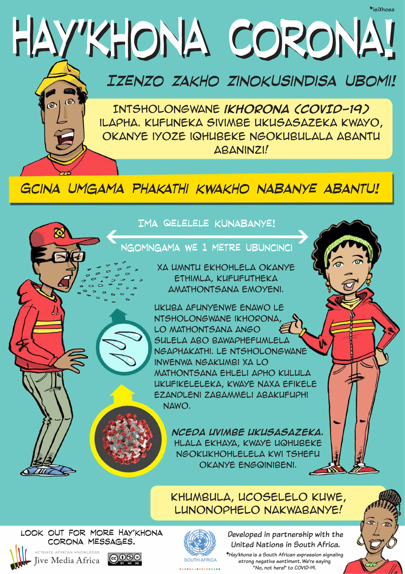  - Umfundi uqaphela izinto ezibalulekileyo ngePowusta yeCorona  - Konke akubona kubalulekile ukubhala phantsi.  - Uncokola namalungu osapho ngokubaluleka kwale Powusta | Itekisi ebalisayo inoveli/ikhathuni  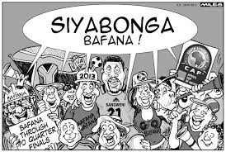  Umfundi ufunda le khathuni aze aphendule le mibuzo ilandelayo:  - Sithini isihloko sekhathuni ?  - Ngobani aba kuthethwa ngabo apha?  - Babephumelele eliphi inqanaba lokhuphiswano?  - UCAF uthetha ukuthini?
Isincoko esibalisayo :
Ubude besincoko (Imihlathi emi-4-6 / amagama
ali- 150-200)
Umfundi ubhala isincoko: “ Ndiyafuna ukuphumelela ebomini”
Bhala ngolu hlobo:

Isihloko: ……………………

Umhlathi wentshayelelo: Chaza ukuba kukuthini ukuphumelela, wena ufuna ukuba yintoni ebomini?
Umhlathi wokuqala wesiqu: Zintoni ezingenza uphumelele ebomini
Zintoni ezingenza ungakwazi ukufika empumelelweni? Chaza ucacise.
Umhlathi wesibini wesiqu: Uza kwenza ntoni ukulwa nezo zinto zinokwenza ungaphumeleli?
Umhlathi wokugqibela wesiqu: Xa sele uphumelele uzibona ufana noobani abantu
Abaphumeleleyo?
Isiphelo: Lithini ithemba lakho, xa umana udibana nobunzima okwangoku?

Isibhengezo/inoveli
Umfundi ufunda esi sibhengezo seCorona ukuze aphendule le mibuzo:
- Sithini isihloko sale Powusta
- Yintoni icorona
- Yosulela njani?
- Chaza zintoni ezinye ezibalulekileyo ekuthethwa ngazo kule Powusta?
- Ucinga ukuba yenzelwe ntoni le Powusta?
- Ikufundise ntoni le Powusta?
Powusta

Umfundi wenza eyakhe ipowusta ngekhorona
Eqaphela ezi zinto zilandelayo:
- Bhala isihloko esinika umdla, esicacileyo.
- Umyalezo mawubhalwe ucace.
- Sebenzisa iintlobo ezahlukileyo zamagama.
- Sebenzisa imibala enomtsalane.
- Khetha ulwimi olusulungekileyo.

Ukuphulaphula Iindaba zikamabonakude | Itekisi yemiyalelo-iresiphi  Umfundi ubhala iresiphi yokwenza isonka sombhako.  Uthathela ingqalelo oku kulandelayo:  - Imilinganiselo yezithako zokwenza isonka  - Izixhobo ezisetyenziswayo  - Indlela yokuxuba izithako  - Imizuzu yokuxova  - Ixesha lokulinda ukunyuka kwentlama  - Indlela yokulungisa imbiza yokubhaka  - Indlela yokufaka intlama epanini/embizeni yokubhaka  - Ubushushu bomlilo wokubhaka  - Ixesha lokulinda ukuvuthwa kwesonka  - Ukukhupha isonka xa sele sivuthiwe  Umbongo; Izitanza zibe ne ezinemigca emihlanu  Umfundi ubhala umbongo ngokuxhatshazwa kwabantwana ngabazali
Umfundi uphulaphula inqaku likamabonakude ukuze aphendule imibuzo yokuqonda ebhalwe blowu ngentla.

Intetho elungiselelweyo/ engalungiselelwanga  Umfundi ulungisa intetho ethi “ Mna nabahlobo bam xa idlulile iCorona”  Umfundi uthathela ingqalelo ezi zinto zilandelayo:  - Ukusebenzisa ithoni elungileyo (atshintshe ukukhwaza nokuthethela phantsi)  - Asebenzise isantya esifanele imeko (acothe okanye akhawulezise ukuthetha ngokwemeko)  - Athethe ngokuzithemba ngelizwi elinika umdla  - Asebenzise intshukumo yamalungu omzimba  - ngokufanelekileyo  - Athethe izinto eziyinyaniso ezinokwenzeka |  | Uxwebhu lwemibuzo  Umfudi ufunda aze azalise uxwebhu lwemibuzo alinikwe ngezantsi.  Unfundi uthathela ingqalelo ezi zinto zilandelayo:  - Ukugcwalisa iinkcukacha ezinyanisekileyo  - Ukuqinisekisa ukuba usebenzisa ukubhala okucocekileyo  - Usebenzisa ulwimi olusulungekileyo nolungekho rhabaxa | Inoveli/idrama(apha umfundi makabhale ibali kuba utitshala akazi kubakho ekhaya ukulungisa iziphene zedrama nenoveli kuba zifuna ingqwalasela enkulu)  Umfundi ubhala ibali elifutshane  “Iminqweno yam yokufunda emva kweCorona”“  Umfundi abhale esebenzisa inkqubo yokubhala:  - Ukucwangcisa/ phambi kokubhala,  - Ukuyila/ ukwenza idrafti,  - Ukuhlaziya,  - Ukuhlela,  - Ukulungisa iziphene  - Ukunikezela ngomsebenzi ogqityiweyo ongenaziphene
Ukufunda uxwebhu lwemibuzo  Igama nefani:……………………………………………………………………………………………..  Indawo ohlala kuyo:……………………………………………………………………………………  Inombolo yomnxeba: ………………………………………………………………………………..  Abantu oza kubabuza: abahlali(mama, tata, ulutsha, amanesi noogqirha  - Yintoni icovid19?  ……………………………………………………………………………………………………………….  - Ivele kweliphi ilizwe icovid19?  ………………………………………………………………………………………………………………  - Zithini iimpawu zomntu one covid19  ………………………………………………………………………………………………………………  - Kufuneka enze ntoni umntu ukuzikhusela kwicovid19?  ……………………………………………………………………………………………………………..  - Umntu uye azazi njani ukuba unayo le ntsholongwane?  ………………………………………………………………………………………………………………  - Ngeli xesha umntu esavavanyiwe kufuneka enze ntoni?  ……………………………………………………………………………………………………………..  - Sithini isizathu sokuba enze oko emva kokuvavanywa?  ……………………………………………………………………………………………………………..  - Ingaba le ntsholongwane iyabulala na?  …………………………………………………………………………………………………………….  - Ingaba bakhona abantu abaye baphila nangona bebenesi sifo?  …………………………………………………………………………………………………………….  - Zithini ezakho iingcebiso ongathi uzinike uRhulumente ekumncediseni  ukulwa nalo bhubhane?  ……………………………………………………………………………………………………………………………………..  ……………………………………………………………………………………………………………………………………..  ……………………………………………………………………………………………………………..  …………………………………………………………………………………………………………….. |  | Ukuzaliswa koxwebhu  Igama nefani:……………………………………………………………………………………………..  Indawo ohlala kuyo:……………………………………………………………………………………  Inombolo yomnxeba: ………………………………………………………………………………..  Abantu oza kubabuza: abahlali(mama, tata, ulutsha, amanesi noogqirha  - Yintoni icovid19?  ……………………………………………………………………………………………………………….  - Ivele kweliphi ilizwe icovid19?  ………………………………………………………………………………………………………………  - Zithini iimpawu zomntu one covid19  ………………………………………………………………………………………………………………  - Kufuneka enze ntoni umntu ukuzikhusela kwicovid19?  ……………………………………………………………………………………………………………..  - Umntu uye azazi njani ukuba unayo le ntsholongwane?  ………………………………………………………………………………………………………………  - Ngeli xesha umntu esavavanyiwe kufuneka enze ntoni?  ……………………………………………………………………………………………………………..  - Sithini isizathu sokuba enze oko emva kokuvavanywa?  ……………………………………………………………………………………………………………..  - Ingaba le ntsholongwane iyabulala na?  …………………………………………………………………………………………………………….  - Ingaba bakhona abantu abaye baphila nangona bebenesi sifo?  …………………………………………………………………………………………………………….  - Zithini ezakho iingcebiso ongathi uzinike uRhulumente ekumncediseni  ukulwa nalo bhubhane?  ……………………………………………………………………………………………………………………………………..  ……………………………………………………………………………………………………………………………………..  ……………………………………………………………………………………………………………..  ……………………………………………………………………………………………………………..
Ubuchule kokuphulaphula nokuthetha Umfundi uvula le link ingezantsi ukuze ave uNoxolo Grootboom ethetha ngobom buka Sakhumzi Jezile.
Qaphela: Yakuvula cofa kwindawo ethi ’Skip the Ad’ uze ke uphulaphule intetho.
https://youtu.be/-F_nzrHVxwE

- Umfundi ufunda isimemo,iajenda kunye nemizuzu yentlanganiso.
- Umfundi wenza isimemo seyakhe intlanganiso.
- Umfundi wenza i-agenda yeyakhe intlanganiso.
- Umfundi wenza imizuzu yentlanganiso yakhe.
Isimemo sentlanganiso I-ajenda yentlanganiso Imizuzu yentlanganiso
Ezasekhaya Ziyaziphandela
Uyamenywa kwintlanganiso yesigqeba
seli qela lingentla
elincedisa ukonwabisa ulutsha kwilali
yakuTsakana eCofimvaba

Intlanganiso iya kubanjwa ngolu hlobo:
Umhla: 01 Agasti 2020
Indawo: Kwisikolo uGuse Lower
Primary
Ixesha : 10;00 ukuya 12:00

Abalindelekileyo
kulo mhlangano sisigqeba esikhokeleyo
Qaphela :
Akungenwa kwintlanganiso ngumntu ongenaso isicheme

Isimemo sikhutshwa ngu S Ncapayi (unobhala)

Ezasekhaya Ziyaziphandela
Umphathi Nkqubo: Z.Mngqibisa

- Ukusayina irejista : Mnu.Ncaphayi
- Umthandazo wokuvula : Nksz.Mathanzima
- Ulwamkelo : Mnu. Xhashimba
- Ukufunda imizuzu yentlanganiso edlulileyo : Mnu Ncapayi
- Ukuxoxa imivuka yentlanganiso edlulileyo:
- Ingxoxo zosuku
4.1 .Ukuhlaziya umgaqo-siseko weqela
4.2 Ukuchonga imiba ekhawuleziyo
efuneka ixoxiwe kumhlangano
ozayo wamalungu eqela
- Ukusonga intlaganiso
- Umthandazo wokuvala: Mnu Xelani

IMIZUZU YENTLANGANISO
Intlanganiso yayibanjwe ngomhla wokuqala kuAgasti,kwisikolo sakwaGusi.Yaqala ngentsimbi yeshumi yaphela ngomkhono emva kwentsimbi yeshumi elinambini
Amalungu onke esigqeba ayephumelele njengoko irejista ibonisa amalungu asayinileyo.
Akukho mivuka yentlanganiso edlulileyo.
Nazi iziphakamiso eziya kwintlanganiso yomntu wonke eya kubanjwa ngomhla we 8 ka Agasti 2020:
- Ukuhlaziya umgaqo-siseko kwandiswe amalungu akwisigqeba esikhokeleyo
- Ukumisela iintlanganiso phakathi kwelali yakuTsakana nelali ezinomdla wokwenza ubuhlobo noTsakana
- Isimo semidlalo yokhuphiswano ngeli xesha leCorana
- Ukukhuthaza abafundi bangayeki ukufunda
- Amatheko empumelelo kwizinto ngezinto.
Intlanganiso yavalwa nguMnu.Xelani ,wawabulela amalungu ngokuzinikezela ekuphuculeni imeko yakuTsakana.

Inqaku lephephandaba  I'solezwe  UMasipala ulumkisa abacinga ngokutyelela esi sixeko  ByAbongile Ginya Jul 25, 2020  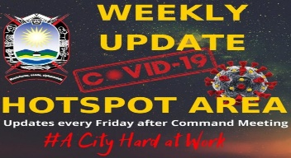  UMASIPALA oMbaxa weBuffalo City uhlaba ikhwelo eluntwini oluhlala kulo masipala okanye olucinga ngokutyelela lo masipala needolophu zawo ekubeni luqaphele ngamaxa onke ngenxa yezinga eliphezulu losuleleko lwentsholongwane iKhorona.  Sithetha nje abasele bebhubhile kulo masipala bangama-183 kwiinkcukacha ezintsha ezikhutshwe ngoLwesihlanu.  “Umasipala uyaligxininisa kwakhona ikhwelo lokuba wonke umhlali naye nabani na ondwendwela lo mmandla ahlale elumkile kuba le yindawo egcwele intsholongwane yekhorona,” esi sisilumkiso esikhutshwe ngumasipala iBCM.  La manani abonisa oku kuxhuma kungaka ngawabantu abavavanyileyo, abaphile kwikhorona nabo bathe babhuba, ikhutshwa lisebe lezeMpilo.  Ngomhla wamashumi amabini anesibini kule veki, iziko iBCM Covid-19 likhuphe ingxelo ethi bali-16 274 abaqinisekisiweyo ukuba baneKhorona kodwa bali-12 867 abathe bayilwa le ntsholongwane baphila ukanti abali-183 babhubhile.  Abe-WHO badiza ukuba abona bantu basemngciphekweni nangakumbi kule ntsholongwane ngabo baphakathi kweminyaka engamashumi amahlanu ukwenyuka, kwaye abanye abasemngciphekweni ngabo baphila nezifo ezifana neswekile, esephepha kwakunye nehigh blood pressure. |  | Inqaku lephepha-ndaba  Umfundi ufunda iphepha-ndaba aze aphendule le mibuzo ilandelayo:  - Lithini igama lephephandaba?  - Sithini islogan seli phephandaba?  - Libhalwa ngubani?  - Laliphume ngowuphi umhla?  - Ngowaphi lo maspala kuthethwa ngaye ?  - Shwankathela ngawakho amazwi le nto ithethwa kweli nqaku.  - Yintoni eyimfundiso kweli nqaku?  - Ucinga ukuba abantu abahlala kula maspala beva njani ngale meko ikweli nqaku?  - Ungabacebisa ukuba benze ntoni ukuze basinde kwiCorona?  Inqaku lephepha-ndaba  - Umfundi ubhala elakhe inqaku ngendlela ayibona ngayo indaba yokuba izikolo zivaliwe.
Bazali nabafundi emakhaya eli linge lelokuncedisana nani ukugcina isibane sivutha njengoko unyaka lo uthambekile.
Qinisekisani ukuba lo msebenzi niyawonwabela, niwenze ngokuzinikela ukuze nibe nakho ukulungela ukuchophela iimvavanyo eniya kuzinikwa ngootitshala benu. Walala wasala!

