WORKSHEET | 2 - (01/04/2020)
GRADES: | 12 (SUITABLE FOR 10 & 11)
SUBJECT: | ENGLISH HOME LANGUAGE (FET)
WEEK | 11-12
TOPIC | POETRY: A HARD FROST
SUBMITTED BY | S.P. NDLOVU
DISTRICT | O.R. TAMBO INLAND DISTRICT

POINTS TO REMEMBER WHEN ANALYSING A POEM
- The meaning of the poem
- After reading the poem, work out what the poem is about
- What is it that the poet is saying?
- Which lines bring out the meaning of the poem
- Determine whether the poem has a storyline, characters, conflicts, suspense, etc. and how these contribute to the meaning of the poem.
- Imagery
- What imagery has the poet chosen for the subject?
- Are the images all related?
- Is there one overall image or several images used for a particular effect?
- What feelings/emotions do the images reveal/provoke.
- Symbolism
- Check if the poet has used symbols in the poem and for what effect.
- Diction/ Choice of words
- The poet’s choice of words is important.
- Always try to determine why the poet used specific words which stand out more than the others, in relation to the subject.
- Work out how these particular words contribute to the meaning of the poem.
- Also look out for repeated words and the overall effect they add to the poem.
- Tone and mood
- Check if the poet takes another persona so that you do not confuse the two
- What mood is created by that tone?
- What are the reasons for using that particular tone? Relate this directly to the subject.
- The structure of the poem
- How the poem looks like (its form) contributes to its meaning.
- Does the poem have stanzas, and are these made up of an equal number of lines or not (regular and irregular stanzaic form)?
- Check if the poem has a rhyme scheme and how this draws attention to certain words and ideas in the poem.
- Type of poem
- Is the poem a lyric? A sonnet? A narrative? Etc.
- What is significant about this type of poem?
- What are the characteristics of this type of poem?

NB: These are points to remember when analysing a poem. Note that it does not follow that all the poems you are studying can be analysed in this mechanical manner. Each poem is unique, so you will have to decide which points are most important for each poem as you analyse the prescribed poems.
Check Past Exam Papers and take note of what the examiners were looking for specifically for each of the examined poems. This will assist you in focusing on key issues as you work on specific poems.

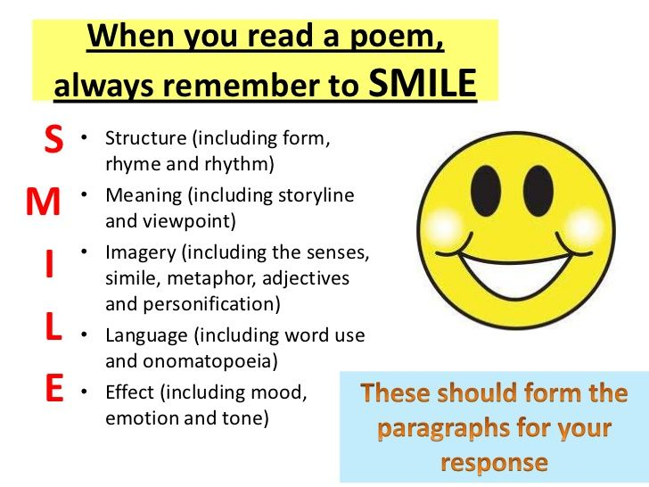

A HARD FROST by Cecil Day Lewis
As shown in the table you are about to work on; remember that the S.I.F.T method of analysing a poem awards you the opportunity to do so focusing on most (if not all) of the elements of a poem, discussed in the ‘Points to Remember’.
For your examination, examiners focus on some of these elements. Making it a regular practice to ‘SIFT’ through all your poems (seen and unseen) will help you to prepare for the essay question in the exam.
ACTIVITY | Using the notes on ‘Points to remember’, analyse ‘A Hard Frost’ using the S.I.F.T. Method. Use the given table to frame your analysis.

S | Structure  Subject
I | Imagery  Intention
F | Feeling (Mood)
T | Tone  Themes

