Province of the
EASTERN CAPE
EDUCATION

DIRECTORATE SENIOR CURRICULUM MANAGEMENT (SEN-FET)
HOME SCHOOLING SELF-STUDY WORKSHEET
SUBJECT | ECONOMICS | GRADE | 12 | DATE | 01/04/2020
TOPIC | MACROECONOMICS | TERM 1  REVISION | X | TERM 2 CONTENT | (Please tick)
TIME ALLOCATION | 50 MINUTES MARKS: 70 | TIPS TO KEEP HEALTHY  1. WASH YOUR HANDS thoroughly with soap and water for at least 20 seconds. Alternatively, use hand sanitizer with an alcohol content of at least 60%.  2. PRACTICE SOCIAL DISTANCING – keep a distance of 1m away from other people.  3. PRACTISE GOOD RESPIRATORY HYGIENE: cough or sneeze into your elbow or tissue and dispose of the tissue immediately after use.  4. TRY NOT TO TOUCH YOUR FACE. The virus can be transferred from your hands to your nose, mouth and eyes. It can then enter your body and make you sick.  5. STAY AT HOME.
INSTRUCTIONS | INSTRUCTIONS AND INFORMATION  - Answer ALL questions in the ANSWER BOOK  - Number the answers correctly according to the numbering system used in this question paper.  - Write the question number above each answer.  - Leave 2–3 lines between subsections of questions  - Write neatly and legibly.

QUESTION 1 30 MARKS − 20 MINUTES

1.1 | Various options are provided as possible answers to the following questions. Choose the correct answer and write only the letter (A–C) next to the question number (1.1.1–1.1.8) in the ANSWER BOOK, for example 1.1.9 D.
 | 1.1.1 | Factors that originate from inside the domestic economic system are referred to as …
 |  | A | exogenous.
 |  | B | production.
 |  | C | indigenous.
 |  | D | endogenous
 | 1.1.2 | In business cycles estimating something known from information that is unknown, is called …
 |  | A | amplitude.
 |  | B | extrapolation
 |  | C | trend
 |  | D | moving average.
 | 1.1.3 | The money market in the RSA is a market for … savings and loans.
 |  | A | short-term
 |  | B | medium-term
 |  | C | long and short term
 |  | D | medium and short term
 | 1.1.4 | One of the main problems in public sector provisioning is ...
 |  | A | providing public goods.
 |  | B | issues of conservation.
 |  | C | marketing with public relations.
 |  | D | a lack of accountability
 | 1.1.5 | The trade balance is the net result of ...
 |  | A | the trade in services.
 |  | B | the trade in goods.
 |  | C | exports and imports.
 |  | D | export prices and import prices.
 | 1.1.6 | This is an argument in favour of free trade:
 |  | A | Economic development
 |  | B | Economic growth
 |  | C | Economies of scale
 |  | D | Infant industries
 | 1.1.7 | Putting laws in place to regulate activities
 |  | A | Regional government
 |  | B | Regulation
 |  | C | Central government
 |  | D | Deregulation
 | 1.1.8 | The currency fluctuates in value according to demand and supply:
 |  | A | Free floating
 |  | B | Appreciation
 |  | C | Fixed
 |  | D | Revaluation (8 x 2) | (16)

1.2 | Choose the correct description from COLUMN B that matches the item in COLUMN A. Write only the letter (A−I) next to the question number (1.2.1−1.2.8) in the ANSWER BOOK.
 | COLUMN A COLUMN B  1.2.1 Market prices A public goods  1.2.2 Jugler cycle B money received without any productive service rendered  1.2.3 Community goods C deepening of the recession  1.2.4 Transfer payment D prices actually paid by consumers and producers for goods and services plus taxes minus subsidies  1.2.5 Depression E caused by changes in net investments by government and businesses  1.2.6 Customs union F anyone can use these whether they are prepared to pay for them or not  1.2.7 Non-rivalry G human resources used to maximum capacity  1.2.8 Real figures H member countries agree to the removal of all tariffs  I national product at constant prices  (8 x 1) | (8)
1.3 | Give ONE term for each of the following descriptions. Write only the term next to the question number (1.3.1–1.3.6) in the ANSWER BOOK. Acronyms and abbreviations will NOT be accepted.
 | 1.3.1 The flow of goods and services between the participants in the circular flow  1.3.2 A diagram that shows expansion and contraction periods of economic activities  1.3.3 The curve that shows the relationship between tax rate and tax revenue  1.3.4 Taxes that are not shifted to the end user  1.3.5 A financing instrument distributed among member countries of the International Monetary Fund (IMF)  1.3.6 Withdrawal of capital investment from a company or country (6 x 1) | (6)
 | TOTAL MARKS | [30]
(EC/JUNE2018)
QUESTION 2 40 MARKS – 30 MINUTES
2.1 | Answer the following questions.
 | 2.1.1 | Name TWO characteristics of fiscal policy. (2 x 1) |  | (2)
 | 2.1.2 | How can the appreciation of the rand affect exports of goods and services? (1 x 2) |  | (2)
2.2 | Study the extract below and answer the questions that follow.
 | 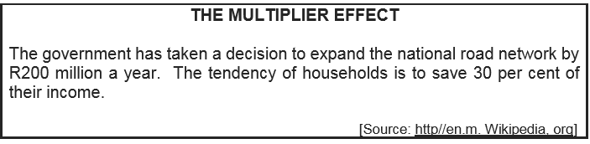
 | 2.2.1 | Identify the concept in the above extract. |  | (1)
 | 2.2.2 | What percentage of their income do households spend? |  | (1)
 | 2.2.3 | Briefly describe the term multiplier. |  | (2)
 | 2.2.4 | What impact will a tax increase have on the multiplier? |  | (2)
 | 2.2.5 | Calculate the size of the multiplier. Show ALL calculations. |  | (4)
2.3 | Study the graph below and answer the questions that follow
 | 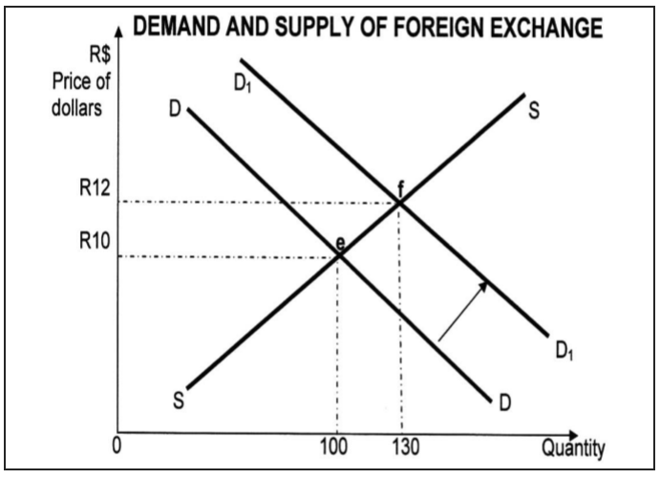
 | 2.3.1 | Identify the original equilibrium point on the above graph. |  | (1)
 | 2.3.2 | What happens to the value of the Rand when the demand curve shifts from DD to D1D1? |  | (1)
 | 2.3.3 | Briefly explain the floating exchange rate systems. |  | (2)
 | 2.3.4 | What effect does globalisation have on international trade? |  | (2)
 | 2.3.5 | How will demand influence foreign exchange? |  | (4)
2.4 | Briefly discuss any TWO arguments in favour of privatisation. (4 x 2) |  |  | (8)
2.5 | What effect does the term of trade have on the balance on the current account? (4 x 2) |  |  | (8)
 |  |  |  | [40]
 | (EC/JUNE2018)
 | TOTAL MARKS [70]

