Province of the
EASTERN CAPE
EDUCATION

DIRECTORATE SENIOR CURRICULUM MANAGEMENT (SEN-FET)
HOME SCHOOLING SELF-STUDY ANSWER SHEET
SUBJECT | ECONOMICS | GRADE | 12 | DATE | 16/04/2020
TOPIC | MICROECONOMICS MARKS: 70 | TERM 1  REVISION |  | TERM 2 CONTENT | X

QUESTION 1
1.1
 | 1.1.1 | B |  | the Johannesburg Securities Exchange
 | 1.1.2 | C |  | Zero
 | 1.1.3 | A/C |  | differentiated/unique
18 | 1.1.4 | D |  | Decreases
 | 1.1.5 | A |  | selling price
 | 1.1.6 | C |  | Positive
 | 1.1.7 | B |  | heterogeneous
 | 1.1.8 | A |  | kinked (8x2) |  |  | (16)
1.2
 | 1.2.1 |  | E |  |  | buyers and sellers do not have market power
 | 1.2.2 |  | G |  |  | do not change as output change
 | 1.2.3 |  | A |  |  | the holder is the only one who can produce the product
 | 1.2.4 |  | F |  |  | cannot be recovered should the firm leave the industry
 | 1.2.5 |  | B |  |  | makes super-normal profit in both the short and long term
 | 1.2.6 |  | I |  |  | often exploited due to absence of ownership
 | 1.2.7 |  | C |  |  | is an example of a negative externality
 | 1.2.8 |  | D |  |  | Used in making the decision whether to accept/reject the project
 |  |  |  |  |  | (8x 1) | (8)
1.3 | Give the correct concept for each of the following phrases.
 | 1.3.1 |  | Artificial
 | 1.3.2 |  | Price leadership / tacit collusion
 | 1.3.3 |  | Oligopoly
 | 1.3.4 |  | Price discrimination
 | 1.3.5 |  | Industry
 | 1.3.6 |  | Marginal product (6x1) |  |  |  | (6)
 |  |  |  |  |  |  | [30]

QUESTION 2:
Markets are the backbone of economic activities in any country.
- Compare the market structure of a monopolistic competitor to that of a perfect market. (26)
- Explain, with the aid of a graph, how economic profit is achieved for a perfect competitor. (10) | [40]
INTRODUCTION
- A market is an institution or mechanism that brings together the buyers and sellers of goods or services /  - A market structure is a framework of how a market is organised /  - Monopolistic competition is a monopolistic market structure with many buyers and sellers where entry is relatively easy but the product is differentiated /  - Perfect competition is a market structure with many buyers and many sellers  (Accept any other relevant introduction) | (2)
MAIN PART
Number of businesses
- There is a number of sellers that are so large in the perfect market that individual market participants are insignificant in relation to the market as a whole An example of a perfect market is the Securities Exchange, or the produce market
- A large number of sellers are active in the monopolistic competitive market Examples of monopolistic markets are producers of cleaning materials, cold drinks, toothpaste or soap
Nature of the product
- All products sold in the perfect market are homogeneous All these products are exactly the same regarding quality, appearance it makes no difference to a buyer where and from whom he or she buys the product.
- Goods produced by businesses in a monopolistic competitive market are heterogeneous They may differ slightly in appearance, shape, size and taste Differences may be imaginary e.g. medicine may have different brand names, but contain exactly the same basic ingredients
Entry and exit from the market
- There is complete freedom of entry and exit of buyers and sellers in the perfect market Entry is not subject to any restrictions in the form of legal, financial, technological or other barriers
- Entry into the monopolistic competitive market is easy and free There are no barriers such as licences, permits, patents and other restrictions
Market knowledge
- Both buyers and sellers have complete knowledge about prevailing market conditions in the perfect market It is assumed that buyers and sellers instinctively know, e.g. available quantities; price at which product is sold
- Market information in the monopolistic competitive market is incomplete The many brands, variety of products or marginal difference causes a lack of information for sellers and buyers
Control over price
- There are so many businesses in the perfect market that the individual business is so small that no single business has control over the price of the product The price is determined through market forces. In other words, the business can be regarded as a price taker
- The individual business in the monopolistic competitive market has some control over the price of a product The control over price depends entirely on the strength of brand loyalty The business can be regarded as a price setter

Collusion
- Collusion is not possible under perfect market conditions There is no need for businesses to collude because they have no control over price setting In addition, the market share of the individual business is so small and insignificant that it cannot manipulate the market in any way
- Collusion does not occur in the monopolistic competitive market Individual businesses rely on brand loyalty to determine prices Prices can be manipulated by the strength of their brand loyalty Prices are normally higher in cases where brand loyalty is intense Control over the market (output) is subject to brand loyalty due to product differentiation
Marketing
- There is no need for marketing strategy in the perfect market due to complete market knowledge
- Marketing strategy is applied in the monopolistic competitive market Deliberate advertising campaigns is launched to create brand loyalty
Profits
- The firm can realise economic profits in the short term, but only normal profits in the long run in the perfect market
- The firm can realise economic profits in the short term as well as the long run in the monopolistic competitive market
Demand curve
- The demand curve for the firm in the perfect market is horizontal  - D=AR=MR  - The demand curve for the firm in the monopolistic competitive market is downward sloping.  - AR=D (average revenue curve is also known as the demand curve)  - The MR curve lies below AR curve  (Allocate a maximum of 8 marks for mere listing of facts/examples)  (Accept any other correct relevant response)  Accept tabular form Max | (26)
ADDITIONAL PART
Explain, with the aid of a graph, how economic profit is achieved for a perfect competitor.
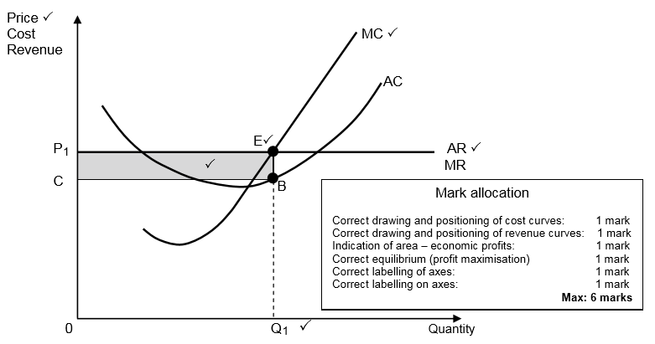

- The minimum point of the short-term average cost (AC) is lower than the market price P1
- The business is maximising profit at MR = MC at point E, the business will therefore produce quantity Q1 at the market price P1
- Total revenue is equal to 0P1 x 0Q1 and total cost is equal to 0C x 0Q1
- Total revenue exceeds total cost, which means the business is making a profit that is represented by area P1CBE
- This profit is known as economic profit, which is profit that is made in addition to normal profit
Max (6) for graph - Max (6) explanation Max | (10)
CONCLUSION
Whilst perfect market does not exist, it serves as a standard that imperfect markets, such as monopolistic competition, should strive to achieve  Accept any relevant higher order conclusion | (2)
 | [40]

