Province of the
EASTERN CAPE
EDUCATION

DIRECTORATE SENIOR CURRICULUM MANAGEMENT (SEN-FET)
HOME SCHOOLING SELF-STUDY WORKSHEET
SUBJECT | ELECTRICAL TECH. (POWER SYSTEMS) | GRADE | 12 | DATE | APRIL 2020
TOPIC | THREE PHASE MOTORS & STARTERS - NOTES | TERM 1  REVISION | (please tick) | TERM 2 CONTENT | (√ )
TIME ALLOCATION |  | TIPS TO KEEP HEALTHY  1. WASH YOUR HANDS thoroughly with soap and water for at least 20 seconds. Alternatively, use hand sanitizer with an alcohol content of at least 60%.  2. PRACTICE SOCIAL DISTANCING – keep a distance of 1m away from other people.  3. PRACTISE GOOD RESPIRATORY HYGIENE: cough or sneeze into your elbow or tissue and dispose of the tissue immediately after use.  4. TRY NOT TO TOUCH YOUR FACE. The virus can be transferred from your hands to your nose, mouth and eyes. It can then enter your body and make you sick.  5. STAY AT HOME.
INSTRUCTIONS

Introduction to Three Phase Motors
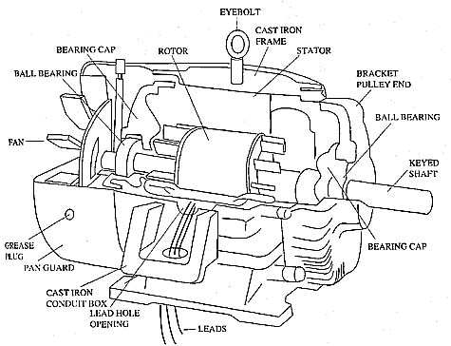

The Three Phase Squirrel Cage Induction Motor
A squirrel-cage rotor is the rotating part (rotor) used in the most common form of AC induction motor.
It consists of a cylinder of steel with aluminium or copper conductors embedded in its surface.
An electric motor with a squirrel-cage rotor is termed a squirrel-cage motor

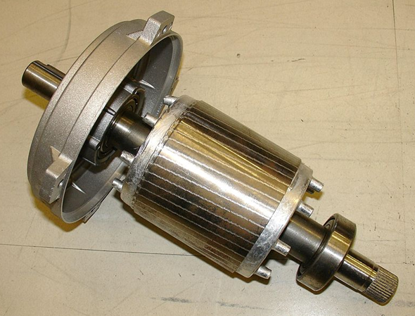

Principal of Operation
The basic difference between an induction motor and a synchronous AC motor is that in the latter a current is supplied onto the rotor.
The induction motor does not have any direct supply onto the rotor; instead, a secondary current is induced in the rotor.
To achieve this, stator windings are arranged around the rotor so that when energised with a polyphase supply they create a rotating magnetic field pattern which sweeps past the rotor.
This changing magnetic field pattern induces current in the rotor conductors.
These currents interact with the rotating magnetic field created by the stator and in effect cause a rotational motion on the rotor.
Construction (see diagram below)
Any Induction Motor has a Stator and a Rotor.
The construction of Stator for any induction motor is almost the same but the rotor construction differs with respect to the type of motor used.
The stator is the outer most component in the motor which can be seen.
It may be constructed for single phase, three phase or even poly phase motors.

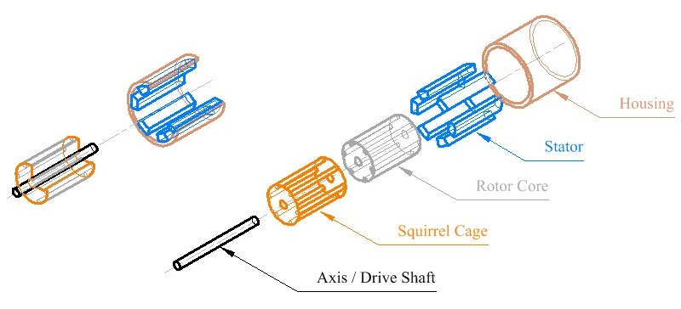

Advantages
- They are easy to manufacture.
- For the same size they are cheap compared to other types of motors.
- They are robust and require very little maintenance.
- They are available in wide range of sizes and power outputs.
- For the same size three phase motors provide more power and torque than single phase motors.
- They can be connected in Star or Delta, provided that the winding insulation is suitable for the voltage.
- They can be mounted horizontally or vertically.
- With suitable inverter power drives, their speed can be varied.
Applications
Squirrel cage induction motors are simple and rugged in construction, are relatively cheap and require little maintenance. Hence, squirrel cage induction motors are preferred in most of the industrial applications such as in:
1. Lathes
2. Drilling machines
3. Agricultural and industrial pumps
4. Industrial drives.
Calculations on Slip, Power and Efficiency
The synchronous speed is the maximum velocity which a motor can rotate at.
This speed is directly proportional to the frequency of the motor supply voltage and inversely proportional to the number of pairs of poles that the stator consists of.
The number of pairs of poles is half the number of poles that there are.
The synchronous speed is measured in revolutions-per-minute (RPM)

FORMULAE
- $Synchronous Speed ns=\frac{60×f}{p}$ RPM
- $Slip s=\frac{Synchronous speed-Rotor speed }{Synchronous speed }=\frac{n_{s-n_{r}}}{n_{s}}$
- $Motor speed n_{r}$= $n_{s}$($1-s)$ RPM
- $P_{a}$ = $\sqrt{3}{×V}_{L×}I_{L}$ VA
- $P= √3{×V}_{L}{×I}_{L} \cos{θ}$ W
- $P_{r}$= $\sqrt{3}×V_{L}$ $× I_{L }\sin{θ }$VAr
- $PF= \frac{P}{Pa}$ = $\cos{θ}$
- η = $\frac{P_{out}}{P_{in}}$ = $\frac{P_{in-P_{losses}}}{P_{in}}$

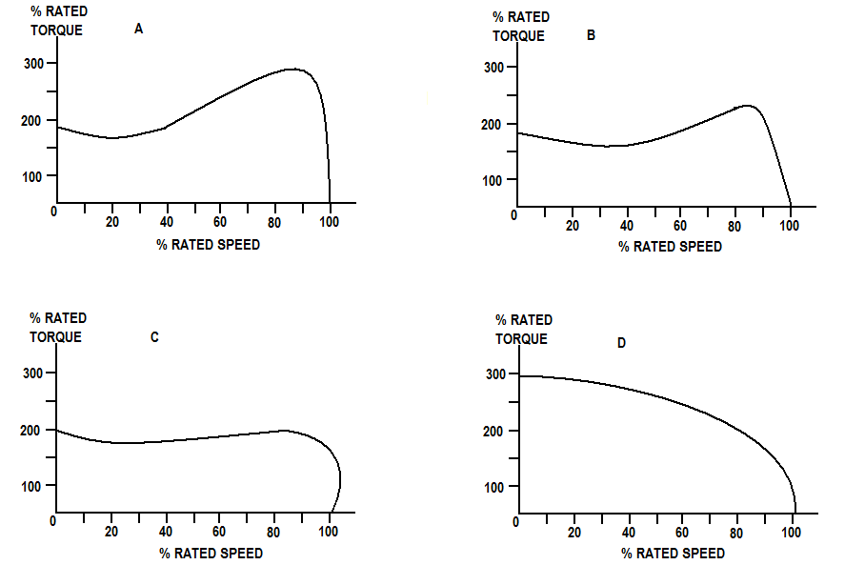

Characteristic curve of Speed vs. Torque

SYNCHRONOUS SPEED
What is Synchronous Speed?
- Synchronous speed is the speed of the rotation of the magnetic field in rotary machine like motors & generators, its unit is R.P.M or revolution per minute.
- The synchronous speed depends on two factors:
- Supply frequency
- Number of paired poles
$$Synchronous Speed ns=\frac{60×F}{P}RPM$$

ELECTRICAL AND MECHANICAL ASPECTS OF 3-PHASE (3Φ) MOTORS
Fault finding / Troubleshooting
Troubleshooting and faultfinding is the process of determining why a motor is not operational. It is of great importance to work safely in this regard. Some steps to consider are:
Use a voltmeter to determine if the motor terminals have a supply. If there is no supply, then it must be checked. If there is, then the motor must be inspected.
If the supply is operational, then the motor must be disconnected for inspection (a notice may be considered to notify others that you are working on the circuit.
Disconnect the load from the motor and retry starting.
If the motor starts, then check the load. If not, then the motor must be checked using a megger (for the electrical inspection).
A mechanical inspection may also be applied once the electrical test is complete.
Motor Testing
Electrical Tests
Electrical Testing
These are all tests that have to do with the electrical system of the motor.
All tests must be done by means of instrumentation.
Continuity Testing
Each individual coil is tested to determine that they all have similar values.
If they are all equal, then the motor is balanced.
Having a balanced motor is unlikely; therefore the three coils must have a very similar value.
Insulation Resistance between Windings
The values between the individual coils must be infinite, as any short between the coils will cause an unwanted connection and thus the motor will not function or will not function properly.
Insulation Resistance to Earth
Between the windings and earth, there should also be no value, as any current through the earth wire will disconnect the earth protection of the circuit and therefore no operation of the motor.
Motor Testing
Mechanical Tests
This is a visual inspection of aspects of the motor, which has a practicality aspect to the motor or an influence on the working of the motor.
Rotor
The rotor consists of the laminated core, the end plates and the conductive rods.
This is the actual moving part of the motor.
Shaft
The shaft is connected to the rotor and is used to transfer energy to other devices.
The shaft rests on two bearings.

Key/Keyway
The keyway is the master switch for the motor and is usually an insulation switch.
Bearings
The shaft runs in these.
Their function is to minimise mechanical losses and aid in the smooth rotation of the motor.
Termination Box
All wiring that goes into the motor is connected via the termination box.
Motor Frame
The motor frame holds all the stator windings and the bearings.
This is to keep all the pieces of the motor in close and stable proximity to each other.
MECHANICAL TESTS
Flange/Foot Mount
The flange or foot mount is on the bottom of the motor and is used to fasten the motor to a stable surface or to let the motor stand on its own.
Shield (front and back)
Some motors are places in shields to protect the operator from the moving parts of the motor.
Cooling Fins
The cooling fins are cast as part of the housing in most cases. Some motors have an additional fan placed on the shaft to aid in further cooling.
Mounting Bolts and Screws
These are used when mounting the flange to the stable surface.
Commissioning. The process involved in preparing the motor and starter to be used by the operator.
This is the process involved in preparing the motor and starter to be used by the operator. The following steps must be followed when commissioning a motor:
- All work is to be carried out only when there is no voltage on the motor. The installation must be carried out according to the valid regulations by qualified skilled personnel.
- The mains conditions (voltage and frequency) must be compared with the data on the rating plate of the motor.
- The dimensions of the connecting cables must be adjusted in line with the rated currents of the motor.
- Always start the motors with an over-current protection device that is set appropriately.
- When the motor is connected for the first time it is recommended to check the insulation resistances between winding and earth and between phases.
- After prolonged storage it is absolutely essential that the insulation resistance is measured.
- Before coupling the motor to the driven machine, check the direction of rotation of the motor to prevent possible damage being caused to the driven machine.
Commissioning
- If the power lines are connected with the phase sequence L1, L2, L3 to U, V, W, the direction of rotation is clockwise.
- If two terminals are changed, the direction of rotation is counter clockwise (i.e. L1, L2, and L3 to V, U, and W).
- For machines with only one direction of rotation the required sense of rotation is marked by an arrow on the machine.
- Before closing the terminal box the following should be checked:
- All connections must be made in accordance with the wiring diagram.
- All connections are tightened.
- The interior of the terminal box is clean and free from dirt and foreign objects.
- All unused cable entries are blanked off and threaded plugs with seals are tightened.
- The seal on the terminal box is clean and glued on all surfaces.
- Before starting up the motor check that all safety regulations are strictly adhered to, that the machine is correctly installed and aligned, that all fixing parts and earthing connections are tightened, that the auxiliary and additional devices are functionally and correctly connected and if a second shaft end is fitted that the key is secured against being thrown aside.
- If possible the motor is to be connected without load. If the motor is running smoothly and without any abnormal noises, the load of the driven machine is to be applied onto the motor.
- When the motor is started up it is recommended to monitor the current consumption if the motor is loaded with its driven machine
so that any possible overloads and asymmetries occurring in the mains can be recognised immediately.
- The starter must always be in the starting position during starting.
- With slip ring motors the correct running of the brushes must be monitored. They must be absolutely spark-free.

STARTERS
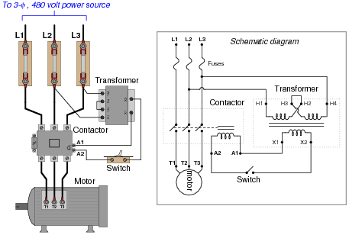

3 Phase Direct on Line Starter
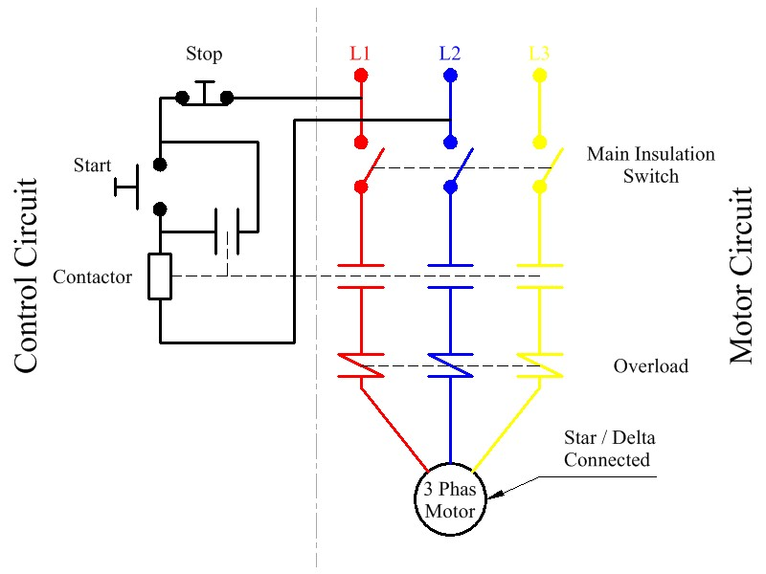

3 Phase Forward and Reverse Starter

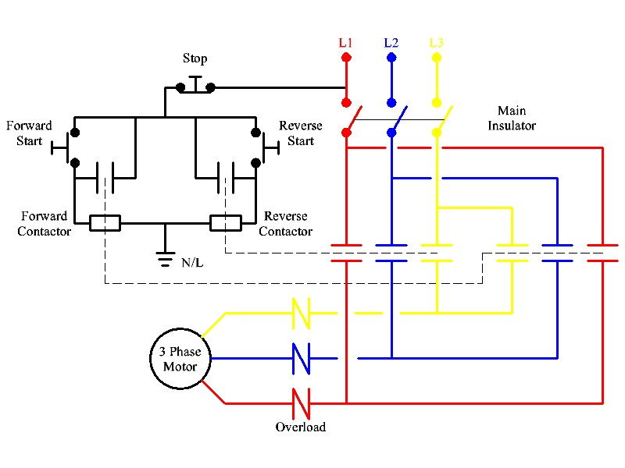

Three Phase Sequence Motor Control without Timer
Main Circuit
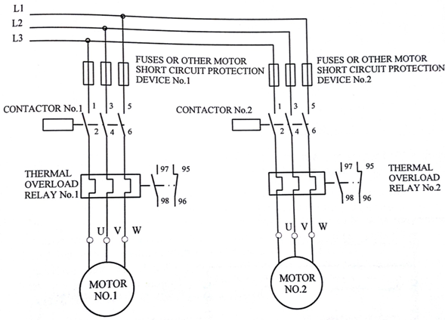

Three Phase Sequence Starter without timer
Control Circuit
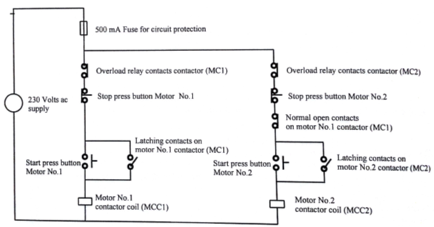

Three Phase Sequence Starter with Timer (see diagram below)
Main Circuit

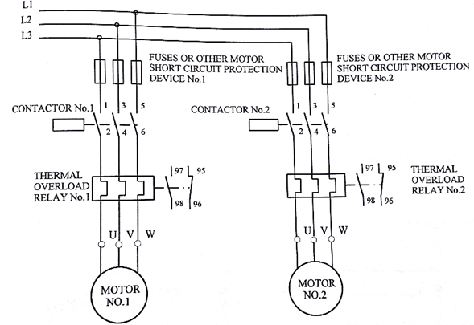

Three Phase Sequence Starter with Timer
Control Circuit

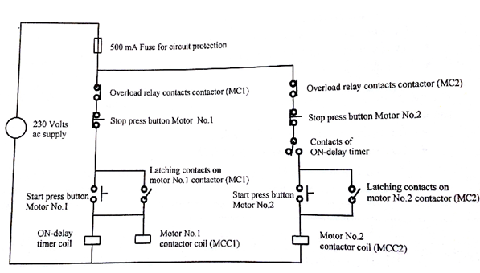

Automatic Star Delta Starter
