Province of the
EASTERN CAPE
EDUCATION

DIRECTORATE SENIOR CURRICULUM MANAGEMENT (SEN-FET)
HOME SCHOOLING SELF-STUDY WORKSHEET
SUBJECT | English FAL | GRADE | 12 | DATE | 01.04.2020
TOPIC | Active and Passive Voice | TERM 1  REVISION | (Please tick)  √ | TERM 2 CONTENT | (Please tick)
TIME ALLOCATION | 50 Minutes | TIPS TO KEEP HEALTHY  1. WASH YOUR HANDS thoroughly with soap and water for at least 20 seconds. Alternatively, use hand sanitizer with an alcohol content of at least 60%.  2. PRACTICE SOCIAL DISTANCING – keep a distance of 1m away from other people.  3. PRACTISE GOOD RESPIRATORY HYGIENE: cough or sneeze into your elbow or tissue and dispose of the tissue immediately after use.  4. TRY NOT TO TOUCH YOUR FACE. The virus can be transferred from your hands to your nose, mouth and eyes. It can then enter your body and make you sick.  5. STAY AT HOME.
INSTRUCTIONS | - On the following pages there are notes on Active and Passive voice and Practice Activities.  - Read the NOTES ON CONTENT at the top carefully to assist you with the general approach to questions.  - Answer all the questions.  - Mark your answers for ALL of the questions.

Notes on content
Active and passive voice
In the Active Voice the Subject of the sentence does the action.
In the Passive Voice the Object becomes the Subject and is having the action done to it.

Remember:

A sentence consists of 3 parts, namely:-The subject, the verb and the Object
• | The subject –is the main person/thing that is being spoken about.
• | The verb – is the action word/doing word.
• | Object – appears after the verb in a sentence, and answers who or what.

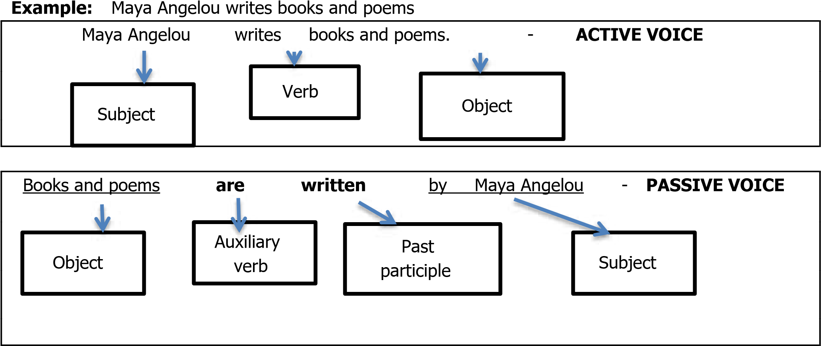
This means that every Passive Voice sentence has to have an auxiliary verb. Study these two sentences above.
They both say the same thing, but are constructed differently.

Note:
- The verb changes its form. It is written with a past participle.
- The verb always has a form of the verb “to be /auxiliary verb in front of it.
Examples of sentences changed from Active to Passive voice.

TENSES | ACTIVE VOICE | PASSIVE VOICE
Present | The child breaks the glass. | The glass is broken by the child.
Past | She broke the glass | The glass was broken by her.
Present continuous | The child is breaking the glass. | The glass is being broken by  the child
Past continuous | The child was breaking the glass | The glass was being broken by the child.
Future | The child will break the glass. | The glass will be broken by the child.
NOTE :
- How the verb form changes in Passive voice, i.e. The “auxiliary verb” is added in front of the verb.
- Pronouns change from the subject form to object form.

Follow the rules given below to change the following sentences from active voice to passive voice.
- Firstly identify the verb and underline it.
- Divide the sentence into: Subject verb Object
- Begin your sentence with the Object.
- Use the correct Auxiliary verb in front of the verb given.
- Change the verb given to Past participle.
Example: Change the following sentences in the active voice to the passive voice.
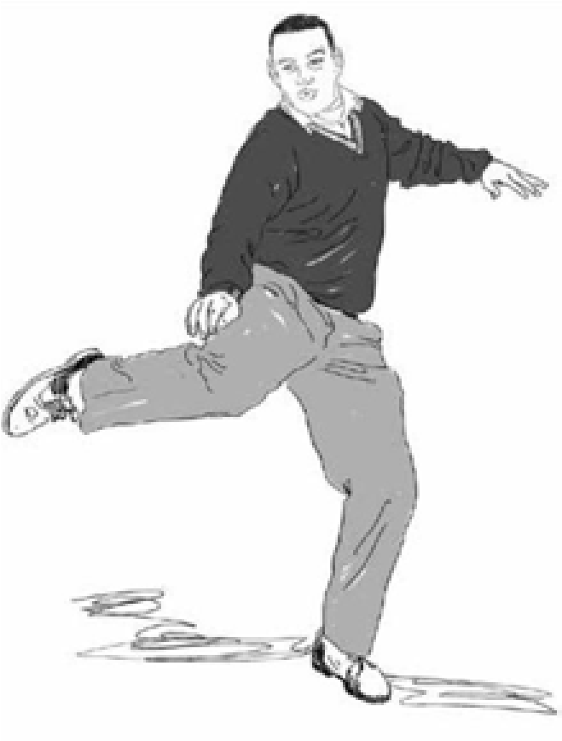
(NB: in the exam you will be asked to rewrite the sentence starting with the object)

‘I kicked the ball.’

I am the subject, the ball

is the object and kicked

is the verb. This is the

active voice

.
For the

passive voice

,

begin the sentence with

the object
-

the ball. The

sentence becomes:

‘The ball was kicked

by me.’

Questions:
- Henry is kicking the ball.
- The man sold three cars.
- My mother baked two loaves of bread.

ANSWERS

 | PASSIVE VOICE | REASON
1 | The ball is being kicked by Henry. | The Verb “kicking’ is in present continuous tense therefore it uses the auxiliary verb “is being” followed by the past participle of the verb.
2 | Three cars were sold the man | The Verb “sold’ is in past tense therefore it uses the auxiliary verb “were ‘ followed by the past participle of the verb.
3 | Two loaves of bread were baked by my mother | The Verb baked “is in past tense therefore it uses the auxiliary verb “were’ followed by the past participle of the verb.

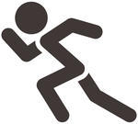
Individual activity:
Questions

1.1 Mum is going to prepare the food.
_______________________________________________________________

_______________________________________________________________

1.2. The delegation will meet the visitors at the airport.
_______________________________________________________________

_______________________________________________________________

1.3 All workers will read the memo.
_______________________________________________________________

_______________________________________________________________

1.4 The Chinese discovered acupuncture thousands of years ago.

_______________________________________________________________

_______________________________________________________________

1.5 Has he given you back the book yet?

______________________________________________________________________________

______________________________________________________________________________

