WORKSHEET | 2 - (03/04/2020)
GRADES: | 12
SUBJECT: | ENGLISH HOME LANGUAGE (FET)
WEEK | 11-12
TOPIC | DRAMA: HAMLET- ACT 3(iii-iv)
SUBMITTED BY | S.P. NDLOVU
DISTRICT | O.R. TAMBO INLAND DISTRICT

POINTS TO REMEMBER WHEN STUDYING ACT 3 OF HAMLET
THE STRUCTURE OF THE PLAY

It is important that as you read through the play, you keep in mind how the play is structured.

The notes below will help to remind you of that.

- The five-part structure, corresponding with the five acts
- Part One- THE EXPOSITION: It outlines the situation, introduces the main characters, and begins the action.
- Part Two-THE DEVELOPMENT: It continues the action and introduces complications.
- Part Three- THE CRISIS OR CLIMAX: This is the turning point of the play.
- Part Four- FALLING ACTION: includes further developments leading inevitably to Part Five.
- Part Five- RESOLUTION/RESTORATION: Here, the final crisis of action or revelation and resolution are explained. HAMLET follows this pattern.

KEY POINTS FROM THE WHOLE OF ACT 3
- Rosencratz and Guidenstern spying on Hamet
- ‘’To be or not to be” soliloquy
- The ‘Antic Disposition’ and The ‘Nunnery Scene’
- The ‘Mousetrap’ play
- Hamlet to ‘speak daggers’ to his mother (Soliloquy)
- The decision to send Hamlet to England
- Claudius’ attempt to pray and Hamlet’s reaction
- Hamlet confronts Getrude
- The death of Polonius
- Enter Ghost
- Hamlet’s knowlegde of being sent to England by Claudius

NB: As you read this Act, use the ovals below to record the events leading up to the climax. Use as many ovals as you need.
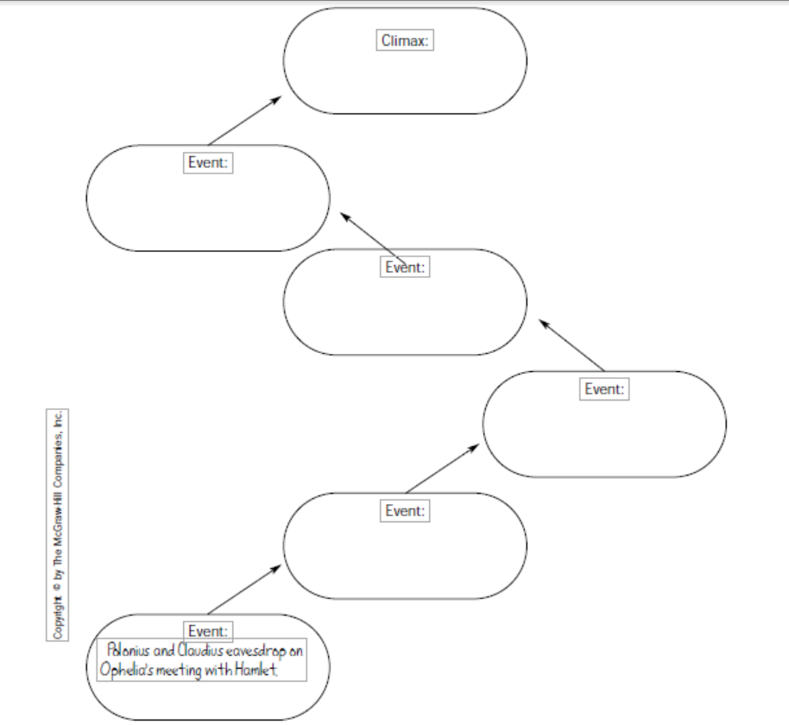
[Source: http://hamletguide.com/pdf/glencoestudyguide]

ACT THREE : WRITTEN ACTIVITY
After reading Act 3, answer the following Questions
- What message do Rosencrantz and Guildenstern carry to the King and Queen? What is their response?
- They tell them Hamlet wants the King to order Ophelia to marry him. The King refuses.
- They tell them Hamlet is having a special Mass said for his dead father. He asks them to come. The Queen accepts, but the King refuses.
- They tell them Hamlet wants to go off on a long journey, on foot, by himself. The Queen objects, but the King thinks it is a good idea.
- They tell them Hamlet wishes the King and Queen to see a play that night. They both accept.

- Hamlet's famous "To be or not to be" soliloquy is in Scene One. Which of the following paraphrases his main points?
- He questions whether love, either romantic or family love, is worth all of the pain it causes.
- He is pondering whether a miserable life is better than the unknown of the death.
- He questions whether peace of mind is a good substitute for material wealth.
- He questions the traditions about succession to the throne in Denmark. He feels that either he or his mother should be the rightful successor to his dead father.

- Describe Hamlet's tone when he speaks to Ophelia.
- He is kind and loving.
- He is patronizing and sarcastic.
- He is rude and aggressive.
- He is meek and fearful.

- What do the King and Polonius decide about Hamlet's condition after eavesdropping on Hamlet and Ophelia?
- They decide he is love-sick, and the only cure is to find him another love.
- They decide he is not love-sick; rather; he has some other trouble deep in his soul.
- They decide his father's death has left him troubled.
- They decide he's not sick at all; he's just being a spoiled brat throwing a tantrum.

- Why does Hamlet give instructions to the players?
- In his madness, he believes that he is really a great actor, not the Prince of Denmark.
- He is helping them remember their lines, because he does not want to disappoint his mother when she watches the play.
- He is merely showing off his superiority, to keep in character with his pretense of being mad.
- He does not want the parts to be over-acted. He wants it to appear as natural and a real as possible, so it will hit home to the King.

- What was the King's reaction to the play, and what did Hamlet and Horatio decide his reaction meant?
- The King had no reaction to the play. They decided it meant they were wrong, and that he was innocent after all.
- The King laughed and laughed. They decided he didn't really get the point, and they would have to be more direct the next time.
- The King got up and called for the lights. They were convinced that the ghost had been correct.
- The King clenched his teeth and gripped the arms of his chair, but said nothing. They thought they were on the right track, but would need to do something else to force the King into making a confession.
- What message does Rosencrantz deliver to Hamlet from the Queen?
- She is angry and won't speak to him for one month.
- She wants to see him.
- She is arranging for him to have dinner with a girl she thinks he will like.
- She wants him to go to Norway immediately.

- The King has Rosencrantz and Guildenstern prepare to do what?
- They prepare to take Hamlet to England.
- They prepare to try and patch things up between Hamlet and Ophelia.
- They prepare to help Hamlet write another play. However in this one, the King has written some lines that accuse Hamlet of the murder of his father.
- They prepare to capture Hamlet and imprison him.

- Why doesn't Hamlet kill the King when the King is kneeling?
- Hamlet wants his mother to be there to witness the deed.
- Hamlet loses heart, and realizes that his father would not have wanted another murder committed.
- Hamlet wants the King to die without a chance for a last confession. If he is praying, he may not be in enough sin to get eternal punishment.
- He thinks he hears noises in the hallway. He is afraid that someone will see him. He decides to wait until he can be sure they are alone.

- How does Polonius die?
- He and Ophelia are standing on the top of the castle tower, talking. Ophelia becomes enraged and pushes him over the edge.
- Polonius is hiding in the Queen's room while she and Hamlet are talking. He makes a noise. Hamlet runs through the tapestry, thinking it may be Claudius, and kills Polonius.
- The King decides to get rid of any potential enemies. He sends Rosencrantz and Guildenstern to murder Polonius. They make it look like a suicide.
- He realizes Hamlet has been right all along. He kills himself in his grief and remorse.

