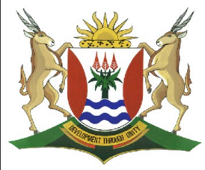
Province of the
EASTERN CAPE
EDUCATION

DIRECTORATE SENIOR CURRICULUM MANAGEMENT (SEN-FET)
HOME SCHOOLING SELF- STUDY TEST
SUBJECT | ECONOMICS | GRADE | 10 | DATE | 15/04/2020
TOPIC | MACROECONOMICS | TERM 1  REVISION | X | TERM 2 CONTENT
TIME ALLOCATION | 50 MINUTES MARKS: 60 | TIPS TO KEEP HEALTHY  1. WASH YOUR HANDS thoroughly with soap and water for at least 20 seconds. Alternatively, use hand sanitizer with an alcohol content of at least 60%.  2. PRACTICE SOCIAL DISTANCING – keep a distance of 1m away from other people.  3. PRACTISE GOOD RESPIRATORY HYGIENE: cough or sneeze into your elbow or tissue and dispose of the tissue immediately after use.  4. TRY NOT TO TOUCH YOUR FACE. The virus can be transferred from your hands to your nose, mouth and eyes. It can then enter your body and make you sick.  5. STAY AT HOME.
INSTRUCTIONS | INSTRUCTIONS AND INFORMATION  - Answer ALL questions in the ANSWER BOOK  - Number the answers correctly according to the numbering system used in this question paper.  - Write the question number above each answer.  - Leave 2–3 lines between subsections of questions  - Write neatly and legibly.

QUESTION 1
  - Give ONE term for each of the following descriptions. Write only the term next to the question (1.1.1-1.1.8) in the answer book.

1.1.1 The highest point of economic activity in the business cycle.
1.1.2 Reasons that originate outside the market or economy.
1.1.3 Changes that may occur at certain times of the year.
1.1.4 The phase that comes after a recession and the growth rate will get to zero.
1.1.5 An indication of sudden drought or unexpected events that influence the trend of a business Cycle.
1.1.6 Refers to the ups and downs of economic activity in an economy.
1.1.7 It is the general direction in which in which the graph is moving’
1.1.8 It occurs when an economy is really growing and improving quickly.
(8 X 1) (8 marks)

QUESTION 2
2.1 DATA RESPONSE
Study the cartoon below and answer the questions that follow
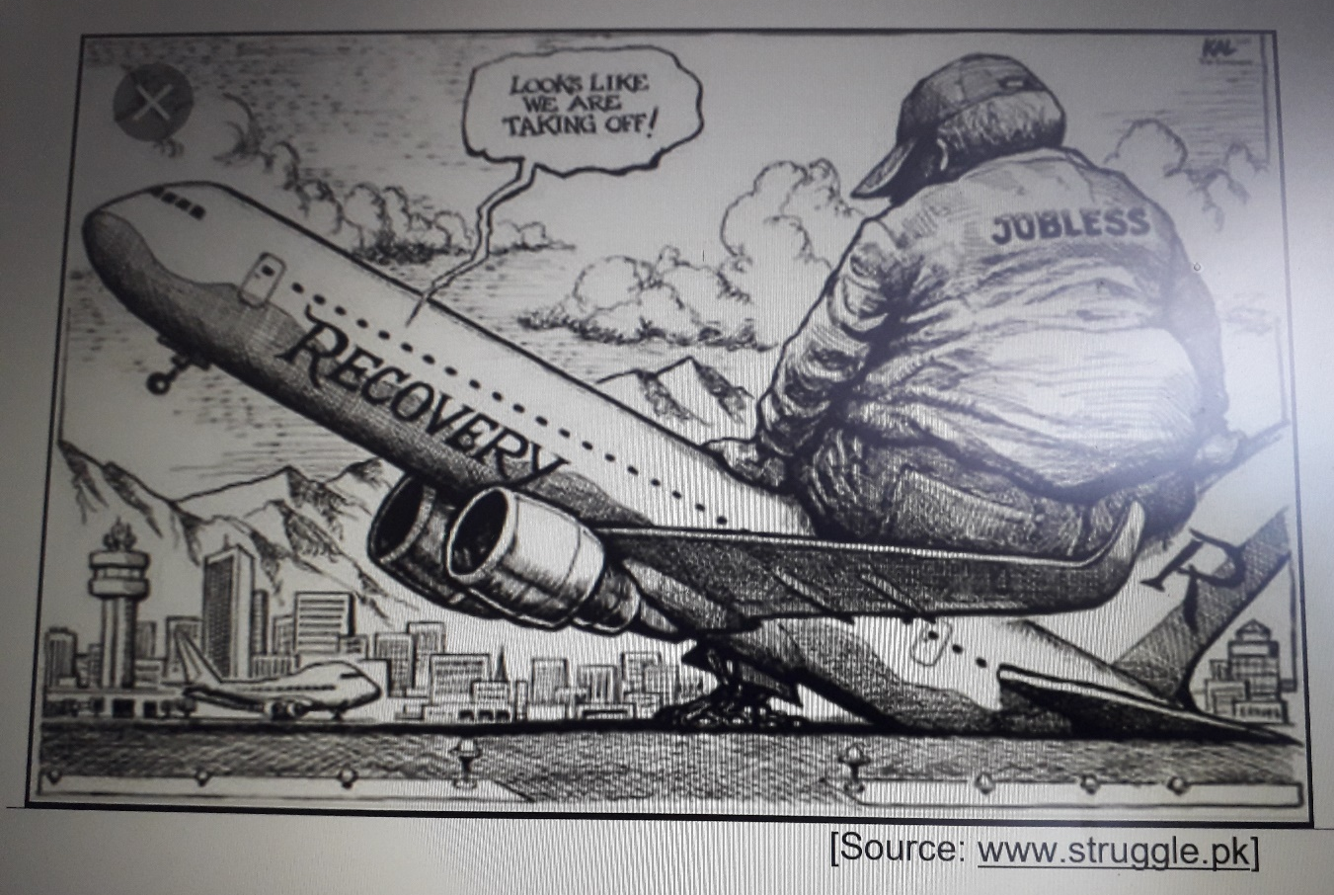

2.1.1 Identify the phase of the business cycle as well as an economic activity from the cartoon (2)
2.1.2 Why do you think that ‘jobless’ will not lead to an economic ‘take-off’? (2)
2.1.3 Which business cycle indicator does ‘jobless’ refer to? (2)
2.1.4 How would you describe the recovery phase of a typical business cycle? (4)

2.2 Distinguish between seasonal changes and random variation. (8)
2.3 How does the recession phase affect the society. (8)

Question3
3.1 Read the extract and answer the questions that follow.
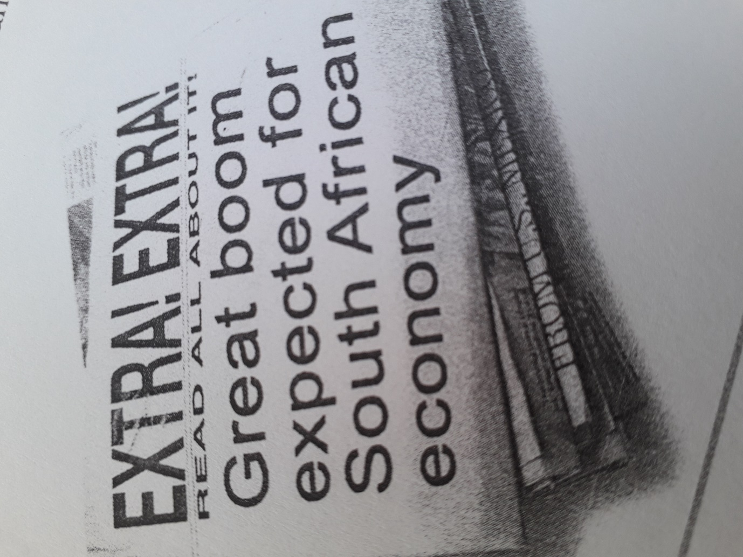
3.1.1 Identify from the extract the phase that is expected to come. (1)
3.1.2 Name one positive effect of the expected phase . (1)
3.1.3 Do you think South Africa’s economy is doing well? Explain your answer. (2)
3.1.4 Describe what happens to the poor people when the economy is not doing very well economically. (2)
3.1.5 How would the expected phase benefit the citizens of the country. (4)

3.2 Distinguish between exogenous and endogenous of the business cycle. (8)
3.3 Why are the measures of economic activities important in the country. (8)

TOTAL [60]

