GRADE 10 WORKSHEETS
04 APRIL 2020
10 MARKS

NOTE: This worksheet is to be completed in your NS exercise/activity book.
Question 4

Complete the compass card/rose by supplying the appropriate cardinal or inter-cardinal point name and/or degrees. (10)
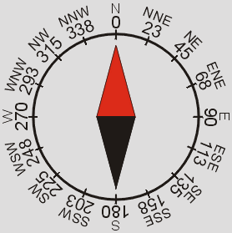
(h)
(e)
(b)
(a)
(d)
(f)
(i)
(c)
(g)
(j)

