ANNEXURE 1

EXAMINATION NOTES AND DEVIATION CARD

- All relevant working must be shown on the answer sheet.

- All work done on the chart must be done lightly, using a 2B pencil.

- Corrections applicable to courses and bearings must be calculated correct to the nearest 1° and plotted to a similar accuracy.

DEVIATION CARD

Comp. Head | Dev. |  | Comp. Head | Dev.
000  010  020  030  040  050  060  070  080  090  100  110  120  130  140  150  160  170 | 4° E  5° E  4° E  3° E  2° E  1° E  1° W  2° W  3° W  4° W  5° W  4° W  3° W  2° W  1° W  0°  1° E  2° E |  | 180  190  200  210  220  230  240  250  260  270  280  290  300  310  320  330  340  350 | 3° E  4° E  5° E  4° E  3° E  2° E  1° E  0°  1° W  2° W  3° W  4° W  5° W  4° W  3° W  2° W  1° W  2° E

ANNEXURE 2

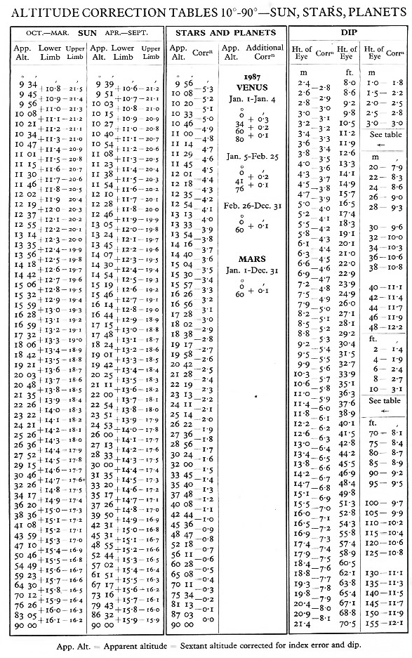
ANNEXURE 3

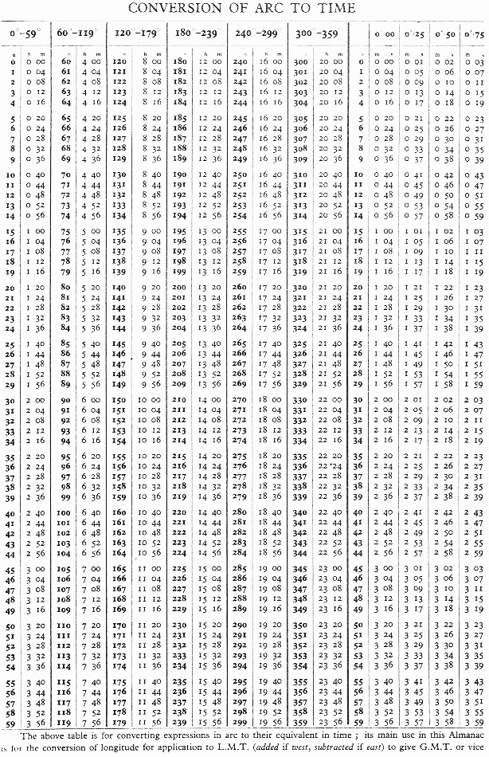
ANNEXURE 4

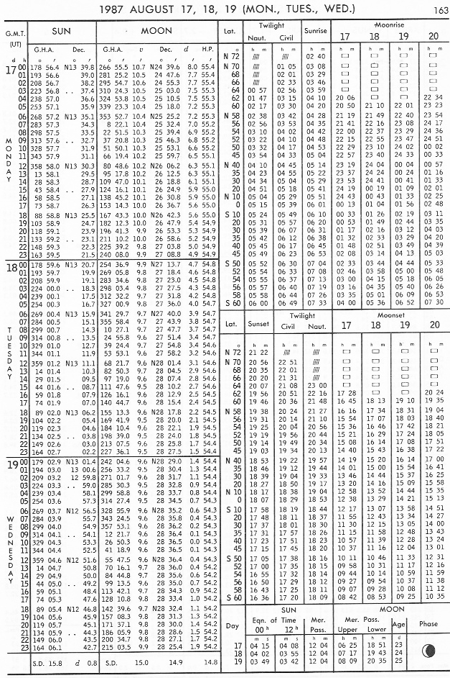
ANNEXURE 5

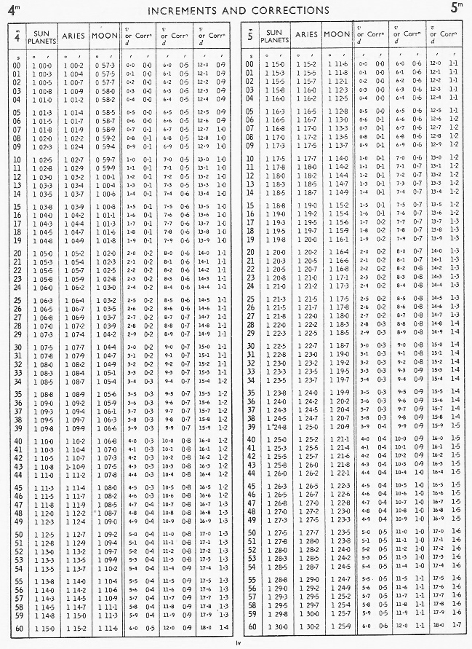

ANNEXURE 6

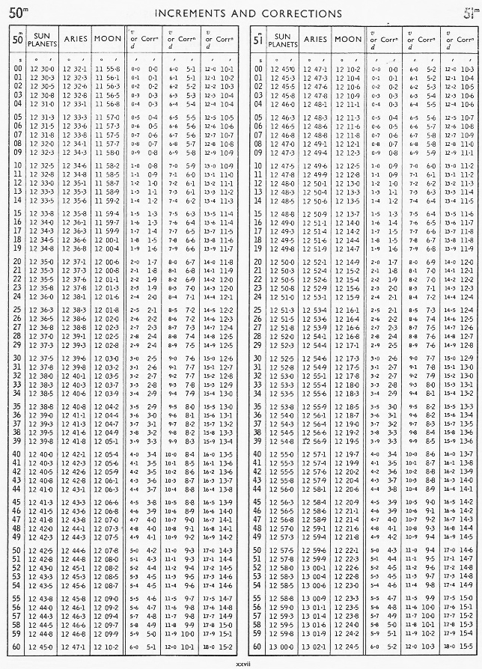

ANNEXURE 7

